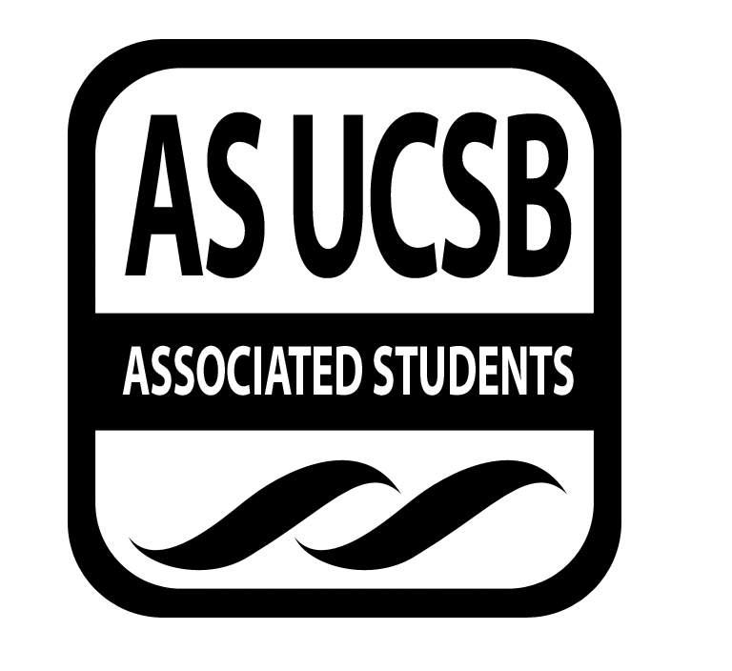
A.S. SIRRC Minutes

Associated Students
April 27, 2017 @ 6:00 pm
AS Annex Minutes Recorded By: James Fonseca

CALL TO ORDER at 6:04 by Lorena Alvarez

A. MEETING BUSINESS
- Roll Call

Name | Note:  absent (excused/not excused)  arrived late (time)  departed early (time)  proxy (full name) | Name | Note:  absent (excused/not excused)  arrived late (time)  departed early (time)  proxy (full name)
Lorena Alvarez | Present | Bryan Garcia | Present
Josh Hudson | Proxy | Salvador Hernandez | Proxy
Michelle Martinez | Excused | James Fonseca | Present
Ernesto Jimenez | Present | Renata Rodriguez | Present
Julia Hsueh | Present | Tiffany | Present
Joseph Rico | Present | Lesly Silva | Excused
Brenda Cruz | Present | Jonathan Lopez | Excused
Carmen Garcia | Present

A-2. Acceptance of Excused Absences
Motion to make Ulises for Salvador. Lorena/Carmen. Tiffany calls to question. Mara calls consent. No objections to consent; motion passes
Motion to make Jerry proxy for Josh. Carmen/Tiffany. Renata calls to question. Lorena calls consent. No objections to consent; motion passes

Additional approval required: YES Senate
B. PUBLIC FORUM
  - Announcements/Information/Introductions/ Ice Breaker
  - Testimony for items on today’s agenda (out of order)
    - Ice Breaker- “Blanket Game”
    - Break-out Groups
    - Announcements
    - Voting
  - Appreciations/Concerns
  - Request to have item added to today’s agenda
- REPORT ITEMS
D-1. Retention-
-Talked about GSO and GTSO
-Talked about the theme for the dance
-Talked about contacts fro the workshops for both GSO and GTSO
-Talked about housing and hoe many applicants to accept

D-2. Recruitment-
-Going over the itinerary for their college trip
-There is a probability that
-Action Items

Presentations

- Los Ingineros
-The event went really well! They went to various companies and the students got a really good experience from it all.

- New Business
Funding Requests

Motion to reimburse Tiffany $27.60 for fliers and digiknows for the Study Jam. Mara/Carmen. Julia calls to question. Brenda calls consent. No objections to consent; motion passes.

Additional approval required: YES Senate

- REMARKS
-Sigma Alpha Zeta club event tickets are available
-CLOP is happening right now. Come help volunteer if you can!
-Micaela J. Diaz-Sanchez will have an event May 2nd called Hablando con Todxs.
-Betas El Sition fundraiser is happening right now until 11pm
SLG is having their Multicultural Awareness week happening this week
-IV Earth day Festival this Saturday
Hermanas Unidas Raza Week is happening next week.
SIRRC Election Application is online. Deadline to apply is May 5th.
-Bookstore is having a sale tomorrow
ADJOURNMENT
MOTION/SECOND to ADJORN: James/Mara
ACTION: Vote: 13-0 to APPROVE
Vote Taken: 7:30 pm

