Queer Commission Minutes

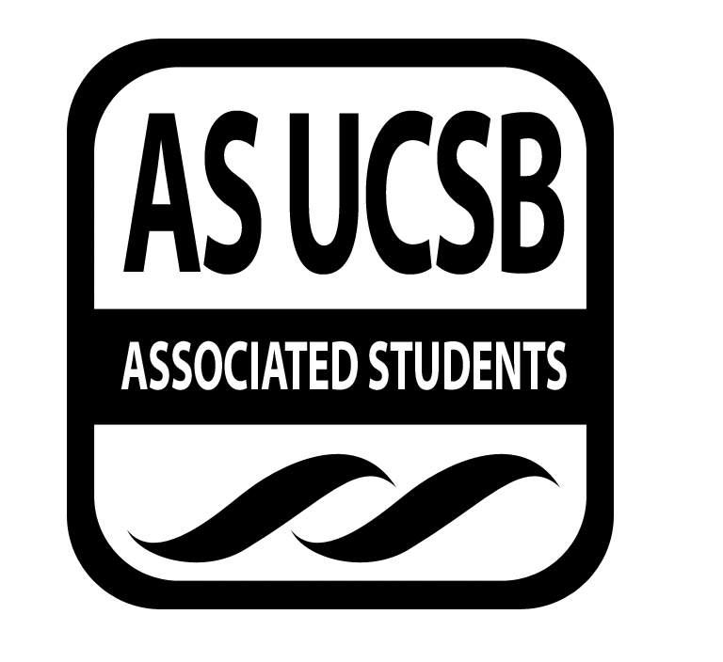
Associated Students
January 20, 2014, 7:00 PM; 2nd floor of MCC
Minutes recorded by: Ryan Orihood, Queerstorian

CALL TO ORDER: 7:15 by Andrew, Co-Chair

A. MEETING BUSINESS
- Roll Call (Pre-entered Names)

Name | Note:  (note if non-voting) | Name | Note:
Chris Buck
Andrew Farkash
Melba Martinez
James Neally
Ryan Orihood
Christian Perez
Shane Stringfellow
Cristina Roman

B. PUBLIC FORUM
  - Ice Breaker: Favorite part of the weekend
  - Announcements
    - FUQIT collages
    - Program on asexuality: Thursday, 6 PM @ UCSB Womyn’s Center Conference Room
    - QSU Big/Little Scavenger Hunt: Tuesday, 7 PM @ State Street Room
    - Queer Book Club: Friday, 3 PM @ RCSGD
    - OStem Road trip for science: 25th

- ACTION ITEMS/FUNDING REQUESTS

F-1. Old Business: N/A

F-2 New Business:
Motion to sustain Melba Martinez as QComm’s External Coordinator
ACTION: Vote, 8-0-0 APPROVE, Melba voted in as new External Coordinator
Additional approval required: YES, senate

- OFFICER UPDATES
Ryan
- Pacific Pride HIV testing
- Soc 145 help for lock in fee
- Womyn’s Comm meeting
Chris
- Winter Wonder Drag a success!
- UOP conference fully funded!
- Planning drag shows for Campbell Hall
Shane
- Safe-Zoneing Safe Sex Peers
Melba
- Budget and funding request next week for event later this quarter
- FEMME film screening
Andrew
- Collaborating with Human Rights Board

ADJOURNMENT: 7:33 PM by James, Co-Chair

