Program Board Agenda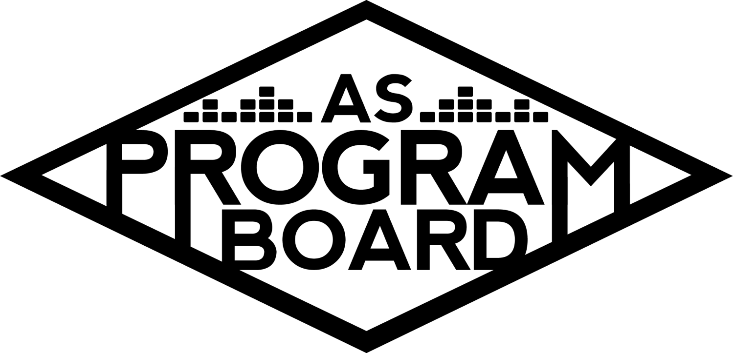

## Associated Students

June 3rd, 2019

SB Harbor Room

**CALL TO ORDER: 5:41pm**

**A. MEETING BUSINESS**

1. **Roll Call**

|  |  |  |  |
| --- | --- | --- | --- |
| **Name** | **Note:**  absent (excused/not excused)  arrived late (time)  departed early (time)  proxy (full name) | **Name** | **Note:**  absent (excused/not excused)  arrived late (time)  departed early (time)  proxy (full name) |
| Adam Salton |  | Kari Liu |  |
| Alexis Xa |  | Kathryn Quinones |  |
| Bethel Tammerat |  | Kiyomi Morrison |  |
| Brenna Collins |  | Lucas Jackson |  |
| Brett Friedman |  | Mikio Sacramento |  |
| Carlos Aviles-Sullivan |  | Mitchell Lewis |  |
| Conner Jones |  | Nathaly Pacheco |  |
| Enaiya Judkins |  |  |  |
| Erica Ko | Late arrival (6:10pm) |  |  |
| Esteban Alvarado |  |  |  |
| Gabriel Reyes |  |  |  |
| Greer Jacobs |  |  |  |

**Acceptance of excused absences, absences, early departure and proxies**

Nathaly motions to excuse Erica’s absence and early departure at 6pm and return at 7pm of Alexis, seconded by Gabe, consent with 17 present

**B. PUBLIC FORUM**

**C. ACCEPTANCE of AGENDA/CHANGES to AGENDA**

Lucas/ Nathaly to accept agenda changes, consent with 17 present

**D.ACCEPTANCE of ACTION SUMMARY/MINUTES**

**E. ANNOUNCEMENTS**

1. Introductions! - Name, year, major, position, fun fact, favorite class at ucsb
2. General Housekeeping
3. Robert’s Rules of Order
4. Email Votes- will not have meetings over summer so votes will be over email, try to email within 1 business day, once discussion is had, we will have phone votes, then we will reaffirm these votes in meeting. State your opinions always.
5. Summer Board- due next monday, will send over email
6. Retreat- 9/14, 9/21 go to a beach house, free food and a long meeting, we will all be driving to the beach house
   1. Driver Training, possible deductions in your insurance, training will happen in session B
7. Budget Overview- $16.75 lock in fees from students

**F. WEEK IN REVIEW**

**G. PREVIEW OF THE WEEK**

**H. OLD BUSINESS**

**I. NEW BUSINESS**

1. 2019 Summer Budget- pass for all summer events, student fees from students taking summer classes
2. 2019 Summer Films Budget
3. 2019 Summer Merch Budget
4. 2019 Fall Publicity budget
5. 2019-2020 Films Budget
6. Storke Show Budget
7. Welcome Back Budget - 9/28
8. Lagoon Film Budget - 9/25
9. Delirium Budget
   1. Discuss Date - 10/26 or 11/2

**J. ACTION ITEMS**

**K. FINANCIAL ACTION ITEMS**

1. 2019 Summer Budget- Gabe motions to pass $60,000 for 2019 Summer Budget / Nathaly seconds, consent with 17 present
2. 2019 Summer Films Budget- Esteban motions to pass $16,100 for 2019 Summer Films/ Brett seconds, consent with 17 present
3. 2019 Summer Merch Budget- Bethel motions to pass $2,298 for 2019 Summer Merch/ Nat, consent with 17
4. 2019 Fall Publicity budget- Nathaly motions to pass $2,670/ seconded by Gabe, consent with 17 present
5. 2019-2020 Films Budget- Esteban motions to pass $45,550 for 2019-2020 Films/ seconded by Kat, consent with 17 present
6. Storke Show Budget- Nathaly motions to pass $20,544 for 2019-2020 Storke Shows, seconded by Carlos, consent with 17 present
7. Welcome Back Budget - 9/28- Nathaly motions to pass $46,575 for Welcome Back/ seconded by Lucas, consent with 17 present
8. Lagoon Film Budget - 10/2- Esteban motions to pass $4,550 for the Lagoon Film / Conner seconds, consent with 17 present
9. Delirium Budget- Nathaly motions to pass $150,500 for Delirium 10/26/ Lucas seconds, consent with 17 present

**L. REPORT**

**Facebook Factory/ Thursday Slide**

**The Marilyn Report-** passed a lot of budgets and money, completely normal, roll over and over enrollment so more money might be coming in, bring ideas to retreat, will need to come in after graduation to get key cards, need to get on payroll so bring in social security or passport

**Commissioner's Report-** super excited, crazy, will be a fun year, study up and business, budgets in by friday at noon and will send out by Saturday, reports at the end of quarter

**Deputy Commissioner’s Report-** working on merch stuff and will send options for shirts, contacting everyone to start driving training, here to help and be friends :)

**Coordinators’ Reports**

Adam, excited to meet with everyone and become friends and start getting to work

Brett, start the year off right with concerts, more on indie side

Carlos, excited to learn and grow

Conner, excited to work with everyone, big ideas to update and change website, in the works of a couple plans, over summer will be here

Erica, excited for the year and grateful for opportunity, not here over the summer

Esteban,

Gabriel, super geeked, compiling list of people to bring for cultural events, reaching out to people, here over summer

Greer, super excited

Kari, pumped to be on board, excited to learn, patient with each other

Mitchell, overwhelmed and excited, trying to bring in art

Nathaly, submissions for artists to bring are due tomorrow, okay to emphasize an artist that is already on there, ask questions, super excited

**Assistants’ Reports**

Alexis, super excited to work with everyone, event staff

Brenna, cool team

Enaiya, very excited, will push everyone’s events

Kathryn, here over summer, excited to get close to everyone

Lucas, hyped

Mikio, looking for next year, and everyone here

**Senator’s Reports**

**ADJOURNMENT : 7:11pm**