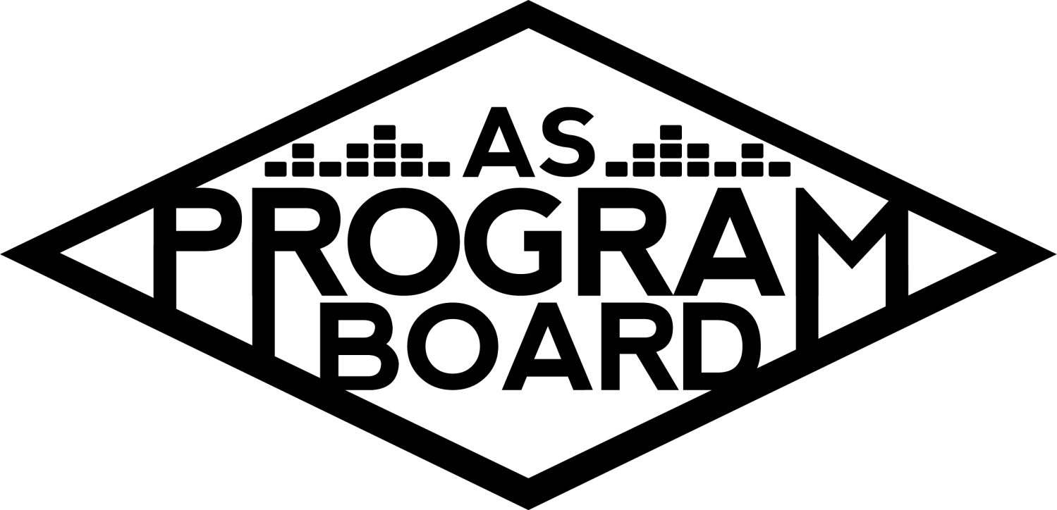
Program Board Minutes

Associated Students
May 23rd, 2022
Zoom

CALL TO ORDER: 5:02 pm
A. MEETING BUSINESS
- Roll Call
Name | Note:  absent (excused/not excused)  arrived late (time)  departed early (time)  proxy (full name) | Name | Note:  absent (excused/not excused)  arrived late (time)  departed early (time)  proxy (full name)
Ashley Yeh |  | Kim Kryshak
Clarissa Mendoza |  | Lauren Schaeffer | Late Arrival 5:04
Emily Duong |  | Lucas Jackson
Emily Kocis |  | Nyah Scott
Enaiya Judkins |  | Sophie Kimura
Flora Mehdi |  | Talia Heimanson
Kathryn Quinones |  | Wally Corngold
Kathryn Supple |  | Jessy Gonzalez | Absent
 |  | Kian Mirshokri | Absent
Acceptance of excused absences, absences, early departure and proxies
Motion to accept the late arrival of Lauren and the absence of Jessy and Kian. Motion by Emily D, second by Kimmy. Consent with 13 present.

B. PUBLIC FORUM

C. ACCEPTANCE of AGENDA/CHANGES to AGENDA
Motion to accept the agenda. Motion by Nyah, second by Clarissa. Consent with 14 present.

D.ACCEPTANCE of ACTION SUMMARY/MINUTES
Motion to accept the minutes from 5/16/2022. Motion by Nyah, Second by Emily K . Consent with 14 present.

E. ANNOUNCEMENTS
- Land Acknowledgement
- Check In: What’s your favorite reasonably priced restaurant for dinner in Santa Barbara, CA? Also- How are you?

F. WEEK IN REVIEW
- Free Tuesday Film: Pulp Fiction 5/17
  - LJ- went well, pretty popular. 50 people 7pm, 60 people 10pm
- Spring Drive In 5/22
  - NS- ty Kat S and Clarissa for coming out! 25 cars, maybe 60 people at one time. Wasn’t what I was expecting location and staffing wise, venue was a bit rundown, minimal to no signage indicating an event was happening and wasn’t a super inviting setting. Boardies stationed at entrance to flag people down to come because people were missing the entrance. Think it would be great for a Halloween-y event and overall the event was good to have for future reference. Would be nice to open up to the public and maybe charge 5 bucks/car.

G. PREVIEW OF THE WEEK
- Storke Show ft. Ping Pong Palace 5/24
  - LS- last Storke show tomorrow. No one signed up to work, please sign up on Notion. Need people from 11:30-1:05ish. Will Slack Kris about production.
- Free Tuesday Film: Howl’s Moving Castle 5/24
  - LJ- haven’t heard back on if IV Theater has officially received tape yet but should be fine. 6:30- Wally, Kim, Kat S, Kat Q. 9:30- no one
- Hub Show ft. Audrey Nuna 5/25
  - TH- Wally sent sign up in Slack, Kim & Wally hosp, Enaiya runner, Lauren, Sophie Kat Q & Lucas working general (need 1-2 more). Sophie will lead volunteers and they’ll scan access cards.
  - AY- past events tickets load on access cards for students and AXS barcode will be sent to general. Will check with Edwin about access cards vs. AXS app. Will probably get a ticket count sometime tmo.
  - TH- will we not be able to just scan access card at the door? Don’t think we’ll go over 800 people
  - MD- will be complicated. Need to keep track of how many people reserve and buy.
  - TH- have parking info for Ashley, still figuring out some production stuff. Still need few more people for general. Hosp room is Lobero and it’s reserved 3:30-10:30. Hosp people meet at office at around 3:15 and we’ll head over at around 3:30.
  - 3 or 4 volunteers should be fine.
  - KE- from production end it feels really tight/close. Hard to find digital consoles, vendor we’re working with has one and hoping to get the other one delivered tomorrow

H. OLD BUSINESS
- Ambassadors
  - ED- forgot about meeting this weekend but will reach out to them for update on things.
- Playlists, Blogs, & Podcasts
  - ED- probably one of last playlists, if you have outstanding blog/podcast ideas please let me know.
- Social Media Takeovers
  - NS- forgot to send Emily K log-in for takeover last week. Enaiya will do this Wednesday
- Hiring
  - KQ- DONE (basically)! Start compiling a list of logins/passwords (email, Slack, other logins you might have). Gonna put everyone in contact with the person who will take your position. Need to have a new board/old board transition meeting (not next Monday because holiday)
- Free Bagel Day
  - NS- budget
  - NS- will call ahead to Costco about bagel order, will go through school’s catering about cream cheese, may or may not have to do cash advance. Basically will be a sign up sheet for Monday (and maybe Tuesday) of finals week.
- End of the Year Volunteer Thank You
  - KQ- do we want to extend this to volunteers outside of X
  - SK- yes open it up
  - ED- yes
  - KQ- will try to figure out dates, please try to have open availability for this and transition meeting and dinner
  - Thurs Jun 2 at 5pm.

I. NEW BUSINESS

J. ACTION ITEMS

K. FINANCIAL ACTION ITEMS

- Motion to pass $1000.00 for Free Bagel Day on June 6, 2022. Motion by Lucas, second by Kim. Consent with 14 present.

L. REPORT
Facebook Factory / Tuesday Slide / Thursday Ad/ Free & For Sale post

Ping pong palace, audrey hub show, howls moving castle!

Kudos

Sophie for dropping things to enaiya
Emily d for getting pranked
Kat for making emily k leave class
Rehiressss!
Hiring committee
Wally for having sophomore sillies
Enaiya for working at STR w sophie
Kim for seeing olivia this weekend
Nyah for driving
Emily D for exposing Kim about Olivia
Kat S and Clarissa for drive in
Kris for production
Md for being Talia’s emotional support bestie
Talia n Wally week of show
Nyah spring drive in
Seniorsssssss <3 :D
Clarissa for being the best assistant
MD for putting up with Lucas for 4 yrs
Nyah for being so amazing at pub and being so inspiring (!!!!!)
Floragirl xp
Lauren!!
Kim for doing the THANG
Kat q Enaiya Kim Nyah Lucas Talia for being a senior and graduating soonish
Kat Q for being commish xP
Sophie for being the best & teaching Flora so much– pleasure doin business
Everyone for this great opportunity
Ur all so cool !
Talia for handling it like a pro
Wally for being emotional support bestie– excited for u
Nyah for being so hardworking
Kat S doing the most

The Marilyn Report
AS Awards Banquet June 1st, probably moving it online
The Kris Report
If you’re available at like 10am tomorrow to help roll some stuff over for Storke show that’d be great. Looking forward to show on Wednesday, manifesting console.
Commissioner's Report
Qtr reportssss, thx for getting them to me. Week 9/Week 10 grind, trying to settle back into school mode. Happy hiring is settled, end of year stuff will be fun.

Deputy Commissioner’s Report
Pls manifest me graduating on time

Coordinators’ Reports
Ashley- will be doing virtual office hours this week, lmk if u need anything!
Emily D- sent out volunteer request email, will be working w ambassador stuff and finalizing guide
Emily K- gonna be running around like wild thang for rest of qtr, give me hug if u see me, lmk if u need anything
Kathryn S- excited for movie tomorrow & other 2 events & class stuff
Kimmy- excited for audrey and other stuff, started formatting my guide and it’s gonna go bezerk
Lucas- getting ready for last film of the year and doing other end of college stuff
Nyah- happy i got to put on my own event, bagel day finna be a movie, glad hiring is done, will get guide done, scaredexcitedscared for graduation
Sophie- excited for Audrey, thinking about Enaiya graduating, gonna sign up for movie tomorrow to have fun
Talia- working on Hub show, pls pub!!! Thank you again everyone for being so supportive of ups and downs of high school football (hub shows)

Assistants’ Reports
Clarissa- working on school, excited for events coming up & trying to appreciate time left before summer
Flora- will be finishing up remaining graphics and doing school. Going home for weekend
Lauren- hope to see everyone at Storke show and at Audrey!
Wally- super excited for audrey show and in person hub show. Hope everyone’s doing well, stay strong ur almost done!

Senator’s Reports
Jessy-
Kian-

ADJOURNMENT at 6:12 PM by Kathryn Quinones

Artists mentioned:

