Program Board Minutes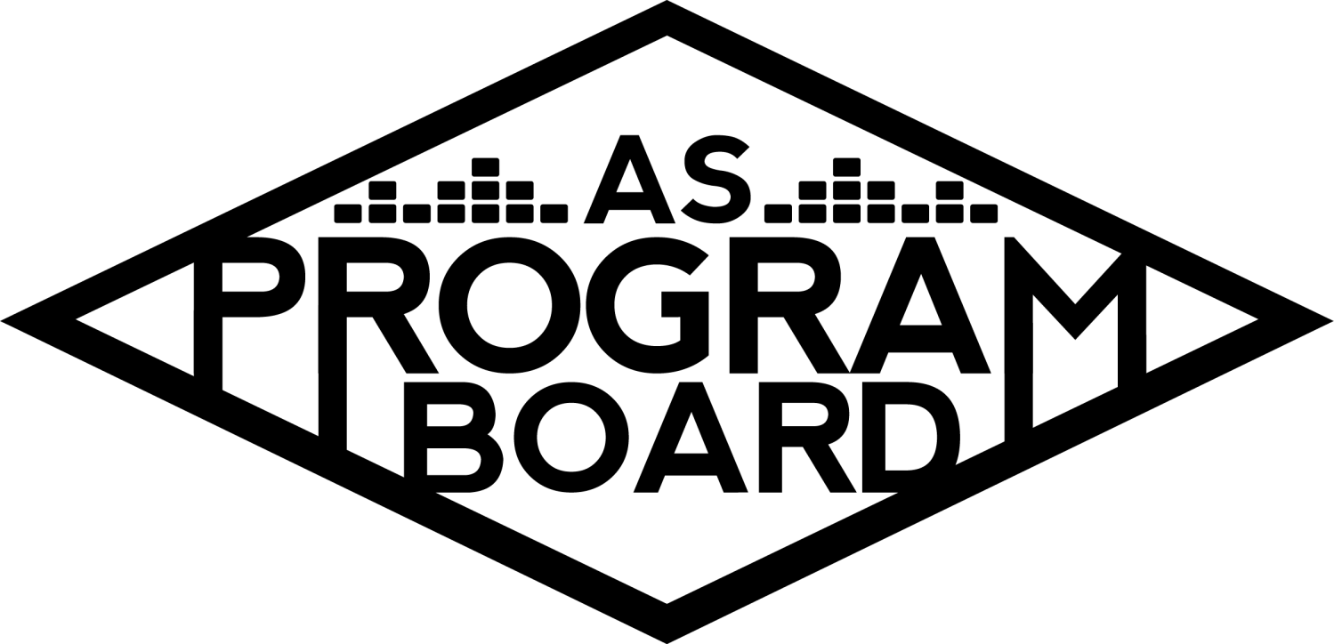

## Associated Students

May 2nd, 2022

UCEN Harbor Room

**CALL TO ORDER: 5:05 pm**

**A. MEETING BUSINESS**

1. **Roll Call**

| **Name** | **Note:**  absent (excused/not excused)  arrived late (time)  departed early (time)  proxy (full name) | **Name** | **Note:**  absent (excused/not excused)  arrived late (time)  departed early (time)  proxy (full name) |
| --- | --- | --- | --- |
|  |  |  |  |
| Ashley Yeh |  | Kim Kryshak |  |
| Clarissa Mendoza |  | Lauren Schaeffer | Early Departure 7:00pm |
| Emily Duong |  | Lucas Jackson |  |
| Emily Kocis | Late Arrival 6:00 pm | Nyah Scott |  |
| Enaiya Judkins |  | Sophie Kimura |  |
| Flora Mehdi |  | Talia Heimanson |  |
| Kathryn Quinones |  | Wally Corngold | Late Arrival 6:00 |
| Kathryn Supple |  | Jessy Gonzalez | Absence |
|  |  | Kian Mirshokri | Absence |
|  |  |  |  |

**Acceptance of excused absences, absences, early departure and proxies**

Motion to accept the late arrival of Wally and Emily K, the early departure of Lauren, and the absence of Jessy and Kian. Motion by Lucas, second by Nyah. Consent with 12 present.

**B. PUBLIC FORUM**

**C. ACCEPTANCE of AGENDA/CHANGES to AGENDA**

Motion to accept the agenda. Motion by Nyah , second by Kat S. Consent with 12 present.

**D.ACCEPTANCE of ACTION SUMMARY/MINUTES**

Motion to accept the minutes from 4/25/2022. Motion by Emily D, Second by Nyah . Consent with 12 present.

**E. ANNOUNCEMENTS**

1. [Land Acknowledgement](https://drive.google.com/file/d/1E-PZKDH6p3gF2cET7L_W0gbz40eGv5ca/view?usp=sharing)
2. Check In: What was the last thing you got really invested in & what did you like so much about it? A hobby, show, album, practice, etc.

**F. WEEK IN REVIEW**

1. Free Tuesday Film: Emergency (4/26)
   1. LJ- Sophie, Enaiya and Flora worked. Studio people had 30 $50 Amazon giftcards, around 35 people showed up so almost everyone got a gift card. Studio wants to do more with us and students seemed to enjoy it.

**G. PREVIEW OF THE WEEK**

1. Free Tuesday Film: Ratatouille (5/3)
   1. LJ- 6:30 Kat S, Emily D, Clarissa 9:30 Nyah and Enaiya. Student choice, please pub! Studio said they might not be able to get it to us in time but IV theater has a backup plan. Unless we have our own copy of a Studio Ghibli film we can’t do it. Would still need to license it.

**H. OLD BUSINESS**

1. Ambassadors
   1. ED- met yesterday to go over theme and release schedule so they know what this week and next week look like.
2. Playlists, Blogs, & Podcasts
   1. ED- lull because everyone’s busy with X and midterms, hopefully can get back into it after. Trying to come up with an intergalactic theme for this week and X soundcheck next week.
3. [Social Media Takeovers](https://docs.google.com/document/d/1xEyVTBqiSj7-m8LbpDWw2iUnDrK7-2gMc1iR_PlmTtw/edit?usp=sharing)
   1. SOPHIE THIS WEDNESDAY
4. Extravaganza (5/15)
   1. KK- third slot likely to confirm. Think fourth slot will pass. Artwork’s being approved.
   2. KE- stage estimate looks good. Sound quotes are looking a bit sketch. Have quote for video wall. Have backline secured for headliner and 2nd slot. Barricade is confirmed. Miller secured.
   3. Struggling with tents for hosp. UCEN catering ready to go.
   4. TH- have a few trailers lined up, need to figure out contracts and get them university approved.
   5. LJ- Fencing and bike barricades and other Marborg invoices have been sent to MD.
   6. KQ- AS recycling low staffed and can’t service X. Suggest we rent their supplies and dispose of waste ourselves or reach out to facilities management about doing it.
   7. KK- have to locate plywood still, tbd for that.
   8. KQ- purchase order for water in MD’s box. More expensive than it used to be
   9. ED- price of photobooth went up, currently trying to confirm photobooth design and he said he needs a check DOS. waiting for contracts on body painting. Wally still waiting on screenprinting stuff, might have to find alternative or cancel.
   10. KQ- wristbands in production.
   11. LS- cons outweigh the pros for the inflatable sign, think we need to go with Lucidity signage. Would be $1450 for the Lucidity sign.
   12. Scheduling meeting with parking this week to finalize how everything will work out. Electrician is confirmed.
   13. AY- water bottles confirmed. In hands date is Fri or Sat of X.
   14. FM - Hats were ordered today. Stickers should be in by this Friday and hats should be in by next Friday. Will need someone separate to sell them.
   15. MD - Have to get a ticket seller for the hats.
   16. NS - Down for extra hats for tabling
   17. LJ - Table in IV on Sat before
   18. SK - Give them out for free
   19. KS - makes sense to sell for $5
   20. KQ - makes more sense to sell for promo/quantity purposes, people are more likely to disregard if free
   21. KK - at X for free would not be a good idea, would be another item to just throw away potentially. Think we should sell at X but free in IV a couple days before.
   22. CM- if we have the people and resources we should sell on Sunday at X
   23. KQ- wonder if anyone would see them at the ticket office. Worry they wouldn’t get enough exposure
   24. Would not be in the ticket office.
   25. MD- people don’t typically bring too much cash, so maybe advertise that we’ll be selling stuff.
   26. Make sure you put amounts in budget as you get prices on things.
   27. EJ: 25 orgs at the meeting. Cut fruit is ok. Gonna try to get exemptions for things like powdered drinks(iced tea type stuff) from EHS. will follow up tomorrow with Peter. Forms due on Thursday. Looks like they’ll be around 10. Woodstocks will be selling pizza. Interested in co-sponsoring with us for board food. Blue light tacos selling food. Student vendors wondering if they could do polaroids. TBL is interested in doing co-sponsorship vendor booth to hand out qtr sheets.
   28. WC- tried to contact Garrett every day since last Wednesday and he’s ghosting him. Will go to store in person and ask. ED asked ucen screen printers about it. Have 9 student art subs so far. Will have to buy easels from Michaels for around $180.
   29. MD- we have some tabletop easels
   30. EK- tent company we’ve used in the past blew me off. It’s wedding season so people aren’t really available but the company we did find is waiting to be Gateway approved. Artist meals are solidified and am waiting on updated quote from UCEN catering. Have talked to Woodstock’s and Sam’s about board meals and will be ordering the rest of those meals at the end of this week. Little stuck on trailers but still looking!
   31. Flora and Kat S will run. Sophie on stand-by?
   32. DOS: all tables and chairs need to be set up, trash and recycling, portafloor, bike barricades for entrances, water bottles moved to fountains, pop-up tents, info booth and safety station, directions signage. When doors open, will need help with lines. Call time at 7AM
   33. For arts & activities, most seem self sufficient, we probably don’t need boardies stationed at them. Will need someone at the obstacle course and maybe someone in the art area.
   34. If not doing hosp or running, during the show you’ll be helping with whatever things come up. Lots of back and forth and helping where needed.
   35. Volunteers should have basic knowledge of things but not floaters. Will need some stationed at the water bottles.
   36. Student opener will only perform from when doors open for around 25 minutes.
5. Free Tuesday Films
6. Spring Drive In (5/22)
   1. NS- contract submitted last week. Licensing should be worked out. Will start pub for this right after X
7. Storke Shows
   1. LS- no shows week 7 or week 8. Will have one week 9 on the 26th pending Storke availability. Have two bands.
   2. KQ- 26th is same day as the Hub show.
   3. LS- no longer planning for 26th
8. Hiring
   1. KQ- started interviews today. Thank you Nyah for being a rockstar and calling everyone. If you reapplied, check your email for your interviews.
   2. NS - New When2Meet
9. Big Storke Show (5/4)
   1. KS- learned Storke was confirmed too late to send out an offer so it’s not happening on the 4th. Ideally we’d find a different date but everything gets super hectic after X. Only week 10 would work but we don’t typically do events that late.
10. May Hub Show (5/26)
    1. TH- sent out offer for Artist A today and her team is pre-occupied with something and won’t be able to give us an answer till the end of the week. Gonna send a bit more and hope she confirms.
    2. Artist B in range but he’s on an unofficial hiatus
    3. KQ- still in favor of Artist C
    4. EK, KS, EJ, LJ, in agreement
    5. LS- I know her name but haven’t listened to her songs
    6. ED- Thursday date makes me think about Kyle Dion and how turnout was a bit low because of date
    7. NS- was reassured by A’s younger audience. Not against slower Hub show vibes but something more upbeat may draw people out.
    8. KQ- Artist D? Big crowd at Coachella but worried he’s still a bit too fresh
    9. LS- popped up on my tiktok a lot post Coachella. Think his genre would fit the best for a Thursday moment. Think we should go down this path more than a R&B moment.
    10. EJ- Please inquire about Artist E
    11. TH- can re-inquire about Artist F
    12. KK- love idea of Artist F, think Artist G might be down. Think the cancellation of the show was Covid related, not popularity related. Artist H is technically in range
    13. FM- Artist I? More mellow less lyrics but fun DJ moment still?

**I. NEW BUSINESS**

1. UC Refund
   1. KQ- UC refunded students for Spring 2020 campus fees.
   2. Some orgs have reached out about voting no on the motion, but this will basically just clog up their funds because the money has already been distributed back to students.
   3. Informal vote to table: Y: 12, N:1, A: 0

**J. ACTION ITEMS**

**K. FINANCIAL ACTION ITEMS**

**L. REPORT**

**Facebook Factory / Tuesday Slide / Thursday Ad/ Free & For Sale post**

Ratatouille, Student Art Subs, Volunteers

**Kudos**

Nyah for helping out w cosponsorships

Flora for letting sophie use her drawing pad

Sophie for drawing stars

Flora for not being afraid to ask qs

Sophie for working on the poster

Enaiya for her new job

Everyone for being enaiyas supporters

Nyah for handing all of interview scheduling

Clarissa for being so on top of the giveaway

Hiring committee :P

Seniors for going downtown on thursday to celebrate kim’s

**The Marilyn Report**

Out on Wednesday all day. Gateway things order ASAP - do your reqs! Orders aren’t approved until we submit a req.

**The Kris Report**

Daughter turns 2 onThursday. Spider box update for work order, working on vendor estimates.

**Commissioner's Report**

Midterm today, midterm tmo, group project and individual project and hiring stuff and living breathing slaying. Senior scaries pero its ok. Might be in office two extra hours this week. Slack me if you need me.

**Deputy Commissioner’s Report**

Really excited about internship yay Outside lands. Going to finalize vendor stuff hopefully by end of the week. Livingggg. Need to do some home improvement type stuff lol

**Coordinators’ Reports**

**Ashley-** finished midterm today and have some next week, going to parking meeting

**Emily D-** working on confirming booth and painting and placement of those. Midterms stuff, contact me if you need me!

**Emily K-** 150 tabs open in brain but slaying. Ask me if you need things, making calls and sending emails.

**Kathryn S-** 2 papers due next week. Brain empty. Sophie’s chapstick <3. Working on making coolest website ever and making it move

**Kim-** hopefully confirming rest of artists, also have senior scaries, happy and proud of u guys for slaying.

**Lucas-** officially never have to take a midterm again for the rest of my life. Film stuff and planning them out. Working on X stuff. Sometimes you drip sometimes u drown but i know how to swim (?!??) has the senior sillies

**Nyah-** senior scaries, midterm, hanging in there, releasing either friday or monday. Fun fresh flirty regardless

**Sophie-** did bulk of poster. If you’re on cosponsorships send me logos once you have them. Tomorrow is start of giveaway. Come help with speaker and energy!

**Talia-** super busy this week, school is hard but we march on. Manifesting for hub artist and rv/trailer. Have senior scaries so grad school it is! We really do march on.

**Assistants’ Reports**

**Clarissa-** finishing up giveaway and scavenger hunt stuff. Excited for release and tabling tomorrow!

**Flora-** doing lots of school and working on graphics and excited for big boards

**Lauren-**

**Wally-**

**Senator’s Reports**

**Jessy-**

**Kian-**

**ADJOURNMENT at 7:16 PM by Kathryn Quinones**

**Artists mentioned: Saucy Santana, Aphex Twin, Lizzy McAlpine, AG Club, Orion Sun, Mike Sherm, Ryan Beatty, Disco Lines, Slowthai**