Program Board Minutes 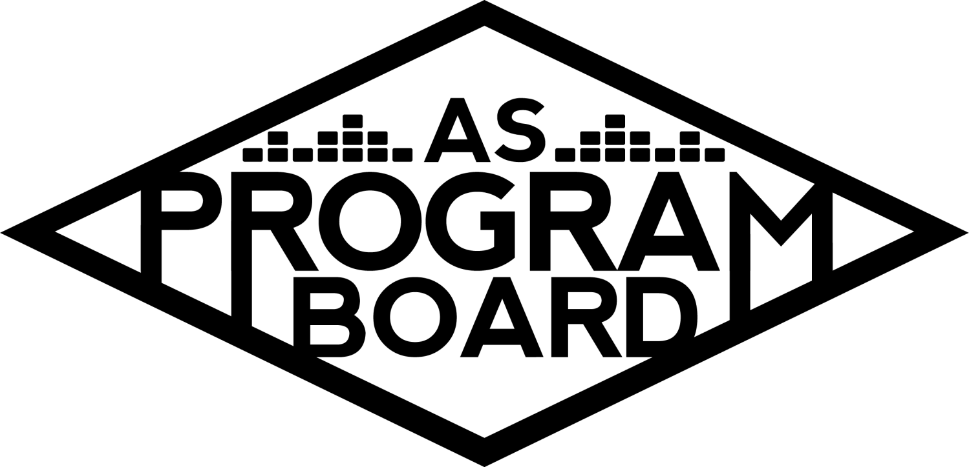

## Associated Students

May 16th, 2022

UCEN Harbor Room

**CALL TO ORDER: 5:05 pm**

**A. MEETING BUSINESS**

1. **Roll Call**

| **Name** | **Note:**  absent (excused/not excused)  arrived late (time)  departed early (time)  proxy (full name) | **Name** | **Note:**  absent (excused/not excused)  arrived late (time)  departed early (time)  proxy (full name) |
| --- | --- | --- | --- |
|  |  |  |  |
| Ashley Yeh |  | Kim Kryshak |  |
| Clarissa Mendoza |  | Lauren Schaeffer |  |
| Emily Duong |  | Lucas Jackson |  |
| Emily Kocis | Late Arrival at 5:11 | Nyah Scott |  |
| Enaiya Judkins | Late Arrival at 5:08 | Sophie Kimura |  |
| Flora Mehdi |  | Talia Heimanson |  |
| Kathryn Quinones |  | Wally Corngold |  |
| Kathryn Supple | Early Departure 7:20 | Jessy Gonzalez | Absent |
|  |  | Kian Mirshokri | Absent |
|  |  |  |  |

**Acceptance of excused absences, absences, early departure and proxies**

Motion to accept the early departure of Kat S., Late arrival of Emily K and Enaiya, and absence of Jessy and Kian. Motion by Emily D., second by Nyah. Consent with 12 present.

**B. PUBLIC FORUM**

**C. ACCEPTANCE of AGENDA/CHANGES to AGENDA**

Motion to accept the agenda. Motion by Wally, second by Lucas. Consent with 12 present.

**D.ACCEPTANCE of ACTION SUMMARY/MINUTES**

Motion to accept the minutes from 5/9/2022. Motion by Nyah , Second by Kat S . Consent with 14 present.

**E. ANNOUNCEMENTS**

1. [Land Acknowledgement](https://drive.google.com/file/d/1E-PZKDH6p3gF2cET7L_W0gbz40eGv5ca/view?usp=sharing)
2. Check In: What was your favorite thing/part from yesterday? Any surprises?
3. QUARTER REPORTS! **Due Friday at 1 pm.**

**F. WEEK IN REVIEW**

1. Free Tuesday Film: Superbad (5/10)
   1. LJ- 7pm had 40ish people, 10pm had 60ish people. Went well.
2. Extravaganza (5/15)
   1. “Planning post show notes” and “DOS Post show notes”
   2. Refer to google drive for full documents! Also should be in ur emails

**G. PREVIEW OF THE WEEK**

1. Free Tuesday Film: Pulp Fiction (5/17)
   1. 6:30- plsss, 9:30- Talia, Emily K
2. Spring Drive In (5/22)
   1. NS- everything prepared, starts at 8:30, gates open at 8. Driver or passenger needs to show student ID or green badge. Westwind is a bit short staffed for people manning entrances, would love 3-5 boardies available to help with that (probs a 7:30 call time). Reached out to Greek besties about spreading the word. Thought it could be cool to get Roger’s to cater the event. Kat S. and Clarissa will help out!

**H. OLD BUSINESS**

1. Ambassadors
   1. ED- been on break.
2. Playlists, Blogs, & Podcasts
   1. ED- interviewing bookers for podcast, getting back on schedule
3. [Social Media Takeovers](https://docs.google.com/document/d/1xEyVTBqiSj7-m8LbpDWw2iUnDrK7-2gMc1iR_PlmTtw/edit?usp=sharing)
   1. NS- EK was slated for last week, but will move to this week instead.
4. Free Tuesday Films
   1. LJ - looking to do a Studio Ghibli one next week, suggestion box to be put up soon
5. Storke Shows
   1. LS- have Storke ready for either 5/24 or 5/25, emailed bands again today and will be reaching out to a few more again today
6. Hiring
   1. KQ- hopefully wrapping up this week. Nyah sending out when2meet again
7. May Hub Show (5/26)
   1. TH- Artist A out of country and asking is too high. Reached out to Artist B’s team and have yet to get an asking yet. Wanna bring Artist C to the Hub instead now?
   2. KK- would have to be a free Hub show.
   3. KQ- also open to it being a BIG storke show so you can have an actual Hub show. Already wondering how many people were there to see her
   4. FM- agree with Kat, didn’t see a lot of disappointment that she wasn’t able to perform
   5. LJ- feel like big Storke would be more expensive than Hub show because of production reasons
   6. KE- looking at rider they’d have to adjust a lot for Storke. Would probably have to hire out sound
   7. KK- feel like we’d have to do a lot to make it happen outside
   8. WC- like idea of Hub show if free. Having more production would really elevate her performance. Feel like the crowd would look small in Storke
   9. SK- agreed, I think Hub vibes are higher.
   10. TH- agree think she’s more of a Hub kinda vibe and she’s also already an established artist. Production would be easier in the Hub
   11. LS- think Storke is already booked that day
   12. TH- could theoretically see if everyone is available on Wednesday. Thursday Week 9 is tricky.

**I. NEW BUSINESS**

1. Free Bagel Day
   1. NS- Emily and I wanna do it. Found a comprehensive guide in drive. Need to do cash advance in time/can we even do them? Would bring budget to next meeting, trying to figure out when MCC is doing their bagel day.
   2. KQ- can be executed in theory, are we allowed to do it re: covid-safety?
   3. MD- maybe we’d have to prepackage the bagels ourselves in bags
   4. For the MCC- students are able to just prep their own food and bagels
   5. Could maybe do pre-packaged bagels and cream cheese
   6. Webb hall geology students have bagel days with pre-cut ingredients out for purchase
   7. MD: could ask catering or Peter about regulations

**J. ACTION ITEMS**

1. Motion to change the date of Hub Show from May 26, 2022 to May 25, 2022 contingent on availability. Motion by Lucas, second by Nyah. Consent with 13 present.
2. Motion to make Hub Show on May 25, 2022 free for UCSB students, open to the public for purchase. Motion by Kim, second by Sophie. Consent with 13 present.

**K. FINANCIAL ACTION ITEMS**

1. Motion to switch headliner from Artist B to Artist C for Hub Show on May 25, 2022 starting at 15k and ending at 20k. Motion by Lucas, second by Kim. Consent with 13 present.
2. Motion to switch Artist B from headliner to headliner contingency for Hub Show on May 25, 2022 not to exceed 20k. Motion by Lauren, second by Flora. Consent with 13 present,

**L. REPORT**

**Facebook Factory / Tuesday Slide / Thursday Ad/ Free & For Sale post**

Pulp Fiction, Drive In Sunday!

**Kudos**

Kimmy and lauren for X :,)

Kim kat enaiya for hot chocolate

Sophie for being sophie

Flora for running w me

Clarissa for painting and being in office

Ashley for tix office

ENAIYA FOR LISTERINE

Emily k lauren talia flora for hosp shopping! And also Kim for joining

Second ashley!!! Put up with a lot of stuff regarding tickets on Sunday

Wally flora emily d for always checking in on info table

MD for helping opening recycling trash can

Flora for being a portafloor warrior- PORTAFLORA

Sophie and kim for being spidermonkeys

Sophie for info table SHES OBSESSED yes i am

Everyone for all the hard work!!

Kimmy and kat for positive attitudes

Flora for being a set up warrior on Friday

Sophie for trash collector this morning

Wally for swinging portafloor

Emily D for volunteers!

Clarissa for waiver table

Ashley for being a warrior

Lauren for artist relations they loved u

Nyah for being amazing

Lucas for being himself

Nai nai for being herself

Kris for killing it w production

Md for always being willing to work alongside us and get her hands dirty

EMily for being kim’s mom

Talia for cheering kimmy on

Clarissa for cleaning up blood on obstacle course

Md for buying gloves

Talia and Lauren for hosp with emily K

Flora and little kat for not complaining about so much running

Lucas for helping w backstage portafloor on friday

Nyah cause the story pub looked so good

Emily d for bringing water

Sophie for screaming from top of bleachers

Flora for holding nyah’s phone

Nyah for being a resource and always having good advice and doing everything

Nyah for getting everything printed for X pub

Sophie for giving hugs

Nyah for fighting the water

Emily K and Kimmy for helping print volunteer sign in sheet

Kimmy for being backstage w Kat

Kimmy being super brave

Little group side stage with Ferg

Kim for always checking on Sophie

**The Marilyn Report**

AS Award Banquet is June 1–Wednesday at 5pm in Corwin. Send photos from the year to Sean for the end of year slide show. If you want to participate in summer Board, let Kat or I know. Don’t have to be on board next year, just need to be here summer. Usually a mix of new and old board.

**The Kris Report**

Will be checking on Event Safety and Production availability for 5/25 Hub show.

Try to submit requisitions soon. We will need to have all requisitions in by June 4th.

**Commissioner's Report**

HAPPPYYYYY WEEK 8!!!!!!!!!!!!!!!!!!

Wow crazy great job with x hope you had a good moment, have school things, reach out if you have questions, i'll be in the office if you want to talk, working on end of the year things, quarter reports are due on friday, make notes on xtrav things

**Deputy Commissioner’s Report**

Congrats on X besties. I was so happy to see it. Catching up on school finally, will be lonely this weekend bc my house is going camping so pls hang out with me, excited to write my report and guide, pls manifest graduating on time for me. If u know how to fix on campus wifi connections pls tell me how.

**Coordinators’ Reports**

**Ashley-** yayX!! The crowd looked like they were having a great time. I have an essay and yield

**Emily D-** hope everyone is proud of themself for X, excited to hear feedback & will be working on req forms

**Emily K-** sleepy time go em em for a min, school exists but will be in office, extrav u will always be famous!!!

**Kathryn S-** Slay. Had a great time at X, love Sloan and his band. Crowd was incredible, everyone seemed like they had a great time including boardies. Hoping everyone gets to relax and sleep a lot!! Love y’all, esp the seniors <3

**Kim-** X was a core memory for me- big moves. Working on framing posters, my extensive SEC guide, and enjoying last few weeks. Hangout w me. Love ya <3

**Lucas-** very proud of everyone for X esp in the time we did it, congrats to everyone, feel proud of yourselves!

**Nyah-** Finalizing potential Roger’s Tacos catering for Drive-In. Tell your friends! Open to all students. Drafting up Bagel Day budget, crafting up a tabling schedule for water bottle / shirt giveaways, and gonna do quarter report. Gonna put in last minute req. form for X… What even is school anymore? Taking grad photos Wednesday :) Senior board photos? Emily D. will learn how to work a camera. Will do Studio Ghibli story callout. Graduating i’m scared! Senior board photos?

**Sophie-** i had alot of fun at extrav it was so fun with you guys

**Talia-** Extrav was so so great. Proud of y’all. Working on hub show.

**Assistants’ Reports**

**Clarissa-** had so much fun at X will be in the office later this week.

**Flora-** proud of board for x and hope everyone has a good week

**Lauren-** X was a definite slay and I feel it…more midterms and a storke show to plan!

**Wally-** proud of board for x and hope everyone has a good week

**Senator’s Reports**

**Jessy-**

**Kian-**

**ADJOURNMENT at 8:07 PM by Kathryn Quinones**

**Artists mentioned: Monaleo, Audrey Nuna, Slowthai**