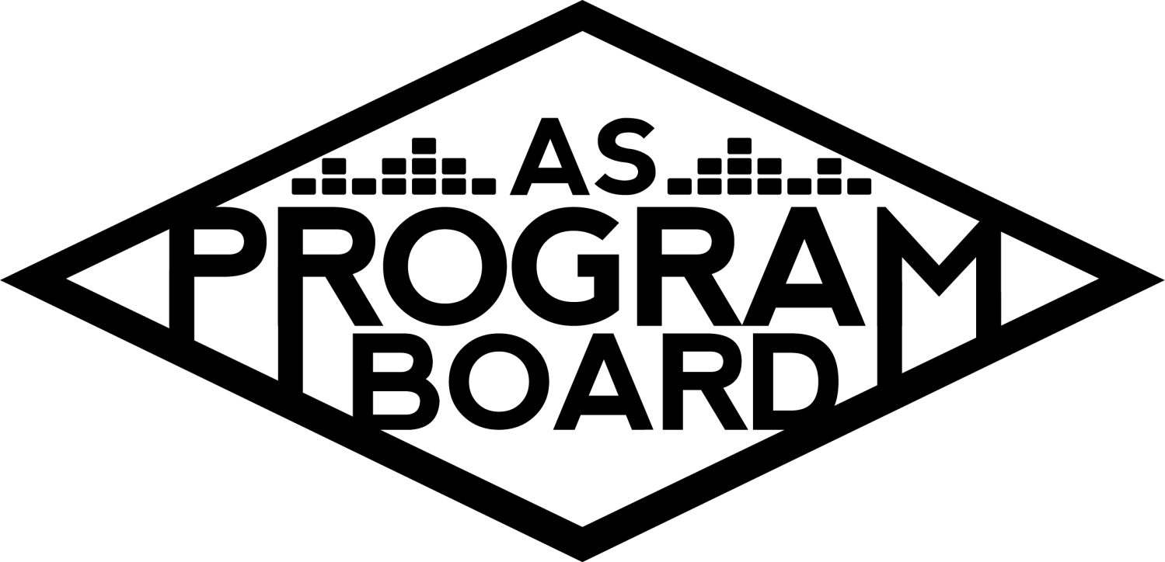
Program Board Minutes

Associated Students
May 16th, 2022
UCEN Harbor Room

CALL TO ORDER: 5:05 pm
A. MEETING BUSINESS
- Roll Call
Name | Note:  absent (excused/not excused)  arrived late (time)  departed early (time)  proxy (full name) | Name | Note:  absent (excused/not excused)  arrived late (time)  departed early (time)  proxy (full name)
Ashley Yeh |  | Kim Kryshak
Clarissa Mendoza |  | Lauren Schaeffer
Emily Duong |  | Lucas Jackson
Emily Kocis | Late Arrival at 5:11 | Nyah Scott
Enaiya Judkins | Late Arrival at 5:08 | Sophie Kimura
Flora Mehdi |  | Talia Heimanson
Kathryn Quinones |  | Wally Corngold
Kathryn Supple | Early Departure 7:20 | Jessy Gonzalez | Absent
 |  | Kian Mirshokri | Absent
Acceptance of excused absences, absences, early departure and proxies
Motion to accept the early departure of Kat S., Late arrival of Emily K and Enaiya, and absence of Jessy and Kian. Motion by Emily D., second by Nyah. Consent with 12 present.

B. PUBLIC FORUM

C. ACCEPTANCE of AGENDA/CHANGES to AGENDA
Motion to accept the agenda. Motion by Wally, second by Lucas. Consent with 12 present.

D.ACCEPTANCE of ACTION SUMMARY/MINUTES
Motion to accept the minutes from 5/9/2022. Motion by Nyah , Second by Kat S . Consent with 14 present.

E. ANNOUNCEMENTS
- Land Acknowledgement
- Check In: What was your favorite thing/part from yesterday? Any surprises?
- QUARTER REPORTS! Due Friday at 1 pm.

F. WEEK IN REVIEW
- Free Tuesday Film: Superbad (5/10)
  - LJ- 7pm had 40ish people, 10pm had 60ish people. Went well.
- Extravaganza (5/15)
  - “Planning post show notes” and “DOS Post show notes”
  - Refer to google drive for full documents! Also should be in ur emails

G. PREVIEW OF THE WEEK
- Free Tuesday Film: Pulp Fiction (5/17)
  - 6:30- plsss, 9:30- Talia, Emily K
- Spring Drive In (5/22)
  - NS- everything prepared, starts at 8:30, gates open at 8. Driver or passenger needs to show student ID or green badge. Westwind is a bit short staffed for people manning entrances, would love 3-5 boardies available to help with that (probs a 7:30 call time). Reached out to Greek besties about spreading the word. Thought it could be cool to get Roger’s to cater the event. Kat S. and Clarissa will help out!

H. OLD BUSINESS
- Ambassadors
  - ED- been on break.
- Playlists, Blogs, & Podcasts
  - ED- interviewing bookers for podcast, getting back on schedule
- Social Media Takeovers
  - NS- EK was slated for last week, but will move to this week instead.
- Free Tuesday Films
  - LJ - looking to do a Studio Ghibli one next week, suggestion box to be put up soon
- Storke Shows
  - LS- have Storke ready for either 5/24 or 5/25, emailed bands again today and will be reaching out to a few more again today
- Hiring
  - KQ- hopefully wrapping up this week. Nyah sending out when2meet again
- May Hub Show (5/26)
  - TH- Artist A out of country and asking is too high. Reached out to Artist B’s team and have yet to get an asking yet. Wanna bring Artist C to the Hub instead now?
  - KK- would have to be a free Hub show.
  - KQ- also open to it being a BIG storke show so you can have an actual Hub show. Already wondering how many people were there to see her
  - FM- agree with Kat, didn’t see a lot of disappointment that she wasn’t able to perform
  - LJ- feel like big Storke would be more expensive than Hub show because of production reasons
  - KE- looking at rider they’d have to adjust a lot for Storke. Would probably have to hire out sound
  - KK- feel like we’d have to do a lot to make it happen outside
  - WC- like idea of Hub show if free. Having more production would really elevate her performance. Feel like the crowd would look small in Storke
  - SK- agreed, I think Hub vibes are higher.
  - TH- agree think she’s more of a Hub kinda vibe and she’s also already an established artist. Production would be easier in the Hub
  - LS- think Storke is already booked that day
  - TH- could theoretically see if everyone is available on Wednesday. Thursday Week 9 is tricky.

I. NEW BUSINESS
- Free Bagel Day
  - NS- Emily and I wanna do it. Found a comprehensive guide in drive. Need to do cash advance in time/can we even do them? Would bring budget to next meeting, trying to figure out when MCC is doing their bagel day.
  - KQ- can be executed in theory, are we allowed to do it re: covid-safety?
  - MD- maybe we’d have to prepackage the bagels ourselves in bags
  - For the MCC- students are able to just prep their own food and bagels
  - Could maybe do pre-packaged bagels and cream cheese
  - Webb hall geology students have bagel days with pre-cut ingredients out for purchase
  - MD: could ask catering or Peter about regulations

J. ACTION ITEMS
- Motion to change the date of Hub Show from May 26, 2022 to May 25, 2022 contingent on availability. Motion by Lucas, second by Nyah. Consent with 13 present.
- Motion to make Hub Show on May 25, 2022 free for UCSB students, open to the public for purchase. Motion by Kim, second by Sophie. Consent with 13 present.

K. FINANCIAL ACTION ITEMS
- Motion to switch headliner from Artist B to Artist C for Hub Show on May 25, 2022 starting at 15k and ending at 20k. Motion by Lucas, second by Kim. Consent with 13 present.
- Motion to switch Artist B from headliner to headliner contingency for Hub Show on May 25, 2022 not to exceed 20k. Motion by Lauren, second by Flora. Consent with 13 present,

L. REPORT
Facebook Factory / Tuesday Slide / Thursday Ad/ Free & For Sale post
Pulp Fiction, Drive In Sunday!

Kudos
Kimmy and lauren for X :,)
Kim kat enaiya for hot chocolate
Sophie for being sophie
Flora for running w me
Clarissa for painting and being in office
Ashley for tix office
ENAIYA FOR LISTERINE
Emily k lauren talia flora for hosp shopping! And also Kim for joining
Second ashley!!! Put up with a lot of stuff regarding tickets on Sunday
Wally flora emily d for always checking in on info table
MD for helping opening recycling trash can
Flora for being a portafloor warrior- PORTAFLORA
Sophie and kim for being spidermonkeys
Sophie for info table SHES OBSESSED yes i am
Everyone for all the hard work!!
Kimmy and kat for positive attitudes
Flora for being a set up warrior on Friday
Sophie for trash collector this morning
Wally for swinging portafloor
Emily D for volunteers!
Clarissa for waiver table
Ashley for being a warrior
Lauren for artist relations they loved u
Nyah for being amazing
Lucas for being himself
Nai nai for being herself
Kris for killing it w production
Md for always being willing to work alongside us and get her hands dirty
EMily for being kim’s mom
Talia for cheering kimmy on
Clarissa for cleaning up blood on obstacle course
Md for buying gloves
Talia and Lauren for hosp with emily K
Flora and little kat for not complaining about so much running
Lucas for helping w backstage portafloor on friday
Nyah cause the story pub looked so good
Emily d for bringing water
Sophie for screaming from top of bleachers
Flora for holding nyah’s phone
Nyah for being a resource and always having good advice and doing everything
Nyah for getting everything printed for X pub
Sophie for giving hugs
Nyah for fighting the water
Emily K and Kimmy for helping print volunteer sign in sheet
Kimmy for being backstage w Kat
Kimmy being super brave
Little group side stage with Ferg
Kim for always checking on Sophie

The Marilyn Report
AS Award Banquet is June 1–Wednesday at 5pm in Corwin. Send photos from the year to Sean for the end of year slide show. If you want to participate in summer Board, let Kat or I know. Don’t have to be on board next year, just need to be here summer. Usually a mix of new and old board.

The Kris Report
Will be checking on Event Safety and Production availability for 5/25 Hub show.
Try to submit requisitions soon. We will need to have all requisitions in by June 4th.

Commissioner's Report
HAPPPYYYYY WEEK 8!!!!!!!!!!!!!!!!!!
Wow crazy great job with x hope you had a good moment, have school things, reach out if you have questions, i'll be in the office if you want to talk, working on end of the year things, quarter reports are due on friday, make notes on xtrav things

Deputy Commissioner’s Report
Congrats on X besties. I was so happy to see it. Catching up on school finally, will be lonely this weekend bc my house is going camping so pls hang out with me, excited to write my report and guide, pls manifest graduating on time for me. If u know how to fix on campus wifi connections pls tell me how.

Coordinators’ Reports
Ashley- yay X!! The crowd looked like they were having a great time. I have an essay and yield
Emily D- hope everyone is proud of themself for X, excited to hear feedback & will be working on req forms
Emily K- sleepy time go em em for a min, school exists but will be in office, extrav u will always be famous!!!
Kathryn S- Slay. Had a great time at X, love Sloan and his band. Crowd was incredible, everyone seemed like they had a great time including boardies. Hoping everyone gets to relax and sleep a lot!! Love y’all, esp the seniors <3
Kim- X was a core memory for me- big moves. Working on framing posters, my extensive SEC guide, and enjoying last few weeks. Hangout w me. Love ya <3
Lucas- very proud of everyone for X esp in the time we did it, congrats to everyone, feel proud of yourselves!
Nyah- Finalizing potential Roger’s Tacos catering for Drive-In. Tell your friends! Open to all students. Drafting up Bagel Day budget, crafting up a tabling schedule for water bottle / shirt giveaways, and gonna do quarter report. Gonna put in last minute req. form for X… What even is school anymore? Taking grad photos Wednesday :) Senior board photos? Emily D. will learn how to work a camera. Will do Studio Ghibli story callout. Graduating i’m scared! Senior board photos?
Sophie- i had alot of fun at extrav it was so fun with you guys
Talia- Extrav was so so great. Proud of y’all. Working on hub show.

Assistants’ Reports
Clarissa- had so much fun at X will be in the office later this week.
Flora- proud of board for x and hope everyone has a good week
Lauren- X was a definite slay and I feel it…more midterms and a storke show to plan!
Wally- proud of board for x and hope everyone has a good week

Senator’s Reports
Jessy-
Kian-

ADJOURNMENT at 8:07 PM by Kathryn Quinones

Artists mentioned: Monaleo, Audrey Nuna, Slowthai

