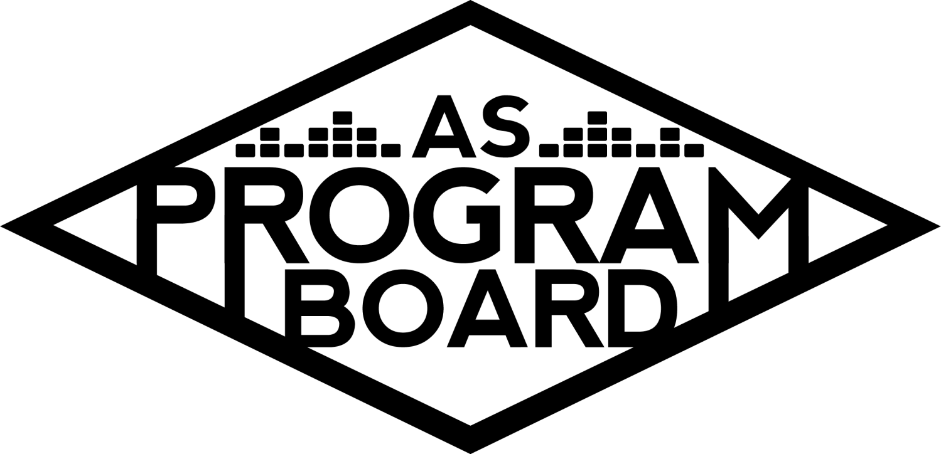
Program Board Minutes

Associated Students
April 4th, 2022
UCEN Harbor Room

CALL TO ORDER: 5:03 pm
A. MEETING BUSINESS
- Roll Call
Name | Note:  absent (excused/not excused)  arrived late (time)  departed early (time)  proxy (full name) | Name | Note:  absent (excused/not excused)  arrived late (time)  departed early (time)  proxy (full name)
Ashley Yeh |  | Kim Kryshak
Clarissa Mendoza |  | Lauren Schaeffer
Emily Duong |  | Lucas Jackson
Emily Kocis |  | Nyah Scott | Late Arrival 5:04
Enaiya Judkins |  | Sophie Kimura | Late Arrival 5:11
Flora Mehdi | Excused Absence | Talia Heimanson
Kathryn Quinones |  | Wally Corngold
Kathryn Supple | Early departure 7:30 | Jessy Gonzalez | Absent
 |  | Kian Mirshokri
Acceptance of excused absences, absences, early departure and proxies
Motion to accept the excused absence of Flora, late arrival of Nyah and Sophie, early departure of Kat S, and absence of Jessy. Motion by Enaiya, second by Emily K. Consent with 13 present.

B. PUBLIC FORUM
- IV Surfriders
  - Concert for the Coast on Saturday, May 21st from 1pm- 10/11pm in Anisq’oyo’ Park. Free day of music, food, and bands to raise money for the coast. Requesting help with security and a sound system. 6-8 bands and DJs towards the end of the night. Expecting ~1000 people.

C. ACCEPTANCE of AGENDA/CHANGES to AGENDA
Motion to accept the agenda. Motion by Kat S, second by Wally. Consent with 14 present.

D.ACCEPTANCE of ACTION SUMMARY/MINUTES
Motion to accept the minutes from 3/28/2022. Motion by Emily D, Second by Emily K. Consent with 14 present.

E. ANNOUNCEMENTS
- Land Acknowledgement
  - Emily D
- Check In: How long did you sleep in on Sunday? What part of your body hurt the most? Were you excited about any of the Grammy winners?
- Finalize OH!

F. WEEK IN REVIEW
- Free Tuesday Film: Dune 3/29
  - LJ- 50 people at first showing, 100 people at second. Went smoothly!
- The Warm Up 4/2
  - Refer to post show notes doc
  - EK: people definitely just bought tickets to get the t-shirts
  - KQ: if we could try to make sure we have quarter sheets before starting tabling or come up with something else physical that we could use to advertise
  - MD: Pubs is printing readers first week of Spring, we would need to have quarter sheets ready last week of winter or spring break, timing is hard
  - SK: Decided not to put pictures of artists on the graphics, past ones didn’t have them
  - KK: we decided not to include pictures before confirming headliners so we just had to throw their names on it. Preferred TWU aesthetic as opposed to trying to get their pictures on there
  - LS: both artists didn’t show up for their soundchecks, maybe that’s why things didn’t flow as smoothly during the actual performance
  - KK: we tried to get artist on stage earlier but they were taking time to map choreo out on the side stage which held things up – missing soundcheck also may have played a part.
  - KQ: shift one felt perfectly timed and had smooth transition into next shift
  - EK: was nervous I’d be working for 12 hours straight as shift two but it worked out really well.
  - CM: Might have been helpful to have one more runner, there were some moments where it was tight. Having Lauren help with hosp was helpful.
  - KS: dinner was originally supposed to be at separate times, but they ended up being at the same time which ended up working out. If this wouldn’t have happened it would have been tight. Maybe someone on Hosp should have a Costco card. Might have been helpful to have another hosp/runner flex to help with little/random things they were requesting
  - MD: if things aren’t on the rider, we don’t need to get them. Ask for DOS hosp check earlier to get non-perishables earlier. Go through the closet week of the show.
  - MD: ran out of water. Also broke two of the water pumps– might have to do a tutorial.
  - NS: would it be possible for people in the security barriers to have water? (A: not supposed to have water bottles/security could pull them out if it was becoming a problem)
  - EK: maybe we should make sure production has more than one shirt because they got gross and sweaty and had to come back wearing them
  - MD: maybe we should get a couple big fans to help with heat in venue
  - WC: red lines on badges – maybe we should have some rapid tests on hand?
  - MD: inconsistent guidelines between the badge testing instructions and written testing instructions
  - SK: people were googling pictures of negative home tests
  - LJ: people were trying to edit the dates and whatnot on their badges
  - AY: AXS app seemed to be more reliable than access cards when scanning tickets. Maybe should fully transition to AXS app
  - MD: AXS is still a bit iffy. Should separate ticket sales from fast pass folks to make sure everyone is going through the security
  - ED: was helpful to have ticket office person at one entrance but they also didn’t seem to have that many answers. Should definitely test scanners way before. Should maybe have ticket office person at both entrances.
  - What is PD’s role? What do we expect
  - MD: artist area is artist area, we shouldn’t be using the ADA bathroom. Also had to set up some seats upstairs for ADA should have those set up in advance if we close the top again.
G. PREVIEW OF THE WEEK
- Free Tuesday Film: King Richard ⅘
  - LJ: been putting FTF on Notion so sign up there! 6:30pm- Clarissa and Wally, no one at 9pm yet. 3 per quarter

H. OLD BUSINESS
- Ambassadors
  - ED: meeting will likely be in person at Little Acorn Park. Nyah, Clarissa, and Ashley are presenting their positions.
- Playlists, Blogs, & Podcasts r
  - ED: theme is probably spring cleaning. Don’t forget to send weekly rotation songs. Hoping to post Tyler podcast middle of this week
- Social Media Takeovers
  - Kat S this week
- Extravaganza
  - KK: will need to meet more frequently as a group (and with committees) outside of Monday meetings. Hoping to send out When2Meet tomorrow to get people’s availability. These meetings will be like in depth discussion whereas Monday meetings will be updates and budgets and things like that.
  - LS: adventure programs did an aerial silk demo of some sort? Does that work with our theme?
  - LS: maybe we do a different type of extrav banner– maybe like balloons (people like the idea)
  - Bounce house discussion. Covid safe? Obstacle course mayhaps?
  - KK: still having trouble finding a headliner. Agent keeps emailing me about Artist A, B. Keep in mind IV music scene versus LA.
  - MD: meetings will probably be a bit of both ^^^^. Can’t afford to wait a week between things anymore.
  - NS: theme release timeline
  - SK: wanted to make the newspapers very clearly ASPB branded and put them in a bunch of places on campus. Thinking about having several of the inflatables in the Arbor as release
  - EK: Nexustentialism’s logo is the little alien, maybe could use Nexus as actual newspaper to release
- Free Tuesday Films
  - LJ: Sing 2 next week. Gonna try to do genre polls and will reach out to pub about this. “Emergency” pre-screening (satirical thriller similar to 21 & Over) folks are flexible with dates. Should get back to them sometime this week
- April Hub Show 4/21
  - TH: sent out an offer today, waiting to hear back. Been talking about letting general public come to show with tickets probably priced at $18-20? (A: people are thinking $20)
  - Will make tickets available to students first and then open to general public
  - NS: student pre-sale period then open to general public so people aren’t mad
- Spring Drive In
  - NS: Top choices from Slack poll were Talledega Nights and Into the Spiderverse. Can continue talking about whether we wanna brand it as a seniors drive-in moment or a general community one. Think things will be fine either way.
- Cultural Event
  - EK: Artist C (eco blogger and popular instagram) book tour collab with BWHC. Maybe outside at Storke plaza at around 4pm or 5pm. Only free week of May 16th (aiming for the Thursday). Would be like a Storke show production wise
  - Would do a reading from book, a talk, and then Q&A with someone from BWHC.
  - NS: Storke vibes are very concrete-y, maybe a lawn would be nicer. People could bring blankets and sit on grass.
  - Commencement Lawn? Might get more foot traffic at that hour
  - MD: we also work all day Monday doing take-down.
  - EK: expecting around 100 people
  - NS: always down for an environmental moment, people love free succulents
  - ED: thinking about asking ASFB to provide free seeds, but if people are more interested in asking about succulents we could do that/both

I. NEW BUSINESS
- Storke Shows
  - ED: Week 3. Thursday April 14th, poppy jazz ensemble called Artist D. Production and band confirmed. Storke plaza reserved
- IV Surfriders Concert for the Coast
  - Refer contact back to Kris for further production questions

J. ACTION ITEMS

K. FINANCIAL ACTION ITEMS
- Motion to pass $200 for Artist D Storke Show on 4/14/22. Motion by Emily D, second by Kim. Consent with 14 present.

L. REPORT
Facebook Factory / Tuesday Slide / Thursday Ad/ Free & For Sale post
FTF. Podcast. Playlists. Look out for When2Meet. Kat’s social media takeover!

Kudos
Emily K for rocking lines
Everyone for incredible work on TWU
Lauren for stepping up and taking initiative
Hosp!
Lucas and megaphone
Sophie for having thick skin
Talia nd wally for DOS
Emily d
Nyah for press ppl
Enaiya for her line
Ashley in the ticket office
Emily k for being a comfort
Kris for all his production knowledge
MD for being a rock
Kian for being at TWU lol
Everyone for hard work, praises from some staff
KIMMMMMMMMMMMM!
Kris for being back at 7 on Sunday
Talia wally enaiya for ramp work today
Enaiya for having a costco card
Clarissa for hosp and cleaning the rooms
Lauren for hosp help
Kim for waking up really early on saturday
Kudos to box truck
Kat q for warning
Emily d for her first red bull
Kat s for driving 70 miles on saturday
Sophie for line stuff
Flora for standing by back entrance
Kat s for kicking ppl out
Flora for being brave at lines
Clarissa for little bears w shirts hehe

The Marilyn Report
Out Wednesday, might be able to do a few things while I’m out but try to get everything in to me before noon tomorrow. And good job! Nice to be back in person! Good practice and went really well.

The Kris Report
Will be working remotely all day tomorrow. Still going to hire for event safety. Put out lead applications for event safety and production positions

Commissioner's Report
Great job everyone, hope u took it all in but if not you’ll have an OMG moment at extrav. Hiring people be on the lookout. AS elections are April 18-21 – will be reaching out to graphics to get election info stuff out, but reach out to me if you have any other ideas. MD was in contact with someone from SB Bowl who said we might be able to get a tour of the venue and see a show on 4/20.

Deputy Commissioner’s Report
Thank u to everyone for bearing with me rn. Love u guys always. Lots of co-sponsorship requests coming in. congrats kimmy for twu i was so happy

Coordinators’ Reports
Ashley- happy with how TWU went, excited for x and meetings
Emily D- feel like everyone’s energy levels were great for TWU, working on ambassador stuff and W9 for storke show
Emily K- feel bonded through blood sweat and tears, will be getting stuff together for this qtrs events
Kathryn S- backstage when dj was announced and heard the crowd and had a surreal moment, excited for X, takeover, etc.
Kim- happy with how weekend went. Big learning experience, cool to see how we moved forwards. Resetting to work on X
Lucas- warm up was fun, got told i sounded like a disneyland announcer, will continue to work on films & good work
Nyah- gr8 time at TWU, kim kept us busy, easier than Delirium. Figuring out drive-in info. Excited for Kat S takeover and X
Sophie- had a really good time at TWU, appreciate Kim for existing and making DOS easier, working on X shirt w Flora, will give Enaiya a rough draft by April 10
Talia- had super great time at TWU, couldn’t have done it w/o u. Working on hub show

Assistants’ Reports
Clarissa- TWU was so cool, thanks to everyone who helped w hosp, tomorrow ashley or I will send slack out about open market. Updates to come
Flora-
Lauren- good job everyone, artists were so happy to be there, all hard work went to use, if anyone else is interested in planning a storke show lmk by this week, busy this qtr so slack me double if i don't respond
Wally- TWU was awesome, seems like we were professional. Will be in office as scheduled doing lots of things.

Senator’s Reports
Jessy-
Kian- had a blast at TWU, still waiting for meeting for senate

ADJOURNMENT at 7:23 PM by Kathryn Quinones

Artists mentioned: After Hours, Joey Bada$$, Leah Thomas, Cordae

