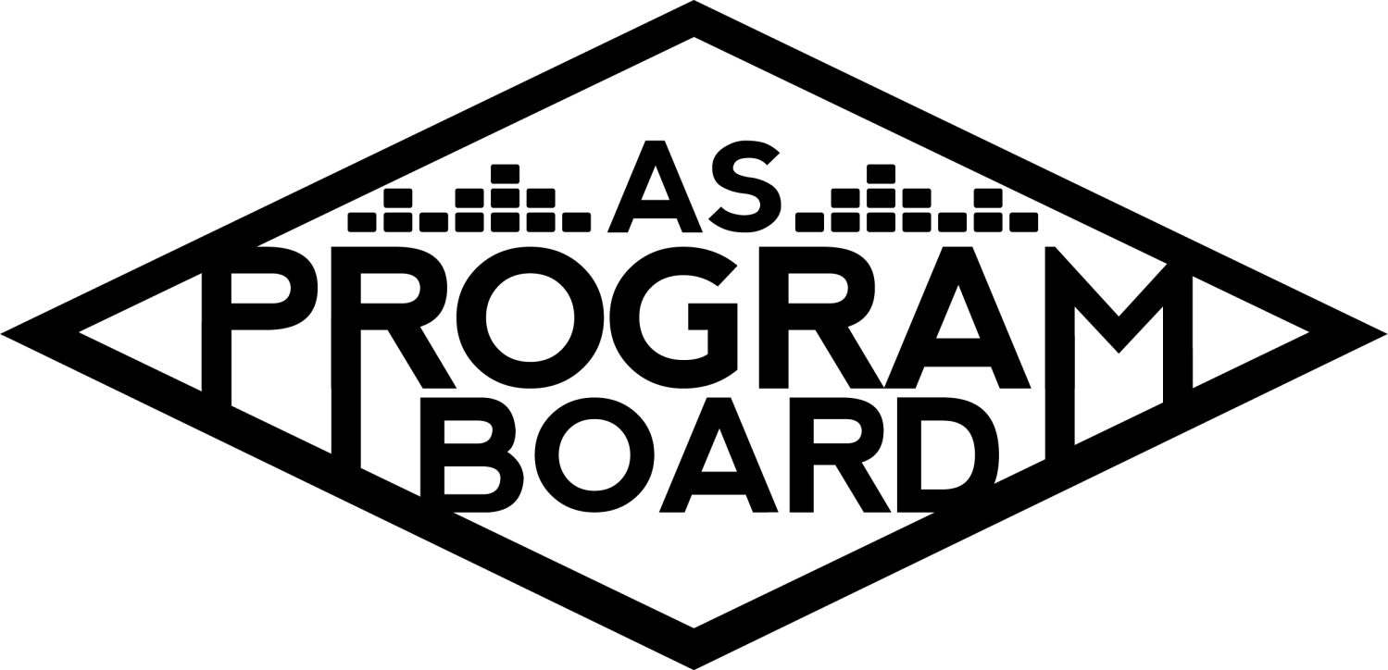
Program Board Agenda

Associated Students
April 22nd, 2019 5:00 pm
SB Harbor Room

CALL TO ORDER: 5:04
A. MEETING BUSINESS
- Roll Call
Name | Note:  absent (excused/not excused)  arrived late (time)  departed early (time)  proxy (full name) | Name | Note:  absent (excused/not excused)  arrived late (time)  departed early (time)  proxy (full name)
Adam Vingino | Absent | Kelsey McBride
Anthony Sciuto |  | Kem Lopez
Ashley Ng | Absent | Kiyomi Morrison
Bethel Tammerat |  | Meagan Murdoch | Late arrival
Bryan Duran |  | Nathaly Pacheco
Carla Martinez |  | Niko Jordan
Chue Ching Xiong | Absent | Nima Bencohen | Absent
Elizabeth Rosales |  | Ryanne Ross
Emma Kuskey | Late arrival 6:30PM | Sarah Soren
Jazz Smith-Torres |  | Waylon Yen | Absent
Jessica Arnold |  | Zack Higgins
Kailah Korsh

Acceptance of excused absences, absences, early departure and proxies
Motion to accept absences and early departures Nathaly/Bryan MSConsent with 15 present

B. PUBLIC FORUM

C. ACCEPTANCE of AGENDA/CHANGES to AGENDA
Bryan moves to accept the agenda; Elizabeth seconds. MS Consent 15 present

D. ACCEPTANCE of ACTION SUMMARY/MINUTES
Next meeting

E. ANNOUNCEMENTS
- AS Elections this week- 04/22-04/25
- ASPB applications out now!
Due on 4/29 @ 5pm

F. WEEK IN REVIEW
- Free Tuesday Film: Free Solo- 04/16
  - Wasn’t avail for DCP got BluRay, 1st showing - 60, Last Showing- ????~89, event staff left last showing without telling Anthony
- Daily Nexus Festival- 04/16
  - Would have been nice to have more crew, lots of fun, took a little bit longer than usual to load out
  - About 100 ppl throughout the course of the day
- Cupcakke in the Hub- 04/17
  - Show was cancelled due to delayed flight, tried to find her alternative flights but it was too late to get her one
  - Paperwork done by morning of
  - Alaska gave COI the day before
  - Everything was ready for the show to happen, only issues that could have happened would have been ticketing issues, discussed errors with ASTO @ previous board meeting
  - Posted about ticketing errors to FB to try to clear up confusion, people/ Sarah very frustrated about issues with ASTO
  - Everyone is going to be refunded and if purchasers have any questions they should contact the ticket office
  - Show will NOT BE rescheduled
  - Sarah & Ryanne went to TBTN meeting and why to not try to reschedule, Asked cupcakke to make a statement and never did/ reached out post show
  - TBTN understood our difficulties and seemed to be on board with not rescheduling the show, are interested in pursuing Megan The Stallion for a hub show w/ the use of their budget
  - 2 PPL came into the office to ask if we could bring Megan the Stallion
- Jaboukie Young-White Comedy Show- 04/18
  - SOLD OUT SHOW- Went smoothly, “surprisingly” well ‘
  - Was a bit of a rush & went into planning pretty late, confirmed at 8.5, moses for 1.5, and student opener (the loss on the show was 6.4k)
  - Doesn’t know if show would have sold out if tickets would have been more expensive
  - Jaboukie and moses were very happy with the crowd
  - Issues: ticket giveaway without needing to, contracting process were slow, ppl tried to buy tickets at the door, could try to do a bigger venue next time, Day of moses was late but went on on time
  - Opener made jokes using the R word, one thing that made some board members uncomfortable
  - Kelsey- Liked intimacy of IV Theater, Bethel Agreed
  - Zach- some points where ppl would tell a joke and it became difficult to hear because of laughter
  - Sarah- maybe let him know that the use of the R word made some ppl uncomfortable
  - Meagan- did not feel comfortable at all, as a board we should not support it, he was bashing the campaign to end the word
  - Kiyomi- can be funny without being offensive
  - Bethel- Press that wasn’t on the list showed up, miscommunication on their end
  - Jessica- Did university announcement, FB ad, + standard pub

G. PREVIEW OF THE WEEK
- Free Tuesday Film: The Lego Movie 2- 04/23
  - Working 1st Showing: kailah, kelsey, bryan
  - Working 2nd SHowing: nathaly, jessica, waylon
  - About 140 people going/interested
- Noon Storke Show: Advocates- 04/24
  - Working: Sarah 11:30-1 (class @1), kiyomi (all time) , ryanne (tentative)
  - Call time: 11:30-1
  - Played Velvet jones yesterday, use yerbs & kind bars
- Earth Day--Anisq’Oyo Park- 04/27
  - Zack handed off the event to Adam & Bryan
  - Bryan has not looked through email yet, got this morning, Adam not present
  - Bryan- 4 bands in park, set up at 10, storke set up, nothing to crazy , need to get a van not a box truck because it is just the storke set up
  - Bryan will be driving the van
- Big Storke Show- 04/29
  - Kiyomi, Jazz, Ryanne can work 11:30-1
  - Ready to confirm with 45 minute set
  - Waiting for backline information
- ASPB Hiring Info Sessions- 04/23 & 04/24--7pm

H. OLD BUSINESS
- X’19- 05/19
  - Kailah- sent out 2 offers: Artist A 5k (rejected), Artist B (out rn), Artist C passed no contingencies for slot 3, 4 & 5, sent out new avails in the email, wants to discuss slots 3, 4 & 5, thinks Artist D would be really good
  - Bryan- thinks Artist D would be really good, played Coachella, EDC, LIB, advocating for her
  - Sarah- Thinks Artist B is worth 45k, advocating for Artist D, also thinks Artist E would be better than Artist D
  - Kiyomi- thinks Artist D would be better for the hub
  - Bethel- Advocating for Artist E
  - Bryan- Concerned with rap heavy/ hiphop/ r&b
  - Sarah/ Kiyomi: they think we should go for Artist B and maybe sacrifice 5th slot
  - Carla: Should talk about Artist E, super cool and up and coming, played coachella & flog, different genre with lead singer being a girl
  - Niko- think’s Artist E is up and coming a few shows in LA that sold out back to back, did the benefit concert with Artist F, think it adds to the diversity
  - Anthony- wants to third Artist E and talk about Artist G, have a connection to Artist H
  - Sticking with going after Artist I for 4th slot
- Hub Show- 05/08
  - Artist J is available, has not gotten confirmation if Artist C would look at 15k
  - Artist K another strong option, may fall too much into the R&B realm
  - Kailah- advocates for Artist D
  - Bryan- Artist D produces music in unique way, great artist for Hub.
  - Anthony- Artist J best option, already passed him for earlier show. Fits genre we haven’t had yet. 1.3m monthly listeners. Saw frat guys at his set at Coachella, I’ve heard them around IV.
  - Meagan- seconds what Anthony said, good option for genre diversity, articles written on them, also thinks Artist C
  - Kelsey- Artist L, Haven’t brought any bands, 2.4 m spotify listners, more than anyone else on this list, would bring out diff crowd
  - Kem- If Artist C goes for u 15, she’s most up and coming, most spotify listeners, if she’s available she’s the best. If not, Artist J on same level as Artist M, Artist N, Artist O, he’s the second best.
  - Nat- Is it certain she wouldn't accept with video wall? Second what Kem says pending response we recieve, also think Artist D would be great, could get a great support given her range. Female DJ, not many in industry rn.
  - Kiyomi- Artist D around for a long time, name discussed previously. If not, Artist J would be good. Artist D v popular, has done very well, up coming shows doing well. IF now Artist J, Artist C.
  - Elizabeth- Push for Artist J, nice break from rap and electronic. Played tropicalia, had really big crowd. Would be nice to have a diff genre in Hub
- Hub Show- 05/29
  - Bryan- Artist P, sold out red rocks, sold out bill graham, support by Artist Q. Really dope option, worth pursuing. If we went for him for the 29, we should do Artist K on the 8.
- Artist R- 05/21
  - Kiyomi- wanted to bring it up again, bill it as ‘Artist R, engage in change’, not tying directly to memorial in advertisements, implicitly involved. Looking into having one of the fathers of one of the familes introduce him, he’ll touch on IV shooting, speech both social activism, gun reform. Hoping to announce April 29, depends on X release. Student tix on sale first, general after. Monday the 6, General the 8 (still have to talk to Emma). 50/50 vs ⅔ / ⅓?
  - Sarah- Have to make sure to clarify, “if there are tickets left over after the first day of sales, THEN GA goes on sale”.
  - Ryanne- think we should prioritize student tickets, then open up to GA
  - Wait for tickets to run out? Or reserve tickets for GA?
  - Nat- Justin sectioned off GA, student tickets went on sale,
  - Informal vote- majority votes for reserve ⅔ for students, ⅓ for General

I. NEW BUSINESS
- Bands Showcase- 05/22
  - Kem- originally going to reschedule BOTB, might be easier and effective to be a showcase. Headed towards end of year so prizes might not be feasible. Want to allow them to perform, community building opportunity. 3 bands down to do it. Could go in two directions- leave it with those three and book a band on lower budget (4k); or have it just be local bands, could open submissions up. Alot going on,
  - Potentially May 30? AS awards banquet. Usually about a 3 hour event.
- Prescreening “Good Boys”- 05/22 or 05/23
  - Produced by Seth Rogem , Prescreening are free for us, they pay us back . perfect for our demographic. Half board pre screening.
  - Nat- typically for prescreenings, low maintenance and affordable. I’m for it.
  - Ryanne- More for Thursday,
  - Jazz- can’t be there Thursday,
  - Kiyomi- I would vote no because we’re going to be so tired.
  - Ryanne- so low maintenance.
  - Kelsey- For it, Thursday probably better to give people a break.
  - Anthony- definitely down for less people staffing the event.
  - MD- 23 is anniversary of shooting, trying to do memorial walk. Not good counter programming for that.
  - Ryanne- lecture is low maintenance, movie is low maintenance. Sounds like we’ve decided on Wednesday.

J. ACTION ITEMS

K. FINANCIAL ACTION ITEMS
- Hub Show- 05/08
  - Artist J, Artist D, Artist C
    - First round- Artist K-16; Artist D- 10, Artist C- 8
    - Artist K, Artist D as contingency
    - Motion to pass $25,622 for Artist J in the Hub on May 8th, 2019, Artist J starting at 13k ending at 16k, with tickets at 14, 22, and 24; with Artist D as contingency, starting at 10k ending at 16k, with tickets at 14, 22, and 24.
    - Second- Nathaly
    - Call to consent:
      - 16-1-0
    - Bryan- not sure if people will pay $14 for Artist D,
- Prescreening “Good Boys”- 05/22
  - Motion to pass $640 for prescreening of good boys on May 22, Second Kelsey.
    - Call to consent-
    - 15-1-0

L. REPORT
Facebook Factory/ Thursday Slide
The Marilyn Report- Food truck fair thursday in arbor, not sure of times. AS elections all this week, push applications, rolling them out slowly this year.
Commissioner's Report- If you need something on the Agenda, please send on Friday.
Deputy Commissioner’s Report-
Coordinators’ Reports
Anthony (DJing again Friday, if it works out will let you know), Bethel, Carla (have team of 9 people, all really nice and have great ideas. Been telling them to like/comment on everything)., Emma, Jessica (excited for ambassador program), Kailah, Kelsey, Kiyomi, Niko, Sarah, Waylon, Zack
Assistants’ Reports
Adam, Bryan, Chue Ching, Elizabeth, Kem, Meagan, Nathaly
Senator’s Reports
Ashley, Nima
ADJOURNMENT : 7:06
Talent discussed: David Hogg, Odesza, Big Wild, Omar Apollo, Still Woozy, Gus Daperton, COIN, Cautious Clay, Yellow Days, Boy Pablo, Tame Impala, POND, Clairo, men i trust, Teyana Taylor, TOKiMONSTA, Elohim, Haley Kiyoko, Anna Lunoe

