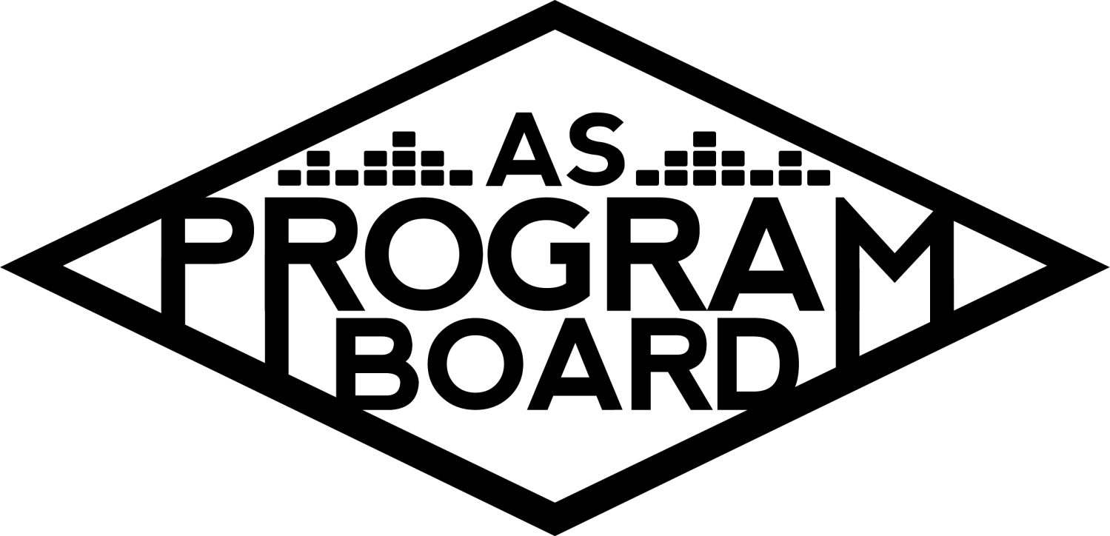
Program Board Minutes

Associated Students
April 18th, 2022
UCEN Harbor Room

CALL TO ORDER: 5:03 pm
A. MEETING BUSINESS
- Roll Call
Name | Note:  absent (excused/not excused)  arrived late (time)  departed early (time)  proxy (full name) | Name | Note:  absent (excused/not excused)  arrived late (time)  departed early (time)  proxy (full name)
Ashley Yeh |  | Kim Kryshak
Clarissa Mendoza |  | Lauren Schaeffer
Emily Duong | Late Arrival 5:20 | Lucas Jackson
Emily Kocis |  | Nyah Scott | Late Arrival 5:20
Enaiya Judkins |  | Sophie Kimura
Flora Mehdi |  | Talia Heimanson
Kathryn Quinones |  | Wally Corngold
Kathryn Supple |  | Jessy Gonzalez | Early Departure 6:30
 |  | Kian Mirshokri
Acceptance of excused absences, absences, early departure and proxies
Motion to accept the late arrival of Nyah and Emily D and early departure of Jessy. Motion by Lucas, second by Kim. Consent with 14 present.

B. PUBLIC FORUM

C. ACCEPTANCE of AGENDA/CHANGES to AGENDA
Motion to accept the agenda. Motion by Clarissa, second by Lucas. Consent with 14 present.

D.ACCEPTANCE of ACTION SUMMARY/MINUTES
Motion to accept the minutes from 4/11/2022. Motion by Wally, Second by Emily K. Consent with 14 present.

E. ANNOUNCEMENTS
- Land Acknowledgement
- Check In: If you could live the life of one other board member for a day, who would you choose and why?

F. WEEK IN REVIEW
- Free Tuesday Film: Sing 2 (4/12)
  - LJ- Went well. 40 ppl at first showing, 60 ppl at second.
  - KQ- lots of crowd engagement at first showing
  - SK- same thing at second showing, really fun
- After Hours Storke Show (4/14)
  - ED- went well, average of around 55 people. Working on req forms
  - LJ- max I counted was ~75. Good vibes!
- AS Zero Waste Festival
  - Didn’t end up helping with bands or anything bc of last minute contracting issues w the bands
  - Loaned them our PA

G. PREVIEW OF THE WEEK
- Free Tuesday Film: The 355 (4/19)
  - LJ- didn’t have time for student vote. 6:30pm- Flora, Kat S. 9:30pm- Wally
- April Hub Show (4/21)
  - TH- Artist A had scheduling conflict, lots of miscommunication, no Hub show anymore :( Working on research doc for May 26th, send suggestions to me or Wally
H. OLD BUSINESS
- Ambassadors
  - ED- Emily K and Sophie presenting. Might be volunteering for X
- Playlists, Blogs, & Podcasts
  - ED- podcast listens are kinda dropping because they’ve been up for a while. If you wanna make one please do!
- Social Media Takeovers
  - NS- Emily D on Wednesday!
- Extravaganza (5/15)
  - KK- need to lock down what you as an individual are responsible for because everyone should have something. If you’re assigned something in your committee you’re responsible for seeing it through until the show. Every day counts, please stay on top of things.
  - LS- inflatable sign would be 5200 or ?? Would use up almost all of the arts and activities budget and would come to us in time and is reusable
  - FM- think worth it because it’s reusable and good for branding
  - LS- more expensive for the funky lettering
  - KQ- Lucidity has huge rentable letters. Renting versus buy re: cost effectiveness?
  - NS- pivoting away from inflatable aliens due to timeline issues, slack me ideas for theme/release if you have them!
  - KK- moving away from Artist B due to controversy. Moving forward with contingency.
  - KK- Overwhelming majority suggested Artist C due to large audience and balancing out other acts on the lineup. Artist D and Artist E are unavail.
  - WC- Surprised Artist F is in range for a 2nd slot. Think he’s very different than Artist G and is pretty popular.
  - KS- As a non-rap listener, I think it’s wiser to shift away from that genre because a lot of people here do listen to indie rock. Really like Artist C, think he’d be incredible, has big following, and released an album last year.
  - TH- really like idea of Artist C. If Artist H doesn’t work out, we could have Artist I as 2nd slot and indie rock as 3rd
  - FM- really like the way the 2019 line-up looked. Wouldn’t be opposed to having someone bordering the rap genre.
  - EJ- Artist C #1 because he’s incredible, is big here and will only get bigger. Feel like Artist F fell off but would generally be fine with a rapper as 2nd slot. Think Artist J would be wild, she’s only gotten bigger and will continue to get bigger.
  - Radius clause for Artist J?
  - KQ, EK, LJ support Artist C as slot 2.
  - KQ- wanna order wristbands really soon. Do we wanna order them at all?
  - Water bottles versus cups?
  - NS- think people will keep the old bracelets because people are sentimental by default.
  - KK- should have logo on them if we can. Can also order significantly less & hand them out as we table. If they’ll be super simple maybe we shouldn’t get them?
  - KQ- someone on arts will have to order the water bottles.
- Free Tuesday Films
  - LJ- updated Notion for pre-screening. Section specifically for pre-screening at 7:30pm
  - LJ- have reached out about screening Studio Ghibli films. Thinking about doing animated, comedy, and throwback student choice
- Spring Drive In (5/22)
  - NS- Into the Spiderverse won Slack poll, contract should still stand at $10k hopefully will get that in this week
- Cultural Event
  - EK- Leah isn’t interested in doing events until next Fall. Gonna think about it, trying to keep it lowkey.
  - EK- think Artist K would be a bit intense for production
  - KQ- maybe reach out to Artist L agent about the book tour
- Storke Shows
  - LS- no Storke show this week. Have one next week and the week after that. Thinking we could maybe do a “Storke Study Sesh” and give things out/set up a speaker. Think people would want to come get ice cream.
  - MD- we have an ice cream freezer, should check and see if it still works
- Hiring
  - KS- have five applicants.
  - KQ- maybe do need to table for hiring
  - KS- people also do tend to turn in stuff last minute
  - KQ- need to make sure to tell people at Storke event and at films,
  - NS- sending quarter sheets to res halls
  - TH- maybe should flyer in university apartments . Know a bunch of freshmen live in Trop.
- Reaffirmation
  - KQ- Voting on GOLD opened today and goes till Thursday. When tabling for hiring, double up on reaffirmation. If people can come in and make some sort of poster saying we’re up for reaffirmation that’d be great.
  - JG- need 20% of eligible students to vote in order for elections to end.
  - MD- currently at 2.4%.
  - Encourage people to vote on GOLD!

I. NEW BUSINESS
- Big Storke Show (⅚)
  - Budget!
  - Research :0
  - KS- running into issues scheduling Storke for May 6th. Doesn’t look like anything’s scheduled but the request was rejected so will follow up on that.
  - KE- If we’re gonna provide backline budget needs to be increased.
  - EJ- support Artist M for the billion reasons we’ve talked about and think they’d do well here.
  - TH- support Artist M and Artist N as contingency
  - WC- Artist O’s music may not be as well known in SB, think he’s really cool. Is a cheaper option which is nice, has put out a good amount of music. Think consistently high numbers make him seem like a good musician.
  - SK- Artist P should be considered. Heard lots of houses listen to their songs, think would be a good option.
  - AY- would say M for reasons discussed before and think people would definitely vibe with them. N as contingency because I’ve heard of him and name pull might work.
  - CM- also in favor of M, love N and think he’d do well here so he’d be my contingency
  - NS- M is number one, 2nd choice is P
  - May 6th doesn’t work for Storke. Kat S will check on dates.

J. ACTION ITEMS

K. FINANCIAL ACTION ITEMS
- Motion to pass Artist C as 2nd Slot for Extravaganza on 5/15/2022 starting at 55k and ending at 70k. Motion by Kim, second by Sophie. Consent with 15 present.
- Motion to pass $14,050.00 for a Big Storke Show on date TBD. Motion by Kat S, Second by Wally. Consent with 15 present.

L. REPORT
Facebook Factory / Tuesday Slide / Thursday Ad/ Free & For Sale post

Kudos
Emily K for X hosp
Lucas for Marborg stuff
Emily D for storke show!
Kim for X!!!!!!!!!!!!!!!!!!!!!!!!
Lauren for X!!!!!!!!!!!!!!!!!!!
Kat Q for hanging out on Thurs!!!!!!
Sophie for shirts!!!!!
Flora for hat designs!
Lucas for Sing 2
Everyone <3
Talia and Emily K
Enaiya for accepting shirt designs
Wally for naming the raccoon
Everybody at storke show
Kudos to the raccoon
Kudos to lucas as a voice actor
Sophie and Flora for being cutie

The Marilyn Report
Refund we talked about -will have to vote on it. If you have questions lmk! If you have other events before or after X, please get that stuff in way early. Been talking about plywood & portafloor. Could add some more in BOH as a road- something to talk about and vote on. Be knowledgeable about your responsibilities for X, be comfortable and ready to be the main point of contact with your tasks. Help Kimmy and step up. Lots of staff out this week- have patience with processing. UCSA membership fee as part of tuition. If you’re in the office & someone comes to pick up a table, hand it over.

The Kris Report
Reqs & W9s. Have more attention to signatures. Lead coordinators for Event Safety and Production on Handshake. Might be taking some days off.

Commissioner's Report
Slammed week coming up pls be patient with me. Doing lots of wristband, water, and recycling stuff. Working on shade structures. Will send updates about my OH I missed today. If you know I’m supposed to talk to you about something please let me know.
Deputy Commissioner’s Report
Really excited for X- happy xp if you need something from me lmk, will update on OH.

Coordinators’ Reports
Ashley- midterms coming up but if you need me lmk, moving OH to Wed/Thurs
Emily D- busy week ahead, X arts stuff to handle, ambassadors and volunteers on my mind, lmk if you need anything
Emily K- Happy tax day!!!!!! Working on X stuff, excited for ambassador meeting, will move into office.
Kathryn S- working on sending out co-sponsorships, looking into Storke for the show, keeping track of applications
Kim- x is life, pre-event meeting on Wednesday hopefully gonna get stuff figured out, super excited for Disclosure. Feel free to ask me questions if u need!
Lucas- excited for porta potties hehe, working on films, lmk if you need help
Nyah- getting Drive In contract in, getting qtr sheets for hiring, will figure out uni announcement for hiring, X teaser qtr sheets, brainstorming release ideas
Sophie- still working on shirt, going to work on volunteer thing for Emily D
Talia- working on Hub Show stuff, will have research doc and budget next week, use me kim pls, wanna know Sun God lineup

Assistants’ Reports
Clarissa- couple midterms this week, excited for X, sent out tabling schedule for hiring and reaffirmation. Will be zooming in for Sunday X meeting, lmk if you need anything
Flora- working on hats and other graphics, lmk if you need something done
Lauren- Storke study sesh on Wednesday forsure, excited for X things
Wally- hub show artist research doc, big storke show, arts and activities, graphics calendar update by end of week, ask me qs if you need me

Senator’s Reports
Jessy- video game minor exists, academic senate might get rid of euro traditions requirement, non-boosted students may be cancelled from courses, budget deficits, senate passed new AS logo, still planning commencement. AS Election Voting closes Thurs at 4pm
Kian- UCSA fee, we paid a different fee than other UCs, will be changing to be equal, concerning how much money goes to AS.

ADJOURNMENT at 7:07 PM by Kathryn Quinones

Artists mentioned: Podcast But Outside, Wallows, Baird, Duckwrth, Toro y Moi, Ferg, Japanese Breakfast, Dayglow, The Marias, Valentino Khan, Dreamer Boy, Rico Nasty, Cordae, Greer, Dreamgirl, Ski Mask the Slump God

