Program Board Agenda

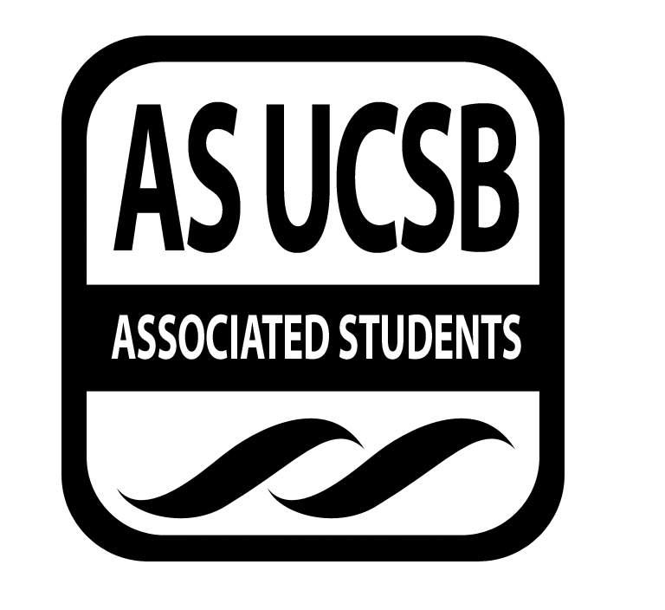
Associated Students
October 28, 2013, 5:00pm
SB Harbor Room

CALL TO ORDER: 5:02pm

A. MEETING BUSINESS
- Roll Call
Name | Note:  absent (excused/not excused)  arrived late (time)  departed early (time)  proxy (full name) | Name | Note:  absent (excused/not excused)  arrived late (time)  departed early (time)  proxy (full name)
Adi Sharma |  | Colton Bentz
Amalia Gudino |  | Jena Pruitt | Class- 5:52PM
Alex Hubert |  | Justin Stasiuk | Late 5:24 PM
Ben Simons | Late- 5:07PM | Karen Masumoto
Brandon Pineira |  | Kimia Hashemian
Brent Kirkland | Class | Leonardo Vargas
Charly Chamber | Absent-Excused | Omar Miranda
Chioma Nwuzi |  | Ryan Yamamoto |  | Late- 5:21PM
Chris Cubbison |  | Sean Nolan |  | Late- 5:15PM
Christina Laskorunsky |  | Tyler Washington |  | Late- 5:08PM
Chrystal Anderson |  | Zach Barrett

- Acceptance of Excused Absences and Proxies
MOTION/SECOND: Sharma/Cubbi
Motion language: Motion to accept Ben, Justin, Ryan, Sean, and Tyler’s lateness and Brent, Charly, and Jenna’s absence and Ben’s early departure.
ACTION: Vote 13-0-0 to APPROVE

B. ACCEPTANCE of AGENDA/CHANGES to AGENDA
MOTION/SECOND: Sharma/Pineira
Motion language: Accept as amended
ACTION: Vote: 13-0-0 to APPROVE

C. ACCEPTANCE of ACTION SUMMARY/MINUTES
1. Approval of our Action Summary/Minutes
MOTION/SECOND: Sharma/Anderson
Motion language: Accept
ACTION: Vote: 13-0-0 to APPROVE

D. PUBLIC FORUM
- Kinotek
  - This is a weekly film festival. We focus on older classic films.
  - Interested in having two event staff members for this event.
- UCSB Rock Against Rape
  - Request eight event staff members for sound and lighting. Wondering if barricades should be used.
  - Request to borrow a few radio sets.
  - Rock Against Rape was designed to be a fundraiser. Deals with students that have been targeted by domestic violence.
  - Event will be on January 23rd 2014. Doors will open at 8:00pm and will run until 10:30PM. This will be a ticketed event. $5 presale, $7 general admission, and $10 at the door.
  - Simons-since it is a rock show, people do get somewhat rowdy and there might be a need for barricades. Will have to discuss with Stasiuk
- UCSB Alumni Association
  - Jordan- alumni and vendors visit UCSB and sample their products. We ask for a co-sponsorship for the event.
  - Event will be from 3:00-6:00PM and we will definitely be out by 8:00PM.
  - Christina- Main goal is to raise awareness for the sholarship fund. Goal is to start focusing on the students who have brought alumni to the event. This provides them with the opportunity to network with the alumni. Along with this, we wish to bring some publicity to A.S.
  - Nolan- From what you have been saying, you will probably only need the audio and the event staff from us. Will you need a generator? (Jordan: we plan on using the plugs on the light posts. We will meet with safety facilities this Friday).

E. ANNOUNCEMENTS

F. THE WEEK IN REVIEW
- Chicago (1/7)
  - Laskorunsky- 50 people in the first showing, 97 in the following one. This is probably because of the amount of time we had to advertise
- Mary Lambert (1/9)
  - Simons- There was a miscommunication. All in all, she was a really awesome performer. There weren’t any security issues.
  - Nolan- That was definitely a good show.
  - Gudino- Everything went really well. However, you should probably get the new event staff trained. No one should really be back there. Everyone cleared out pretty quickly. Really good event. Really enjoyed it.
- International Students Association (1/11)
  - Simons- She had the artists come up and play two songs. Then, she stopped them so that people could go get cookies. All in all, it was very poorly managed but there were no problems, surprisingly. We were out of there pretty early even though it started pretty late.
  - Nolan- They didn’t reply to my email until late on Friday. Poorly organized to say the least.
  - Miranda- She had nothing to say but nice things. I will say that she was nervous about the event.
G. PREVIEW OF THE WEEK
- Drinking Buddies (1/14)
  - Laskorunsky- Please post the posters! They should definitely be up already.
- Storke Tabling (1/15)
  - Pineira- Good opportunity to hand out ice cream. It will be from 11-1:00PM.
- Winter Drag Show (1/16)
  - Simons- It’s always an interesting event.
- Cloudy with a Chance of Meatballs (1/21)
  - Laskorunsky- Looking forward to it!
- Storke Show: Helo (1/22)
  - Pineira- Need two people for next Wednesday 11:45-1:00PM
- Of Montreal (1/24)
  - Cubbi- happening next Friday. We have posters but I need someone to help me post them up in Downtown.

H. OLD BUSINESS
- Ecen Show (2/28)
  - Sharma- Finally have our ticket sale dates. They go on sale this Friday for students and Tuesday for general audiences. Sent posters to Jenna and we should start putting them up. Please publicize this event.
- DJ Competition (2/19)
  - Barrett- This will go down like March Madness. Two DJs will face-off against each other. Contestants will be judged on originality and audience response. I don’t think getting eight DJs will be an issue. With the video submission, it leaves us more vulnerable getting someone who isn’t as good as they seem.
  - Nolan- If this will be broken up into two events, you might want to have both dates set in stone before board decides. I still believe that this is a one-event thing.
  - Stasiuk- First round should only be video submissions. That way we won’t have to have two separate events.
  - Gudino- Even though the two-event thing could be a good thing, this is only because people will return to support their friends. But really, this is a pretty long event.
- MCC Co-Sponsorship (2/7)
  - Yamamoto- We still need to figure out how much we want to give for talent because I think $3000 is too much
  - Nolan- I think that if we’re giving that much money for talent, it should be a full board event.
  - Cubbi- I say we go for it. It doesn’t seem like that much money. But I do think that we would be using too many of our people. It will be overkill. However, I’m not sure what exactly we will be doing the day of.
- Extravaganza (5/18)
  - Sharma- Meeting date will be Thursdays at 8:00PM. Next week will be at 7:00PM. A lot of talent is starting to close away. We should probably scratch ticketing.
  - Hubert- If we are going to lose out to a lot of acts, I think it would probably be better if we didn’t ticketed. This way we could have a lot of other acts available. Many people do ask if we’ll ever break the EDM or rap headliner. If we’re ever going to do this, we must raise the budget.
  - Nolan- I think we have a responsibility to these students so we should not ticket.
  - Pineira- I agree with Sean that we should not ticket.
  - Simons- We should definitely not ticket because we all know how out-of-towners act. So let’s try to avoid that
  - Cubbi- I really want to raise the budget.
  - Stasiuk- I think we’re all on the same page with ticketing.

I. NEW BUSINESS

J. ACTION ITEMS

K. FINANCIAL ACTION ITEMS
- Kinotek
MOTION/SECOND: Stasiuk/Cubbi
Motion language: Motion to pass $500 for Event Staff to work the Kinotek festival
ACTION: Vote: 19-0-0 to APPROVE
Staff/Advisor Instruction/Request: Insert if Applicable
Responsible for Follow-through: Justin Stasiuk
Additional approval required: YES (Senate)

- UCSB Rock Against Rape
MOTION/SECOND: Nolan/Sharma
Motion language: Motion to pass $750 for Event staff and production crew as well as two sets of radios for UCSB’s Rock Against Rape on January 23rd.
ACTION: Vote: 19-0-0 to APPROVE
Staff/Advisor Instruction/Request: Insert if Applicable
Responsible for Follow-through: Sean Nolan
Additional approval required: YES (Senate)

- DJ Competition
MOTION/SECOND: Cubbi/Sharma
Motion language: Motion to table until a phone vote.
ACTION: Vote: 19-0-0 to APPROVE
Staff/Advisor Instruction/Request: Insert if Applicable
Responsible for Follow-through: Cubbi
Additional approval required: YES (Senate)

- MCC Co-Sponsorship
MOTION/SECOND: Yamamoto/Stasiuk
Motion language: Motion to pass $3000 for the MCC Co-Sponsorship on Feb. 7, $1000 for event staff and production and $2000 for talent.
ACTION: Vote: 19-0-0 to APPROVE
Staff/Advisor Instruction/Request: Insert if Applicable
Responsible for Follow-through: Ryan Yamamoto
Additional approval required: YES (Senate)

- UCSB Alumni Association
MOTION/SECOND: Stasiuk/Sharma
Motion language: Motion to table until we receive more information
ACTION: Vote: 19-0-0 to APPROVE
Staff/Advisor Instruction/Request: Insert if Applicable
Responsible for Follow-through: Justin Stasiuk
Additional approval required: YES (Senate)

L. REPORTS
BOTWFTW!!

Thursday Page/Slides
The Marilyn Report

The Commissioner's Report:
Deputy Commissioner’s Report
Coordinators’ Reports
Adi, Alex, Brent, Chioma, Chris, Christina, Chrystal, Jena, Justin, Karen, Ryan, Sean
Assistants’ Reports
Ben, Brandon, Charly, Leonardo, Tyler, Zach
Senators: Colton, Kimia
ADJOURNMENT 6:46PM

