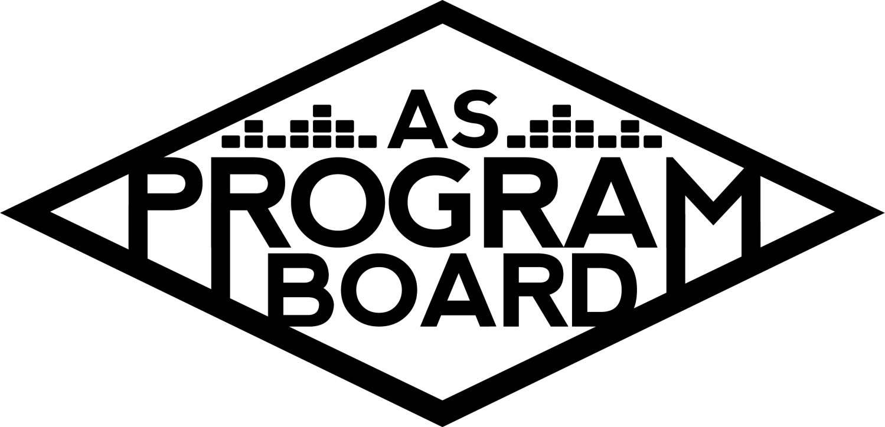
Program Board Agenda

Associated Students
January 27, 2020
SB Harbor Room

CALL TO ORDER: 5:00PM by Kiyomi Morrison
A. MEETING BUSINESS
- Roll Call
Name | Note:  absent (excused/not excused)  arrived late (time)  departed early (time)  proxy (full name) | Name | Note:  absent (excused/not excused)  arrived late (time)  departed early (time)  proxy (full name)
Adam Salton |  | Kari Liu
Alexis Xa |  | Kathryn Quinones
Bethel Tammerat |  | Kiyomi Morrison
Brenna Collins |  | Lucas Jackson
Brett Friedman |  | Mikio Sacramento | Late Arrival
Carlos Aviles-Sullivan |  | Mitchell Lewis
Conner Jones |  | Nathaly Pacheco
Enaiya Judkins |  | Sarah Danielzadeh | Late Arrival 6:15PM
Erica Ko |  | Benjamin Chocron | Absent
Esteban Alvarado
Gabriel Reyes
Greer Jacobs

Acceptance of excused absences, absences, early departure and proxies
Motion: Adam, Second: Lucas, Consent with 17 present.

B. PUBLIC FORUM
- Department of Psychological & Brain Sciences - Alumni event - 4/24, 2-4PM
  - Requesting funds to bring Sarah Laflorge - singer songwriter who graduated in 2011 to perform on campus for a 2 hour show
    - Event with alumni and pannells for those with psych degrees
    - Requesting $300.00, don’t need event safety or production
- UCSB EAB - Earth Day - 4/25, 1-5PM, set up around 10/11AM
  - Requesting sound equipment, soundboard, technician, and event safety staff for 50th anniversary Earth Day Celebration
  - Thinking about 300 people there at a time
  - Anisq’Oyo Park in IV
  - 4-5 bands will be performing

C. ACCEPTANCE of AGENDA/CHANGES to AGENDA
Motion by Gabe, second by Bethel. Consent with 18 present.

D.ACCEPTANCE of ACTION SUMMARY/MINUTES
Motion by Brett, second by Bethel. Consent with 18 present.

E. ANNOUNCEMENTS
- Position Guides
  - Start creating guides for whoever will get your position next year
- Mid-quarter meetings
  - Will ask about position guide everyone is making during these meetings
  - Will be during office hours

F. WEEK IN REVIEW
- Free Tues Film: Maleficent - 1/14
  - 7PM- 54 people, 10PM- 87 people
  - Pubbed UMI and corrected previous issue with sound
- Sad Girl - 1/15
  - Postponed
- Noon Storke Show: The Mouth-Breathers - 1/17
  - First show of the quarter, a lot of people came and asked who they were
  - A lot of people didn’t know we gave out Yerba Mate- had a lot leftover
    - Should put this on the graphic
- Free Tues. Film: Knives Out-1/21
  - 7PM- 239 people, 10PM- 371 people- highest attended movie!!
  - Pubbed UMI
  - Started ~10 minutes after the hour for both
- Noon Storke Show: Yung Fuzz - 1/24
  - Good turnout- a lot of jazz fans in IV
  - Handed out a lot of Yerbas and pubbed UMI and other events

G. PREVIEW OF THE WEEK
- Free Tues Film: Doctor Sleep - 1/28
  - 6:30PM- Mitchell, 9:30PM- Brenna and Enaiya
    - If anyone else can work the 7PM, let Esteban know
  - Same day as UMI, so numbers aren’t as high- pub more
- UMI - 1/28
  - Ticket sales are at 741! Probably will sell out before ticket office closes tomorrow
  - UMI will be getting here at 5PM, soundcheck ~6PM, may do surprise meet n greet for first 5 people in line- will be done before doors open
    - Will give them wristbands then bring them back outside and take them off
  - Trying to push artist takeover, but she is busy with the Grammys- will have Erica talk to her
  - LA dj opener at 9, UMI at 10
  - There is also merch
  - Green rooms were booked so 3rd floor foodbank room will be used for artist
  - Working- call time 7:00PM for those working front
    - Gabe, Conner, Mikio, Kiyomi, Nat, Bethel, Erica-
- Propaganda - 1/31
  - Production will get there at 3:30 for set up- running like a normal Hub show timing-wise
  - Ordered extra lights for the Hub
- Noon Storke Show: Strange Case - 1/31
  - Erica is only person signed up- reminder: everyone has to work 1 Storke Show

H. OLD BUSINESS
- Artist A - 2/20- IV Theater
  - Doors 7:30PM, lecture 8PM
  - Half board event-
  - Free event for Black History Month- open to public
  - Working
    - Esteban
    - Nath
    - Brenna
    - Carlos
    - Adam
    - Lucas
    - Brett
    - Mikio
    - Enaiya
    - Kari
    - Mikio
- Battle of the Bands - 2/27
  - 3 submissions right now- keep pubbing (want 5 minimum)
  - A lot of IV band showcases this weekend- can give names of bands to reach out to
    - Could also make simple flyers to put up to find groups
      - Postering may be more beneficial to find groups than tabling?
        - These events are targeted- should figure out who we are trying to get- posters may also reach more people
      - Ambassadors could table/flyer?
        - Could make directory with ambassador info/emails?
        - Should also start getting them more independent with tabling so we don’t have to do as much to set up/take down
      - Graphics were ordered but there was an issue- need to figure out before ordering more
        - PDF vs jpeg
- Battle of the DJs - 3/5
  - Can look on Free and For Sale or make a radio post to find DJs
  - Should print posters before all details are finalized- can pub it earlier and at events this week (for Battle of the Bands and DJs
  - Paired in email with UMI and Battle of the Bands
    - Shared info with music department list-serve
  - Want another poster to come out to publicize DJ that will be performing
  - Only 1 submission so far and people have been emailing with questions- due Feb. 3
  - Judges: Dylan and booker from Eos club
  - Student favorite/professional judges to figure out winner?
    - Could reach out to last year’s winner to judge this year
    - Brett also has a friend that DJs that lives in IV
  - Could also push more for DJs after the battle of the bands
  - Also may be helpful to push the submission deadline for DJs back
    - Could print posters
  - Could also be smart to make posters and publicize both with the original deadlines- we usually get more bands than DJs and could be tough if we have to push back both deadlines
    - Last year, events were closer to the start of the quarter
- The Warm Up - 4/4
  - Artist B passed on the first offer, sent offer to Artist C today. If they say no, moving on to Artist D and will need contingency
  - Reminder: If you can’t make a mandatory event, need to tell event coordinator AND commissioner
- Extravaganza - 5/17
  - Sent email spreadsheet with asking prices based on slots
  - Since people didn’t respond to email until today, can’t provide more info on artists today
  - Seems like people are interested in pursuing Artist B, Artist E
    - Could co-headline with Artist F
  - Looks like Wednesday 6-7PM is best to meet for X meeting
    - Could we start at 5:30?- people could come a little late
  - Headliner Discussion:
    - Artist E is on of the most requested artists
      - May be willing to accept offer below $100k
        - If it goes over $100k, the process gets a lot more complicated and takes more time
    - Co-headline could mean we change around set times a bit
      - We could start later, but open doors at same time to allow people to get in
    - Artist F could be great headliner- has played big shows that sell out fast
      - Radius clause- didn’t get specifics, but would be breaching radius clause and this could be an issue
    - Should also consider Artist G- released an album this week, have a lot of monthly listeners, and have a lower asking price
      - Can’t pay a second slot more than a first slot
    - Are we sleeping on Artist H?
      - May be more in price range and other students aren’t as big of music nerds as we all are
        - (also Gucci cowboy hat)
    - We have a lot of good 3rd and 4th slots that are cheaper, so we could look into spending more money on 1st and 2nd
    - Going to try to do committee updates during these meetings to make sure everything is on track
      - Theme and release-
        - More of the gaming element (racing)- students racing cars to reveal each slot
          - Need to make sure everyone can see reveal in crowd
        - Attendance at event- could put that we are announcing Artist B an exact time
        - Digital element could also increase publicity- easy to share
        - Waiting on samples of graphics too
      - Arts and Activities-
        - Gathering quotes so by next meeting will have more info
      - Co-sponsorships
        - Packet is ready but needs MD’s approval
- Bonding
  - Everyone voted for karaoke game night- Kiyomi will probably host

I. NEW BUSINESS
- Artist I - 3/4
  - Day before battle of the DJs but he’s pretty available the rest of the quarter
  - MCC is also showing Queen and Slim and Arts and Lectures has an unrelated show this day
  - There are a lot of events going on at this time- hard to pub
  - Comedy set/lecture/concert
  - Don’t think should have 2K for opener; can probably get opener for 1K
  - Discussion about comic style and potential controversy
  - Suggest IV Theater better location than Campbell
  - Conversation on ticket prices $8, $13 & $15

- Shelving - Capital Reserves
  - Shelving for 2 offices within ASPB office
  - Possible spring break installation
- Production Shirts
  - Production is putting together a budget for staff shirts
- Hospitality towels might need to be washed or replaced.

J. ACTION ITEMS
- The Warm Up - 4/4
  - N/A
- Extravaganza - 5/17
  - N/A

K. FINANCIAL ACTION ITEMS
- Department of Psychological & Brain Sciences - Alumni event
We funded this last year--could go to Finance and Business to request.
Motion: Bethel to pass $300 , Second: Brett. There is no consent.
Vote: 13-2-4

- UCSB EAB - Earth Day - 4/25
  - $900 for event safety and production staff
    - $256 event safety staff &
    - $125 production vehicle, $500 production staff
  - Motion: Alexis; Second: Carlos Consent with 19 present
- The Warm Up - 4/4
  - No vote
- Extravaganza - 5/17
  - First slot & contingency vote:
  - Nathaly, Motion to pass Artist E for Headliner for X starting at $90K and ending at $95K. Second by Kat. Consent with 19 present.
  - Nathaly-Motion to pass Artist F as contingency for X starting at $80K and ending at $95K. Second by Bethel, No Consent. Vote-16-2-1
- Zack Fox - March 4
  - Gabe-Motion to pass Artist I for IV Theater on March 4 starting at $5.5K and ending at $10K with tickets at $8; $13; $15. Second by Nathaly. Consent with 19 present.
- Shelving - Capital Reserves--Brett--Motion to pass $850 out of Capital Reserves for Shelving Brett seconds. Consent with 19 present
- Production Shirts - tabled until next week
  - Motion: Adam
  - Second: Bethel

L. REPORT
Facebook Factory / Tuesday Slide / Thursday Ad
- Free & For Sale post
Kudos

The Marilyn Report-TV will be installed week of February 4, if everything goes well. Please be careful plugging in additional appliances to the new outlet. Did everyone get their $$. Let me know--if still have problems. Talk to Kiyomi with any other office improvements this year.

The Kris Report
Excited for UMI tomorrow. Kudos to Brenna for Storke show.

Commissioner's Report
I’m focusing more on the reunion event and also hiring and setting up mid-quarter meetings. Will be planning the bonding fun event.

Deputy Commissioner’s Report
Things are happening. Excited for UMI. Working on sponsorships and the Drive-In.

Coordinators’ Reports
Adam - Umi’s going to be a lot of fun, looking forward to Propaganda on Friday.
Brett - Looking forward to the show tomorrow. Excited for the future.
Carlos-Looking forward to the two hub shows this week and scheduling the event safety bonding this week.
Conner - Any questions about ambassadors ask me! Excited for UMI.
Erica -Also excited for Umi and our pub meetings are officially on Friday from 4-5.
Esteban - Excited for Doctor Sleep. Also sent out a rough list for Spring films. Getting Priya for Pride week. Hopped on a call with Rachel -- Gabe will discuss.
Gabriel - We are on to big things over here in the Cultural Department. Had an inquiry about a pre-screening for something with a Q and A with the star of the movie and it looks like it will be pretty good.
Greer - Nothing major, just working with Mitchell on 2020 volunteer shirts. Also so many people wanted to volunteer for UMI we had to reject people.
Kari -Really excited for Umi. Ticket Office opens at 7:45pm that night.
Mitchell - Looking forward to Doctor Sleep. Working on shirts, other graphics.
Nathaly -Working on the warm up and X. Trying to appreciate the process of it all. If anyone is interested in the booking department for next year my door is always open.

Assistants’ Reports
Alexis - Looking forward to everything this week. Good luck with midterms.
Brenna - Looking forward to the STorke shows and the Hub shows. Wash your hands because everyone is getting sick.
Enaiya - Really excited for UMI. If you haven’t put up your film posters, please check your boxes.
Kathryn - Super excited for Umi tomorrow and for Propaganda show--would love for us to go as a bonding thing.
Lucas - Super excited for everything this week.
Mikio - Excited for the Umi show and storke show. For joker or Queen and Slim if anyone needs me to cover, let me know because I will be there anyway.

Senator’s Reports
Benjy - N/A
Sarah - More and more passive aggressive in the senate chat. Also talking to Benjy about us being more active.

ADJOURNMENT: 7:35PM

Artists mentioned:
Dr. Lafayette, Zack Fox, Oliver Tree, Roddy Ricch, City Girls, Alison Wonderland, Megan Thee Stallion, Zeds Dead, Lil Nas X

