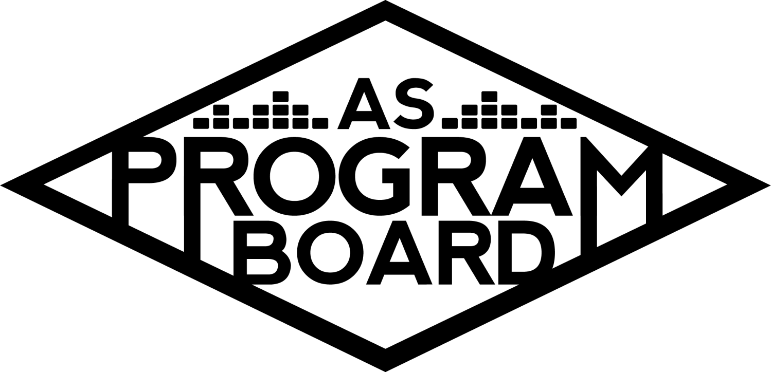
Program Board Minutes

Associated Students
January 18th, 2022
Zoom

CALL TO ORDER: 5:01 pm
A. MEETING BUSINESS
- Roll Call
Name | Note:  absent (excused/not excused)  arrived late (time)  departed early (time)  proxy (full name) | Name | Note:  absent (excused/not excused)  arrived late (time)  departed early (time)  proxy (full name)
Ashley Yeh |  | Kim Kryshak
Clarissa Mendoza |  | Lauren Schaeffer
Emily Duong |  | Lucas Jackson | Absent
Emily Kocis | Early Departure 6 pm | Nyah Scott
Enaiya Judkins |  | Sophie Kimura
Flora Mehdi |  | Talia Heimanson
Kathryn Quinones |  | Wally Corngold
Kathryn Supple |  | Jessy Gonzalez | Absent
 |  | Kian Mirshokri | Late Arrival 6:20 pm

Acceptance of excused absences, absences, early departure and proxies
Motion to accept the absence of Lucas and Jessy, the early departure of Emily K and the late arrival of Kian . Motion by Kat S , second by Nyah. Consent with 13 present.

B. PUBLIC FORUM
- KCSB Collab Proposal
  - Ryan- Artist A reached out to see if we were interested in a q&a + book reading (possibly a performance, depending on budget) with Artist A for AAPI heritage month. A&L too far booked to help. KASA eager and willing to hop in on this. Don’t know the asking/a potential budget. Don’t have any concrete availability, just the general month of May. Want us to help as much as we’re willing to, think performance wise it’s probably more up our alley.
  - Their biggest event this year is probably around 20-30k

C. ACCEPTANCE of AGENDA/CHANGES to AGENDA
Motion to accept the agenda. Motion by Nyah, second by Flora. Consent with 13 present.

D.ACCEPTANCE of ACTION SUMMARY/MINUTES
Motion to accept the minutes from 1/10/2022. Motion by Nyah, Second by Kat S. Consent with 13 present.

E. ANNOUNCEMENTS
- Land Acknowledgement
  - Emily D
  - Nyah next week
- Check In: What’s the first thing you would do if you found out the world was ending tomorrow?

F. WEEK IN REVIEW
- Free Tuesday Film: Dear Evan Hansen
  - Went well, appreciated help with pubbing. 106 people registered and a majority of them actually clicked on the link.

G. PREVIEW OF THE WEEK
- Free Tuesday Film: Shang Chi 1/18
  - this event we put up earlier than the last one to give people more time to sign up. as of yesterday we had around 35 people registered and I hope if we pub a little more we can get a few more people signed up but going well so far given that it is also available on Disney+
- PTR Hub Show 1/21/22
  - TH- 93 people are registered. Currently finalizing questions, make sure y’all are registered
  - Chat monitors log on 10-15 minutes before showtime.
  - Wally and Talia are moderators, Kat S and Enaiya are monitoring the chat, Kim is backup moderator
  - NS - Some DMs came through about refunds for tickets, but all of them notified that refunds have already been done.

H. OLD BUSINESS
- Ambassadors
  - Sheet
  - ED- Kat S and I are presenting our positions at meeting. Sign up to do yours!
  - Trying to start our tiktok
- Playlists
  - Sheet
  - POV: its march 13 2020, suggestions in by friday. Pls lmk if you have theme suggestions. Playlist on Saturday
- Blogs/Podcasts
  - Sheet
  - Music as Healing blog coming out this Sunday
  - One of the ambassadors is willing to do a Artist B podcast
- Collab Event w RCSGD
  - EK- potentially moving date to Thursday 2/10 if we’re all ok with it. Will talk to Nyah and Sophie about making a fire and informative graphic
- Social Media Takeovers
  - NS- this week is Talia!
- Battle of the Bands 2/24
  - WC- 3 submissions so far. One judge secured. 2 out of 3 submissions are kind of weird because of formatting on website
  - NS- maybe we should get small BOTB submission posters up around Pardall.
  - Sophie, Clarissa and Kat can help poster
  - Judge is Wally’s cousin who went to Berkeley Music
  - KE- Raul from Livenotes SB would be a good judge
  - MD- Zack Gill from Artist C’s posse would be good
  - NS- you can let me know if you want to use the aspb account to reach out
- Battle of the DJs (3/3)
  - LS- reached out to graphics, pub, and DMC. Planning to announce either this Thurs or Fri
- Free Tuesday Films
  - LJ- I'm locking in an overall calendar so we know what films we have coming up in what order and will send that out to everyone as soon as it is completed. Next week it is best if we show James Bond: No Time to Die. I will get that shoreline page up and running ASAP so that we can get pub and registration started as well
  - Should maybe put together a full lineup poster and just say it’s subject to change location-wise
- Spring Cultural Event
  - No updates as of now– will check back in as things change campus-wise
- Meet the Board
  - ED- Enaiya brought up having it at an IV business and setting it up as a more casual event where people could come sit and talk with us/ask questions but a lot of that is dependent on it being in person. But it should still be fairly easy to do online.
  - 25 person limit for inside events still apply but no limit on outside events
  - Rockfire > Woodstock’s
- Winter Hub Show
  - TH- Emily K and I were thinking about collabing on an In Convo with Artist D. He’s OOR for a live music performance.
  - EJ: obsessed w this, funny & think ppl would care, a lot of his music is popular, 4.4m monthly on Spotify, personality pretty captivating with popular following on socials
  - KK- we should push for him to do a cameo on our Instagram as promo, think seeing his personality a bit more beforehand would persuade people to come
  - TH- I think he could sell out IV Theater. On the original date for this show (2/17) there’s a conference in the UCEN so we’d have dressing room issues, but moving to IV Theater would alleviate some of those issues.
  - Need to talk more to the agent about what he’d be comfortable with. Maybe audience improv rapping or a writer’s workshop.
  - Would be during week 7 the night after meet the board.
  - Asking for musical is 35k, in conversation would be significantly less
- The Warm Up 4/2
  - Budget: same as Delirium, outdoor costs, publicity stuff tweaked bc already passed, promotional material may be a different budget entirely
  - ED- love Artist E, they had an SB show scheduled
  - KK- Artist F is very OOR now
  - TH- Think Artist E would be a great opener but not enough name pull to headline Deltopia weekend
  - WC- Artist G would also be a good opener if we want to spend more on an opener
  - TH- I’m not super well versed in EDM but I recognize Artist H name and have seen her on big festival lineups
  - KQ- Shocked that H is in range and between her and Artist I think she might have more name pull
  - EJ: Artist E could be a good opener but not comfortable with them headlining. H is definitely someone I know just bc of PB. think Artist J has grown a lot since we first started talking about him, have good collabs, would bring people in from Deltopia
  - SK- I’m pro H, a lot of my friends know and listen to her, she was really big when I was in high school but hasn’t grown too much, wondering if Artist K would fit the vibes.
  - TH- K’s asking in October was around 25k, don’t know if she’d be a strong TWU headliner but maybe X
  - NS- Feeling an EDM vibe, especially for Deltopia
  - KQ- I’s and H’s EDM is easier to acclimate to and fits in with SB EDM
  - KK- if people are thinking co-headlines that’s possible.
  - Artist L is going on a tour in spring/possibly releasing a show. He could do a musical/DJ set or possibly do a comedy set and collab with Artist M but don’t know if people would leave their plans for this.
  - ED- Artist N mayhaps, think Artist L could be a good idea
  - LS- not super familiar with L but I’m a big M fan, know they’ve done an event like this before but don’t know if it would draw the Deltopia crowds.
  - KK- For L, wouldn’t be strictly a comedy set + q&a, it would definitely involve music and then an interview style bit between the two of them and students.
  - NS- we know there’s an audience for L and adding M means it would be something like an event we wouldn’t wanna miss out on.
  - TH- I feel like TWU’s point is to pull people away from Deltopia and I think a comedy show kind of thing wouldn’t fit the bill. H had a really popular New Rules remix. Vouching for an all musical performance.
  - WC- music + a bit would be fun. M does a great job of interacting with students
  - EJ- did just have L, audience for the other artists discussed definitely exist, feel like some students are really excited for a Warm Up like we’ve done in the past
  - KQ- wondering the same thing about bringing L back so soon, thinking L event would be great for a virtual warm up kind of like Delirium 2020, think people would want a musical performance, need to bring people to something they really want to do and I think that’s music. H live is a good mix of different types of EDM and played a top slot when I saw her so she’s definitely still in demand
  - KS- if we’re sure it’s in person I’m comfortable with H, but because we’re unsure of the format I’m on the fence especially re: Deltopia
  - LS- Artist O’s vibes are pretty cool but i can’t speak to how they’d be in SB
  - TH- they’d be great for X
  - SK- I think they’d be nice but I think Artist P would be better in that range
  - AY- Haven’t really heard of anyone but H, know she’s in a lot of festivals but still don’t know if name pull is big enough
- Extravaganza
  - KK- nothing much but will use TWU discussion as I think about it

I. NEW BUSINESS
- KCSB Collab Proposal
  - Book reading and q&a but possibly a performance.
  - NS- familiar with artist and students have asked for her in the past.
  - KS- familiar with artist and the book is supposed to be really good, support KASA moderating the Q&A
  - SK- haven’t heard of artist but have heard of the book, pro this event even if it doesn’t revolve around music.
  - Little more than half of us have heard about the artist/book
  - Book is getting pretty good press.
  - Over 1600 copies of the ebook are on hold at the LA public library
  - Scary-ish that it would be in May, will ask about it being held earlier in may
  - Book tours are typically free, money probably came in re: performance.
- BHM Event Ideas
  - NS- could we collab with groups in the greater SB area? (A: probably couldn’t co-sponsor an event with an outside group). I know Healing Justice SB brings speakers and puts on events.
  - ED- Maybe collab with other orgs instead of trying to put on our own event
  - EJ- maybe doing podcast topic with someone from BSU or BWHC, making sure we’re centering Black voices as much as possible

J. ACTION ITEMS
- Motion to change the date of the RCSGD Collab Event to 2/10/2022. Motion by Enaiya, second by Emily D. Consent with 13 present.

K. FINANCIAL ACTION ITEMS
- Motion to pass $152,735.00 for TWU on 4/2/2022. Motion by Kim, second by Kat S. Consent with 13 present.

L. REPORT
Facebook Factory / Tuesday Slide / Thursday Ad/ Free & For Sale post
Shang chi, botb, botdj

Kudos
Kat, kat s, enaiya for notion
Flora for graphics
Kim for helping flyer iv and dp!
Kat s & sophie and flora and clarissa for botdj help
Big kat for leading meeting
Kim and nyah for postering
Emily and kim for marketing firm
Talia and wally for ptr
Emily d for killing it always
Enaiya for being kims kryptonite
Big kat for notion
Everyone for keeping kim company for OH
Sophie for working with kat to plan breaking into concert
Lauren for helping last minute stuff
Kim and lauren for twu and X
Enaiya for sending out boardie of the qtr

The Marilyn Report
Think about doing some Hub bands outside as a special Storke show since we can do them outside. Licensing for movies is expensive so if we don’t think a movie will do well maybe we shouldn’t do it. Had a meeting about outside security today. They're willing to support us for the special security we need for big events, but may need to find another solution for smaller events.

The Kris Report
Reached out to production vendors for backline, stages, looking forward to ptr!

Commissioner's Report
Will reach out Ryan, really wanna do a podcast with Enaiya and Marty, really excited for February and in person tings. If we can go to basketball we should. Answer BOTQ form

Deputy Commissioner’s Report
Pls fill out form! Excited to talk about meet the board, excited for Feb

Coordinators’ Reports
Ashley- looking forward to us going back in person and having in person events eventually
Emily D- support naked voices, will work on playlists and podcasts etc, excited for events
Emily K- working on the collab event this week & hoping everyone is staying happy n healthy <3
Kathryn S- will post BOTDJ’s, working with Emily on blogs
Kim- look out for my slack about TWU artist suggestions, collab with me on a pod
Lucas- Sorry I couldn't make it to meeting today but thank you all for pubbing the FTF so well so far. they have been doing well so let's keep it up! If anyone has any questions or anything feel free to reach out! Stoke levels are high
Nyah- pub all things! Send slack about botdj, reach out to BSU, wally if u need messages sent lmk, botb flyers maybe!
Sophie- rlly wanna use a staple gun with Nyah, working on IG BOTDJ stuff, should be done soon
Talia- excited for PTR! Make sure to register, buy a naked voices valentines gram

Assistants’ Reports
Clarissa- super excited for ptr, botdj’s posts should be up thursday. Will research TWU artists
Flora- doing graphics stuff, if you need something lmk!
Lauren- working on BOTDJ stuff, helping Kim if she needs help, can’t wait for normalcy and to see u in person hopefully soon
Wally- excited for ptr, looking out for judges

Senator’s Reports
Jessy-
Kian- nothing happening in senate, excited for what board’s coming up with

ADJOURNMENT at 7:36 PM by Kathryn Quinones

Artists mentioned: Yung Gravy, Remi Wolf, Toro y Moi, Tyler, the Creator, Slowthai, Japanese Breakfast, Polo and Pan, Jack Johnson, Alison Wonderland, AG Club, KAYTRANADA, Zack Fox, Ty Dolla $ign, Oliver Tree, Duke Dumont, Andrew Callaghan

