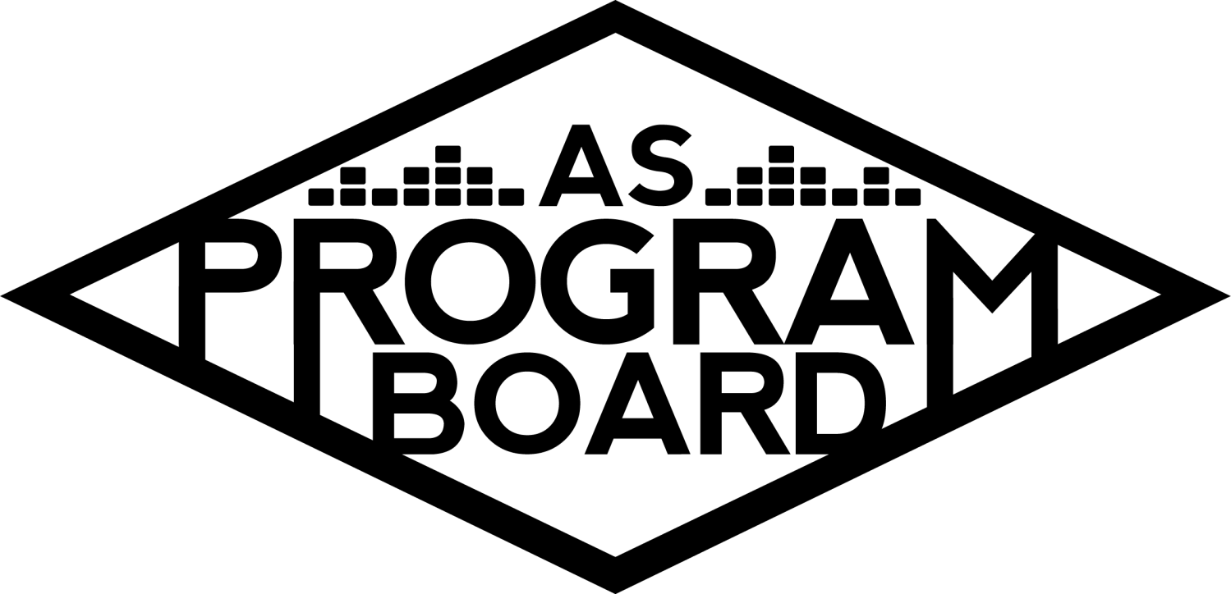
Program Board Minutes

Associated Students
January 3rd, 2022
Zoom

CALL TO ORDER: 5:01 pm
A. MEETING BUSINESS
- Roll Call
Name | Note:  absent (excused/not excused)  arrived late (time)  departed early (time)  proxy (full name) | Name | Note:  absent (excused/not excused)  arrived late (time)  departed early (time)  proxy (full name)
Ashley Yeh |  | Kim Kryshak
Clarissa Mendoza |  | Lauren Schaeffer | Late arrival 5:03
Emily Duong |  | Lucas Jackson
Emily Kocis |  | Nyah Scott
Enaiya Judkins |  | Sophie Kimura | Excused Absence
Flora Mehdi |  | Talia Heimanson
Kathryn Quinones |  | Wally Corngold
Kathryn Supple |  | Jessy Gonzalez | Absent
 |  | Kian Mirshokri

Acceptance of excused absences, absences, early departure and proxies
Motion to accept the late arrival of Lauren, excused absence of Sophie and absence of Jessy. Motion by Emily D, second by Kim. Consent with 14 present.

B. PUBLIC FORUM

C. ACCEPTANCE of AGENDA/CHANGES to AGENDA
Motion to accept the agenda. Motion by Kat , second by Nyah. Consent with 14 present.

D.ACCEPTANCE of ACTION SUMMARY/MINUTES
Motion to accept the minutes from 11/22/2021. Motion by Nyah, Second by Lucas. Consent with 14 present.

E. ANNOUNCEMENTS
- Land Acknowledgement
- Check In: Something fun you did, a cool update, a New Year’s Resolution, tbh anything
- Office Hours dun dun dun
  - sign up sheet

F. WEEK IN REVIEW
- Nightmare Before Christmas 11/23
  - 6:30: Flora (excusd absence), Nyah ; 9:30: Nyah, Emily K
  - 15-20 ppl at 7pm, 25 ppl at 10pm

G. PREVIEW OF THE WEEK

H. OLD BUSINESS
- Ambassadors
  - ED- trying to determine winter quarter meeting times, want board to come talk to ambassadors about board & roles.
- Playlists
  - Sheet
  - ED- making schedule for this quarter, send in fresh finds for this week please!
- Blogs/Podcasts
  - Sheet
  - ED- trying to figure out how to post the first podcast, still working on how all of this will look. Send us suggestions for what you wanna see on the blog/podcast!
  - NS- maybe look into doing evergreen topics so you can post things once you figure out tech-y stuff and still have the topic be relevant
  - ED- they used an app called anchor and they did it together in person, but they should be able to do them virtually!
- Social Media Takeovers
  - NS- we have Ashley doing a takeover this week! Please sign up for one if you haven’t!
- Artist A Hub Show 1/21/22
  - TH- we don’t know if we’ll be back past the 18th, Artist A says they’re down to do a virtual performance, haven’t said anything about rescheduling
  - EJ- would prefer to reschedule if possible, but I think their fanbase would still show out for a virtual show
  - KE- would we want to do a virtual show and then renegotiate to have them come back in the future?
  - TH- they said they want the same amount of money for a virtual show
  - KK- will we still face difficulties with having it in the Hub if we’re allowed to have it in person?
  - MD- we can’t have it in person on the 21st
  - TH- I have the Hub reserved for Feb 17th, can ask Artist A if they can do it then?
  - NS- If we can’t do it in person on the 21st I’d prefer to reschedule. I think the more time we have to pub things correctly, the better chances we have of having students show up
  - MD- do you know if Artist A has rescheduled other shows around that time? (A; Talia will look into it)
  - WC- I agree that we should postpone in hopes of doing something in person, but once we get into February Hub scheduling gets really busy. Think holding it for the 17th might end up being extended too
  - AY- Second what Wally said, might be better to have a virtual event instead of pushing it back. Don’t wanna move Artist A to 2/17 because I don’t wanna limit how many artists we bring.
  - LS- students gave us good feedback about this show and that should be motivation to have it in person if possible.
  - TH- I reserved the 21st bc it felt like a good date but they said they had availability 2 weeks out (in November though), they don’t have any shows scheduled until Lollapalooza
  - KK- could we possibly wait until we know if they’re available on the 17th
  - TH- would be free if it were online, no chance to break even on ticket sales since we’re paying the same amount
  - EJ- i do think that Artist A will do well virtually and I agree with Ashley that it would be sad to lose out on another artist if we push to the 17th and it’s still online
  - EK- not super sold on giving them that much money for a virtual show
  - TH- thinking about Winter Chill Sesh, maybe we do 2 artists in one night outside
  - KQ- if we’re worried about underperforming it would be cool to do something like that if we have 2 artists of the same caliber at the same event.
  - EJ- can we get Artist A to do a Q&A or something so it feels like we’re getting more bang for our buck (A: Talia will ask)
  - NS- if we could secure a Q&A for the 21st I could see that being a great standalone event
  - WC- i think the q&a is a really good option
  - TH- will ask about the q&a first and if they’re not down I can ask about the 17th
  - MD- you either have to move the show or just trust Talia because we don’t have much time before the show is set to happen. We don’t have time to wait/come back and vote again
  - Everyone is comfortable with moving it online if they agree to a Q&A
  - Most people want to postpone if they say no to adding a Q&A
- Battle of the Bands 2/24
  - WC- website is being created, I’ve reached out to graphics about the poster and talked to pub. Hopefully we can start pubbing before the website opens, hoping to have the posters up soon, want submissions to start coming in the 2nd week of January, 3rd week we’ll close submissions and schedule a listening party. Hoping to have 4-5 bands. Still figuring out judging.
  - KQ- submissions should be open for at least 2 full weeks.
  - WC- wanted to leave some time after subs closed to have time to find judges and book bands. Hopefully we can have posters done by the end of the week. Website will open by the end of the week.
  - NS- graphic should be done by the end of the week according to graphics calendar
  - WC- Jill said the meeting rooms won’t be available for hosp rooms but we’ll deal with that later
  - KQ- bands is a lot of production so if you’re b/t 4 and 5 bands I’d probably do 4
  - WC- do we have a house drum kit or?
  - KE- I’d recommend backlining a drum set and a base rig and just have the bands bring their guitar/keyboard amps
- Battle of the DJs (3/3)
  - LS- tentatively on 3/3. Kris sent me a potential DJ judge. Once we figure out the judge and date I’m gonna start figuring out a schedule and DOS. will be reaching out to pub soon
  - KQ- while you have some downtime, planning out your timeline will be super helpful. I had 5 DJS in 2019 and the previous year’s winner as one of the judges (three judges total)
- Free Tuesday Films
  - LJ- our Swank contact has been out of office for a few weeks, brought up the virtual screenings but she hasn’t gotten back to me, hoping to hear back from her tomorrow. Looks like we should plan for virtual screening for at least the next 2 weeks. What do we want to show this week and next week?
  - EJ- please dear evan hansen because it would be great to live tweet
  - KS- i like Dear Evan Hansen because it isn’t streaming anywhere and I think Bond would be best in person
  - KS- Shang-Chi is probably the least timely so if we show it too late people will already have seen it, but I think all of them would do fine
  - NS- super okay with showing any of them. I know we show older movies sometimes that would be interesting in person too.
  - LJ- Encanto and Shang-Chi are both on Disney+ rn
  - Dear Evan Hanse week one, Venom week two!
  - Licorice Pizza has good reviews and just because we show a film doesn’t necessarily mean we condone it
  - LJ- I brought LP into discussion because it had good reviews and we were kinda on a crunch for movies but it seems like people are uncomfortable showing it and that’s fine
- Spring Cultural Event
  - EK- not really too much to report, don’t feel super confident passing a budget right now and sending out an offer since it feels like everything’s kinda up in the air
  - KK- TWU and X are on the agenda kinda just to have some discussion re; what they might look like so that might help you
- Meet the Board
  - ED- just wanna check in to see how we feel about this. We said we’d wanna do it somewhere in IV so maybe table this for later in the quarter
  - EJ- I was thinking kinda late winter quarter because that works best for us but not necessarily best for covid? Maybe wait
  - KQ- I would pick a date now because we can still use the date if we do it virtually and this event would be fairly easy to do virtually
- Winter Hub Show
  - TH- not too much to report, hopefully it happens!

I. NEW BUSINESS
- The Warm Up
  - KK- because everything is kind of on a week by week basis it’s a good idea to set up a plan B now. What do y’all think? Like location, artist structure?
  - EK- thinking outside, we did it once we can do it again
  - CM- I think Storke worked well for Delirium and it would work well for TWU too
  - Lots of support for outside, possibly @ Stroke
  - KK- if it has to go online I’d wanna make TWU different in structure. Do we think giveaways have been effective in the past? What can we add to make them more inviting?
  - EJ- I really like the idea of a meet and greet, don’t really think the giveaway helps much attendance wise and it’s stressful. The meet and greet idea also probably won’t draw in too many extra people since they’d probably bring in the same people
  - ED- i think if we have like extra money from doing virtual it’d be nice to do a giveaway to help soothe students.
  - KQ- I feel like we couldn’t get a big enough artist to draw people out for cheap, I also think Deltopia is going to happen in full force. But, I think if we booked someone and gave out virtual meet and greets it would be pretty enticing even without a performance
  - NS- need to decide if we’re prioritizing making an alternative programming thing or if we’re trying to get the best bang for our buck. Meet and greet would be nice but only a few students would actually be pulled away and not really serve alternative programming.
  - KQ- yeah if we did meet & greets it probably wouldn’t provide safe AP. what if we did like a market kind of thing? But that’s also an in person event and idk what would be better virtually?
  - NS- UCSB didn’t wanna pub our concerts because it was bad optics wise, they’d probably boost a market kind of thing
  - ED- MCC is planning a market thing in spring
  - KK- I want to send out a doc or form about this event to really get your feedback and have all the ideas on one page
- ExtravaGanZaaaAaa
  - KK- normally we’d start planning X now, but having X in its normal capacity kinda sounds like a stretch. MD was thinking about kinda spreading out the performances over multiple days to minimize crowds, what ideas do you have?
  - EJ- love the idea of a multi-day kind of thing, think it would help with crowds. Alternatively, a Drive-in event would be cool but idk how much that helps?
  - KQ- I think we typically have Extrav in Harder because of how many people but if we split it up maybe we don’t have to have it in Harder
  - KK- if we did a reservation system where you could get a ticket for a day that could help us control capacity
  - KQ- in the past we’ve always released the lineup but never the set times, idk if we could release set times so people would know when they actually wanna be there. But the lines would still be an issue
  - EK- if we split day 1 and day 2 maybe we could have people pick to either go to day 1 and day 2, not both. Would have to have equal caliber artist
  - TH- maybe split by genre so it’s easier to pick which day they wanna attend
  - KK- please share ideas that you think will be no’s because they still help!
  - FM- there’s so many unpredictable variables so it’s hard to give ideas, but I think it’d be good to look at what other schools are doing and possibly reach out for ideas?
  - KQ- it’d be really cool if we could have multiple stages
- Collab Event w RCSGD
  - EK- met with Sky and they’re really excited about making this a collab. They’d be able to contribute financially and reach out to other sponsors as well. How do we feel about Artist B? They had a really viral podcast moment, have done a keynote and Ted Talk. They’d probably do a keynote style presentation and q&a.
  - Thinking about week 5 and week 7, but a virtual event would probably free us up more and we could do it sooner. Asking is $10-15k and RCSGD would probably be able to fund around half of that.
  - LS- I think having it earlier in the quarter would be best and I think it would be a good and accessible virtual event.
  - EJ- I’m not super familiar with Artist B but I think this would be a good event overall and agree with Lauren.
  - KS- I think Week 5 is ideal and if we have school in person, having it in person would be ideal but I think it would still be a good virtual event.
  - EK- I think we should plan for in person and then shift if needed.

J. ACTION ITEMS

K. FINANCIAL ACTION ITEMS

L. REPORT
Facebook Factory / Tuesday Slide / Thursday Ad/ Free & For Sale post
FTF, BOTB (later, stay tuned)

Kudos
MD for finals week snacks
Graphics pub for graphic today
Wally for being back!!!
All my insecure besties who think they don’t make sense

The Marilyn Report
Campus has asked everyone to get tested when they get back. The offices don’t seem locked if you wanna go in. Events have to be less than 25 people for at least the next two weeks. The Super Bowl is 2/13 and the Olympics are 2/2-2/20 so try to be careful scheduling events around then.

The Kris Report
Well rested, amped to get going, look forward to getting going again.

Commissioner's Report
If you know of any req forms or artist checks that haven’t gone through pls lmk, boardie of the qtr! Enaiya and I will work on that, keep an eye out for the form! Good luck with week one, lmk if you have questions or need support. I’ve been trying to figure out Notion

Deputy Commissioner’s Report
Covid testing: its been super booked so if you’re home try to schedule an appt now for when you return; be proactive! Excited for this qtr, if you have questions for me feel free to ask them. More boardie things were requested, so if I ask about it ANSWER MEEEE

Coordinators’ Reports
Ashley- super excited for the quarter!
Emily D- feel more refreshed coming back, figuring lots of ambassador stuff because i’m a superstar, lmk if anyone needs help with anything
Emily K- excited for working on a show, appreciate everyone sticking it out, look out for slack soon
Kathryn S- all my classes are dependent on papers, excited for the events, working on the BOTB website
Kim- will be proactive w upcoming events, have a class with emily & enaiya
Lucas- so excited to be back, waitlisting a class for the first time ever, manifesting megan replying to me abt movies
Nyah- excited to be back, only 1 class on M, saw Kat S, pubbing upcoming films and botb so stay tuned and attentive to slack
Sophie-
Talia- excited for what’s to come, emailed Artist A’s agent abt doing a q&a, keep an eye on slack

Assistants’ Reports
Clarissa- excited for upcoming events, hope everyone has good week 1!
Flora- if people have graphic things pls put them into the graphics calendar with the exact wording you want!
Lauren- working on BOTDJ, confirming djs, covid sux, happy week 1!
Wally- working on botb stuff, will keep appropriate ppl looped in, thinking abt doing listening party week 3, stay safe!

Senator’s Reports
Jessy-
Kian- senator position open!

ADJOURNMENT at 7:28 PM by Kathryn Quinones

Artists mentioned:

