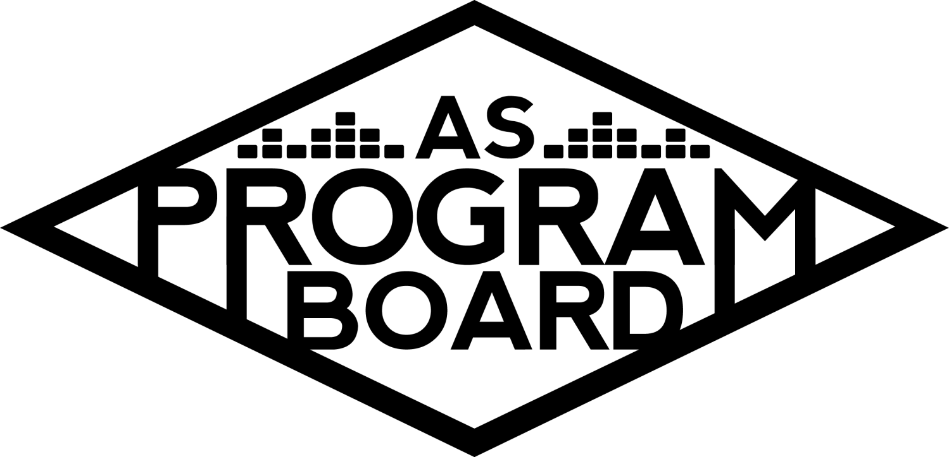
Program Board Agenda

Associated Students
February 3, 2020
SB Harbor Room

CALL TO ORDER: 5:04 PM by Kiyomi Morrison
A. MEETING BUSINESS
- Roll Call
Name | Note:  absent (excused/not excused)  arrived late (time)  departed early (time)  proxy (full name) | Name | Note:  absent (excused/not excused)  arrived late (time)  departed early (time)  proxy (full name)
Adam Salton |  | Kari Liu
Alexis Xa |  | Kathryn Quinones | Early Departure 7:00PM
Bethel Tammerat |  | Kiyomi Morrison
Brenna Collins |  | Lucas Jackson
Brett Friedman |  | Mikio Sacramento
Carlos Aviles-Sullivan |  | Mitchell Lewis
Conner Jones |  | Nathaly Pacheco
Enaiya Judkins | Early Departure 7:00PM | Sarah Danielzadeh | Late Arrival 6:15PM
Erica Ko |  | Benjamin Chocron | Late Arrival 6:50PM
Esteban Alvarado
Gabriel Reyes | Early Departure 7:00PM
Greer Jacobs | Late Arrival 5:56PM2

Acceptance of excused absences, absences, early departure and proxies
Motion by Nathaly, second by Esteban. Consent with 17 present.

B. PUBLIC FORUM
- EVPLA event for IV Open Market on 2/8, 11-3PM, Little Acorn Park
  - Requesting PA system for band for IV Open Market
    - Local vendors from community sell clothes, jewelry, art
    - Usually get ~500 people throughout the day but this year, adding voter registration drive
  - Stage (size: 8 by 16) and live performers
  - ASPB Staff member will need to be there the whole time
  - Set up is at 10am- need staff then

C. ACCEPTANCE of AGENDA/CHANGES to AGENDA
Motion by Bethel, second by Lucas. Consent with 17 present.

D.ACCEPTANCE of ACTION SUMMARY/MINUTES
Motion by Esteban second by Alexis. Consent with 17 present.

E. ANNOUNCEMENTS
- Mid-quarter meetings
  - Going on now
- Send in stuff for meeting by Friday- next meeting is last one before 3 day weekend

F. WEEK IN REVIEW
- Free Tues Film: Doctor Sleep - 1/28
  - 7PM- 83, 10PM- 75 people.
  - Went well even though show was the same time
- UMI - 1/28
  - First sold out show!!
    - Attendance: ~740
  - Opener was good but UMI soundcheck ran long (went almost an hour over allocated time)- switched riders and asked to use more inputs than originally agreed on- had to make it work with production
    - MD- In the future, can tell them that we are sticking with the contract
  - Did an artist takeover with questions students submitted over the week
  - Planned on doing a 1st five people in line meet in greet but had issues with green room and soundcheck running long
  - Didn’t have cash to give us 25% of merch- gave us check back and we voided it- how do we go about this?
    - Usually don’t do merch with credit cards
  - UMI went on late because she lost her in ears- played ~40-50 minutes
    - Are we recording artist playing times?- should start doing this
  - As they were shutting down, she went towards the barricade and interacted with fans even though we requested she go back to the green room
  - People were also waiting outside the venue for them to leave- CSOs told them to go back there
    - Paramedics came and caused additional confusion on where to lead people
    - UMI came back out on stage and people upstairs wanted to come back down but we told them they couldn’t
      - Need to get all groups to get people out of the venue faster when the show ends
  - Should start to get CSOs outside of artist rooms- people gather around here too
  - Moving hosp to Chumash room worked out fine
  - People complained about the water fountain in the Hub- apparently only half of the buttons work on it- maybe should put up a sign?
  - Girl came in on crutches- helped her down an elevator and gave her a chair- we are allowed to accommodate just make sure people know
  - Avoid hanging out on top floor of the Hub and don’t bring your friends up there
  - Put up lights in the Hub for the first time this year- looked good- do it again
    - Make sure you plug them into the production port so people don’t trip on cords
- Propaganda - 1/31
  - Set up quickly, ran their lighting through our audio patch
  - Soundcheck went well, there was a backline problem but it didn’t end up being an issue- not ASPBs fault
  - Didn’t give set change times- opener went over set time- tried to get Taska Black on as fast as possible
  - Load out started at 12 and got out very quickly
  - Co-sponsorships are supposed to provide production manager- need to hold co-sponsorships accountable and not let them put all the work on ASPB
  - Only ~200 people there- may have overstaffed event safety but it was an easy show
  - Had big Propaganda poster hanging from Hub- was really cool and could be a good idea for us
    - Had a neon sign outside the Hub too- good advertising, something to look into
- Noon Storke Show: Strange Case - 1/31
  - Band got there early and set up and had a good turnout (and moshing)!
  - Pubbed battles of the DJs and bands and handed out yerbas
  - Note: Make sure to sign up for at least one storke show this quarter

G. PREVIEW OF THE WEEK
- Free Tues Film: Joker - 2/4
  - 6:30- Kiyomi, Brett, Gabe
  - 9:30- Erica, Nat, Conner
  - FB numbers look good- we expected this- has 11 Oscar nominations
  - Very heavy film- put a “viewer discretion advised” note before
    - Could add a mental health discretion as well- emotionally intense
      - Could make signs to put on doors and post on event page
      - Could also print out mental health hotline phone numbers

H. OLD BUSINESS
- Production Shirts
  - Fixed budget and added in some XXL shirts in case
  - Mitchell made design- need to make font smaller
- Artist A- 2/20- IV Theater, doors at 7:45, lecture at 8PM
  - Scheduled to go up Wednesday- waiting to get graphic approved
  - Will send DOS sheet later this week
  - Reaching out to classes?- waiting on graphic and have been talking to professors in Black Studies Department
  - Lectures are different than usual events- need to change up pub plan
  - Reach out to SBCC professors?
  - Will assign hosp next meeting
- Battle of the Bands - 2/27
  - Submissions closed at 5PM- 6 submissions total (less than in the past years but enough to have a show)
    - Extending deadline?
      - 2 more days may not hurt because 2 groups submitted today
        - Yes- will extend to Wednesday at 5
    - Insurance cost may have been a deterrent to groups
      - We pay them enough to cover it in the contract
  - Listening party this Thursday combined with others- would be a very long party
    - Could send music out before then have meeting to discuss?
    - Would rather meet twice for 2 shorter times
  - Winner gets to record at KCSB, but difficult because a programmer has to confirm with the winner (but we don’t have a winner yet)
    - Pubbing this fact may help increase submissions
      - But KCSB hasn’t confirmed they will allow it, so it all has to be TBD
    - Possibly could be on Kiyomi’s show!
      - Listen to it :)
- Battle of the DJs - 3/5
  - As of 5PM, had 22 submissions and haven’t gotten any since. Had over 10 submissions in the hour before the deadline
  - Need to plan listening party- if we can’t do it this week, will have a week and a half to get all contracts in which will be stressful
  - 2 judges for sure and talking to a 3rd who sounds interested now
  - Waiting on contract from Dylan and need to make a poll for listening party
  - Note: Keep half board shows in mind
- The Warm Up - 4/4
  - Advertising and marketing wise the save the date has been done
    - Pub plan- save the date tomorrow- is that early?
      - People may forget if we announce too early- maybe mid-March?
        - Spring break adds to weird timing
      - Still need to make stickers and t-shirts
      - Dead week? - wanted to announce artists then
      - 2 weeks to promote if possible.
    - Artist B
      - Deadline approaching, haven’t heard back yet.
    - Waiting to hear back about about police using wands at event entry
- Extravaganza - 5/17
  - Theme and Release
    - Considering between 4 or 5 artists, this will affect the length of performances.
    - People need to respond to emails and contribute during meetings
      - People want more options but don’t send ideas
    - Working on sending slot 4 offer out tomorrow
    - Headliners- 2 days to research then can have meeting on Wednesday
    - Goal is to book headliner first
    - Artist C - probably will be able to breach radius clause but we need to act fast to figure that out- they need to show an actual offer
      - As much as possible, general meetings are to pass money- other meetings are designed to figure out everything else
    - Issues with meeting times- people need to check out all times they’re available, not just when they want to come in
    - Theme- cars/nascar or x-games
      - Car show/meet- students and faculty could bring cars to show off
        - ASPB/Extravaganza decals
        - Lot 22- could be dangerous
        - Commencement Lawn
        - Renting Luxury cars to place them somewhere students can come see
          - Or dirt bikes
            - May not be exciting unless they do ~tricks~
      - Flags could be released when a car revved its engine
      - OR students could race remote controlled cars and winners could reveal names
        - Increases student involvement
          - BUT we need to rely on other people- adds more to figure out
      - Could also put letters on sides of car costumes
      - Projectors on Storke Tower- would need to do at night and there’s scaffolding now

I. NEW BUSINESS
- Facilities borrowing plywood
  - Late June- need to cover a trench hole (??)
  - They would pick it up and load in/out- need to put back the way they found it

J. ACTION ITEMS
- Facilities borro wing plywood in late June
  - Y- 18, N- 0, A- 0.

K. FINANCIAL ACTION ITEMS
- EVPLA event for IV Open Market on 2/8, 11-3PM, Little Acorn Park
  - Need a box truck, people are over hours, and Adam is going home, plus they only gave a week’s notice
  - Vote: Y- 0 , N- 15, A- 3.
    - Not enough staff to help
- Production Shirts
  - Motion by Lucas to pass $660.00 for new production shirts, second by Nathaly.
    - Consent with 18 present.
- The Warm Up - 4/4
  - Not voting today
- Extravaganza - 5/17
  - Reaffirm Vote
    - Motion by Nathaly to reaffirm Artist D for slot 4 starting at $15k and ending at $30k, second by Gabe.
      - Consent with 18 present.

L. REPORT
Facebook Factory / Tuesday Slide / Thursday Ad
- Free & For Sale post

Kudos- Brenna killed it with the Storke show artists!! AND she postered. Conner for managing ambassadors!! Production for dealing with UMI’s team professionally!! Este for his bomb movies!! Event safety doesn’t get enough credit!! Nat for X Meetings!! MD for helping even though she has a ton of jobs now!! And me :’)

The Marilyn Report- Women of Color Conference is Wed.- can still register. Will be out tomorrow afternoon.

The Kris Report- Taking inventory of production closet

Commissioner's Report- Mid-quarter meetings are good- feel free to always talk to Kiyomi about anything. Submitted budget for next year- hearing is on Friday

Deputy Commissioner’s Report- Working on co-sponsorships- Urban Decay (!) trying to give out setting spray. Personalized merch/budget- only a few people responded but they wanted personalized merch. Want everyone to vote through slack so we can move forward. Mitchell offered to put in labor for personalized ones.

Coordinators’ Reports
Adam Going through closet. Production team meeting tomorrow- upcoming events.
Brett - Looking for Spring artists- send recommendations
Carlos- Busy last week with 2 shows but had event safety bonding before Propaganda- went well.
Conner - Ambassadors taking over postering next week. May still need extra help. Come to pub or X meetings if you have ideas.
Erica - Working with creative part of AS to do new kinds of pub. Keep an eye out for BOTB extended deadline.
Esteban - Working on Pride Week screening and prescreening. Budget to come soon.
Gabriel - Working on lecture- insurance. Looking into feasibility of Q&A and prescreening. Happy Black History Month!
Greer - Going to get volunteers to do postering. Art night.
Kari Took over Spotify and making a midterms playlist- send songs! If anyone needs help let her know.
Mitchell - Good luck on midterms!
Nathaly - Killing it in school (no surprise). Willing to help out with events. Kiyomi says let her rest.

Assistants’ Reports
Alexis - Bonding event went well- let her know if you need help.
Brenna - Share extended BOTB deadline- tell bands too. Will figure out time for listening party.
Enaiya - Earthgang played in Starbucks today ooh
Kathryn - Planning pre-event meeting this week for both events. Thank you for help pubbing.
Lucas - RIP to him
Mikio - Looking forward to this week.

Senator’s Reports
Benjy -
Sarah -

ADJOURNMENT: 6:43 PM

Artists mentioned: City Girls, Alison Wonderland, Omar Apollo, Dr. Lafayette

