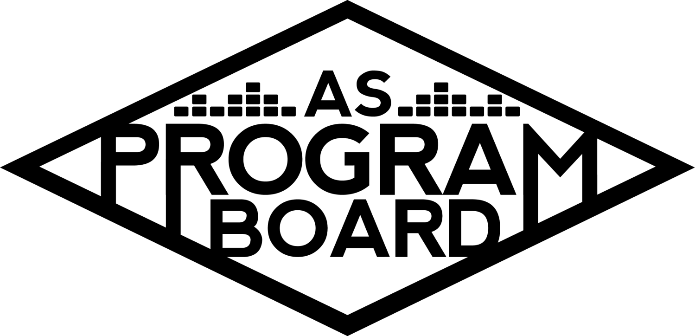
Program Board Minutes

Associated Students

November 9th, 2020
Remote

CALL TO ORDER: 5:02PM by Kathryn Quinones
A. MEETING BUSINESS
- Roll Call
Name | Note:  absent (excused/not excused)  arrived late (time)  departed early (time)  proxy (full name) | Name | Note:  absent (excused/not excused)  arrived late (time)  departed early (time)  proxy (full name)
Adam Salton
Alexis Xa |  | Kathryn Quinones
Celine Liu | Late arrival 5:30 | Lucas Jackson
Emily Duong |  | Sophia Castro
Emily Kocis |  | Sophie Sharma
Enaiya Judkins |  | Hayley Slater | Absent
Gabriel Reyes |  | Bee Schaefer | Absent
Halle Dawite
Jake Einsiedl

Acceptance of excused absences, absences, early departure and proxies
Motion to excuse late arrival of Celine & absence of Hayley and Bee. Motion by Gabe, Seconded by Sophie, Consent with 11 present.

B. PUBLIC FORUM

C. ACCEPTANCE of AGENDA/CHANGES to AGENDA
Motion to accept the agenda. Motion by Sophia, second by Sophie. Consent with 11 present.

D.ACCEPTANCE of ACTION SUMMARY/MINUTES
Motion to accept 11/2 minutes. Motion by Gabe, second by Lucas. Consent with 11 present.

E. ANNOUNCEMENTS
- Land Acknowledgement
- Offers & Req Forms
  - Reminder to send it to Kat to proofread before sending it to MD and Kris
  - Sample offer in the drive

G. WEEK IN REVIEW

H. PREVIEW OF THE WEEK
- Storke Show ft. Art Official 11/10
  - Show starts at 7pm for 60min
  - Waiting for them to sign the contract
  - Announce tonight or tomorrow with a graphic
- Hub Show 11/12
  - Confirmed a 20 minute guided meditation, a 25 minute set, and 15 min Q&A
  - Start at 8 pm
  - Moderating: Emily K
  - Monitoring: Enaiya and Lucas
  - Waiting for contract to go through
  - Figuring out a time to sound check
  - One student question submitted that would want to ask live
  - Could try to get some from the insta story

I. OLD BUSINESS
- Storke Show: Live with Artist A 11/18
  - Planning on wednesday night at 7pm for a 45min set
  - Planning on announcing beginning of next week with graphic
- Cultural Event 11/19
  - 45min Q&A @ 7pm
  - Monitoring: Lucas, Emily K, Emily D, and Sophie
  - Announcing this Friday
  - Drafting a contract
  - Lucas can be back up moderator incase Gabe’s wifi goes down
  - Might try to get Artist B a UCSB hoodie to wear
- Storke Shows
  - Lucas is working on trying to secure an artist
  - Adam is trying to secure Artist C but will move on if they do not come back to him
  - Sophie has connections to Artist D and Artist E if we are still looking for artist
- Festive Programing ideas
  - “Happy Holidays from ASPB” snapchat filter
  - DIY kits
- TWU 4/3/2021
  - Artists
    - Artist F
      - Growing tiktok fame
      - If we wait they would be harder to book later on
      - Alexis thinks they would be an amazing book
    - Artist G
      - A growing audience
      - Performed for another school and had a really engaging performance
      - Really personal Q&A following
      - Is there enough of a fan base here to have them for this big of a show?
    - Artist H
      - Has good features but solo stuff is not as good
      - Associates with problematic people
    - Artist I
      - Big edm artist
      - Appeals to people outside of the edm audience
    - Artist J
      - Bigger name pull than Porter Robinson
      - Also a huge edm name
      - Have talked about wanting to book this person for a long time now
    - Artist K
      - Have huge songs that are often played at parties
    - Artist L
      - Could be an alternative route we don’t normally cater to
      - Students want them
      - Also viral on tiktok
      - Requested a lot on insta and on formal paper polls during tabling
    - Try to come back with a more firm decision next week!!!!
      - Bring more research and come with at least 1 artist ready to pass

  - Shirts
    - Getting estimates from companies to see how many shirts and colors we can do
    - Reached out to two companies so far

J. NEW BUSINESS
- Winter Quarter Show
  - Maybe a different genre to reach more audiences
  - Indie could be a winter quarter vibe
  - Might be a good way to test the waters
  - Do genres opposite to who we book for the warm up
- Thunderdome Cut Outs
  - Budget for three cut outs
  - Cut outs will be at home UCSB basketball games
  - Kat, Gabe, and Lucas will take the photos
  - Use this for more promo

K. ACTION ITEMS

L. FINANCIAL ACTION ITEMS
- Motion to reaffirm 11/5 motion to pass Art Official for a Storke Show on November 10th starting and ending at $200. Motion by Gabe, Second by Halle. Consent with 12 present.
- Motion to reaffirm 11/5 motion to pass Artist A for a Storke Show on November 18th starting at $1,000 and ending at $1,500. Motion by Emily k, Second by Jake, Consent with 12 present.
- Motion to pass $150 for three ASPB Fan Cut Outs for the Thunderdome. Motion by Sophia, Second by gabe. Consent with 12 present.
- Motion to pass $50,000 for the Winter Quarter Show (date TBD). Motion by Alexis, Second by Emily. Consent with 12 present

M. REPORT
Facebook Factory / Tuesday Slide / Thursday Ad
- Free & For Sale post

Kudos
Gabe for being a chef
Jake for being helpful with booking
People doing Storke shows
Enaiya for helping Halle
Kat for the energy
Sophie for loving philz
Enaiya for making a great coffee cake
Kat for holding down the fort
Emily for turning 19
The Marilyn Report
Holiday on Wednesday! Plan ahead on Storke shows! 102 registered for Raveena! Letters to Storkie festive event?
The Kris Report
Meeting with Pub on tuesday! Looking forward to shows coming up!
Commissioner's Report
Exploding. Midterms are scary.
Deputy Commissioner’s Report
Excited for everything we’re doing
Coordinators’ Reports
Adam- working on Artist C and the stroke show in general
Alexis- be ready to have a solid artist suggestion next week for TWU
Celine- yield
Enaiya- super excited for Raveena on Thursday. Putting poll responses together. Got the job at Starbucks!!
Gabe- Getting things ready for the 11/19 event. Congrats to new bookers
Jake- all set for storke show tomorrow! Will keep everyone updated for Raveena sound check
Sophie- excited for events and getting contacts for IV bands

Assistants’ Reports
Emily D- Daily Nexus Print Ad w/ our socials and old events.
Emily K- Super excited for Raveena and Artist B. Working on Storke show thanks MD for the help!
Halle- excited for Raveena and Artist B! Burnt out from midterms
Sophia- Second ambassador meeting tomorrow making a playlist to encompass the vibez of IV to play in restaurants around IV. working on a ASPB spotify year in review. This week’s playlist is country

Senator’s Reports
Bee-
Hayley-

ADJOURNMENT: 6:45 PM by Kathryn Quinones

Artists mentioned: Playyard, Porter Robinson, Ty Dolla $ign, Denzel Curry, Wallows, Mary Clifford, Alison Wonderland, John Mulaney, Louis the Child, Luna Luna, Closeout, Don Toliver

