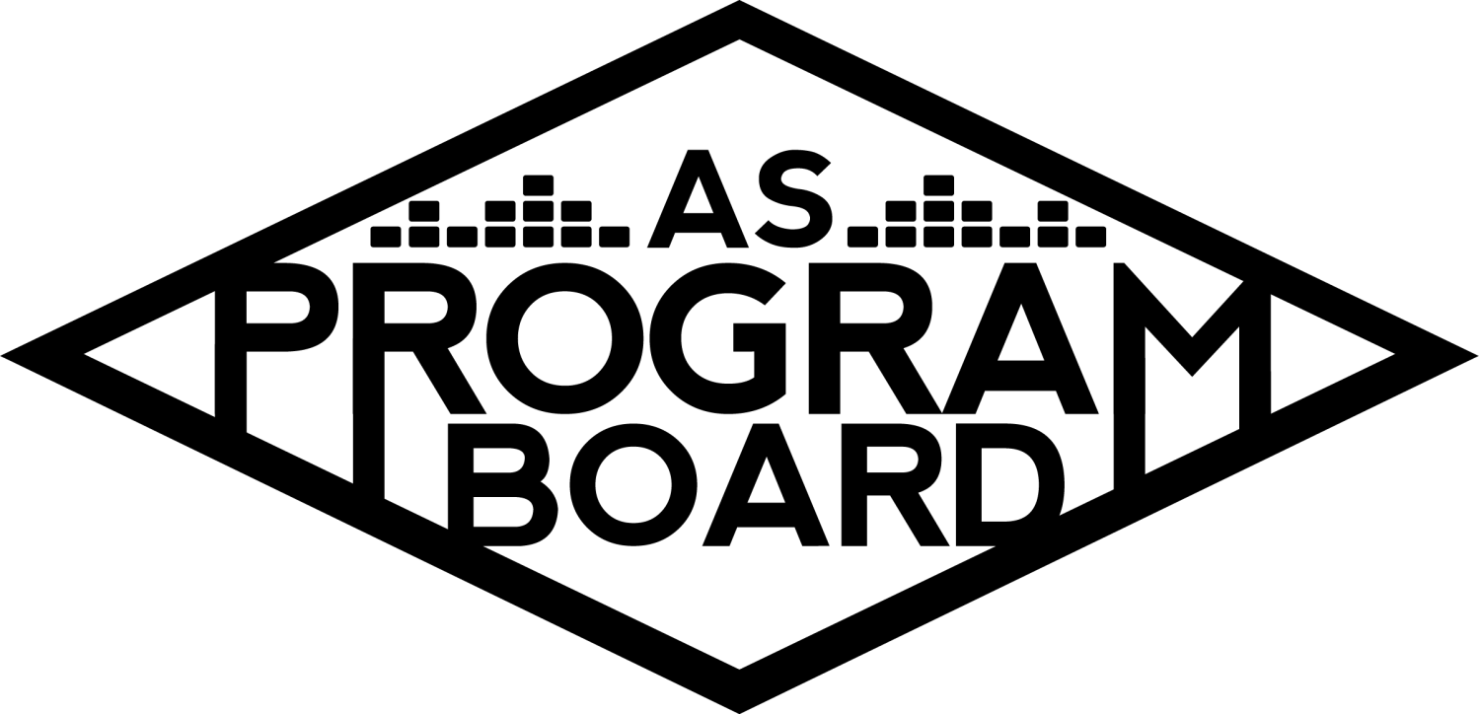
Program Board Minutes

Associated Students

October 12th, 2020
Remote

CALL TO ORDER: 5:08PM by Kathryn Quinones
A. MEETING BUSINESS
- Roll Call
Name | Note:  absent (excused/not excused)  arrived late (time)  departed early (time)  proxy (full name) | Name | Note:  absent (excused/not excused)  arrived late (time)  departed early (time)  proxy (full name)
Adam Salton
Alexis Xa |  | Kathryn Quinones
Celine Liu |  | Lucas Jackson
Emily Duong |  | Sophia Castro
Emily Kocis |  | Sophie Sharma | Late arrival @ 5:15
Enaiya Judkins |  | Hayley Slater | Early departure 6:30
Gabriel Reyes | Early departure 6:30 | Bee Schaefer | absent
Halle Dawite
Jake Einsiedl

Acceptance of excused absences, absences, early departure and proxies
Motion by Jake, second by Gabe. Consent with 13 present.

B. PUBLIC FORUM

C. ACCEPTANCE of AGENDA/CHANGES to AGENDA
Motion by Gabe, second by Lucas. Consent with 12 present.

D.ACCEPTANCE of ACTION SUMMARY/MINUTES
Motion to accept 10/05 minutes. Motion by Gabe, second by Alexis. Consent with 12 present.

E. ANNOUNCEMENTS
- Land Acknowledgement
- Indigenous Peoples’ Day

G. WEEK IN REVIEW
- Cautious Clay 10/08
  - Went really well
  - Great Q and A
  - Sound was good
  - 63 unique viewers attended the event with a max of 46 at one time
  - Pub might have been stronger on this than on Welcome Back
  - Might have been more than 63 because some people don’t watch alone
  - Management should be aware that there is stable connection to the internet

H. PREVIEW OF THE WEEK
- Cultural Event 10/15
  - Gabe is trying to see when we can announce
  - Trying to approve contract
  - The questions are ready to go
  - Monitors for chat is Jake and Alexis
  - Gabe is doing the Q and A
  - Sophie will back up for Gabe
  - Will also be taking questions from students
  - Good idea to test video student interaction during this event

I. OLD BUSINESS
- Delirium 10/30
  - Confirmed for 38k
  - 12k left over for an opener or another act
  - Emily Kocis will help moderate; Adam will be backup
  - Will be fun!!!!!
- Delirium 10/31
  - Artist A updates: Steven the agent said they need more money for production costs
  - The offer was for 60 min but they asked for a shorter set with a Q and A
  - Should we do a 3 act set and include Artist B?
    - They are already pop/RNB
    - Edm might give us a bigger draw
  - Support
    - Artist C is up and coming RNB and is becoming quite popular
      - New album debuted at #30 on Billboard top 200. Soul food sessions are very popular on YouTube. LA based
    - Artist D: his album is blowing up and is all over social media but might be due to like minded people on our social feeds. His popularity could just be new album excitement and not established
  - Giveaway
    - Look at the budget and see the prizes
    - Should we do few big prizes or more smaller things
    - People might stay home for the biggest prize so the smaller prize are still good
  - Promotion
    - Maybe promote with a video directly from the artist
    - Enter the giveaway through insta
    - How do we connect with the first years?
    - Posters? Can only get them on Wednesdays or friday
    - Will also do a uni announcement that goes to everyone
    - Tabling in IV with quarter sheets
- Hub Show 11/12
  - Talking to Artist E agent
  - Doing guided meditation and a musical set
  - Hoping to confirm soon
- Cultural Event 11/19
  - Artist F is ready to go just needs the paperwork
  - Will continue on the same road from before
- Ambassadors Program
  - Steadily getting applications
  - Due by friday at 11;59
  - Really effective to personally reach out to your friends or other people you think would be good at it
  - Received 11 applications so far
  - Would like to hire 10 ambassadors
- OBSD Until Freedom Event
  - MD had emailed them and asked if they need our funding
  - They got all the funding they needed
  - Kat and Lucas have now made a guideline document for those who are requesting money from ASPB

J. NEW BUSINESS
- SASA Event
  - They reached out to Gabe for help bringing Artist G in January
  - Asked for help booking
  - Students who have a history of sexual violence are not allowed into the event
  - Will not be a partnered event with us
  - Cannot keep people from attending an event while using AS funds

K. ACTION ITEMS

L. FINANCIAL ACTION ITEMS
- Delirium 10/31 Giveaway
  - Motion to pass $5k for the delirium give away. Motioned by Alexis, Seconded by Sophie, Consent with 11 present

M. REPORT
Facebook Factory / Tuesday Slide / Thursday Ad
- Free & For Sale post

Kudos
Jake for a good event
Lucas for working with Kat and felt nostalgic about the office
Kris for having a gorgeous baby
Gabe and Sophie for moderating
Everyone who helped Jake w/ the event
Sophie for being a nice texter
The Marilyn Report
Yay for a good start to the year and looking forward to Ramy. Also super busy so send reminders and be nice
The Kris Report- Great event last week and excited to see promos for the Halloween events

Commissioner's Report . Halloween Collab will have a meeting this week. Thanks for being amazing everyone

Deputy Commissioner’s Report . Hoping to order masks and meet with yerba mate soon

Coordinators’ Reports
Adam- Jake and Kris made a production recommendation list. Also want to get rolling on stroke shows
Alexis- in case Artist H is too expensive be ready with more artists good productive discussion today
Celine- Ramy Graphics are ready and getting all other graphics ready maybe a lil animation
Enaiya- excited to announce Ramy and for it to happen. STOKED for tabling. Looking forward to the rest of the quarter
Gabe- gonna cry
Jake- keep us updated with Artist E thanks for the help
Sophie- sorry for being late. And working on newsletter and ambassadors

Assistants’ Reports
Emily D- working on spotify playlist cover
Emily K- shoutout to everyone for getting through week 1. Excited to meet in person for tabling
Halle- excited to take over on Instagram and excited for Ramy. Shoutout to Alexis for being amazing
Sophia- this week will be us and student suggestions for Road Trip song Playlist

Senator’s Reports
Bee-
Hayley-look out for AS training. senate is doing weekly BCU reports. Senate meetings on wednesdays at 6:30. OH T 1-3, R 1-2.

ADJOURNMENT: 7:28PM by Kathryn Quinones

Artists mentioned: Giveon, John Mulaney, Raveena, Chanel Miller, Chloe x Halle, Kiana Lede, 24kGoldn

