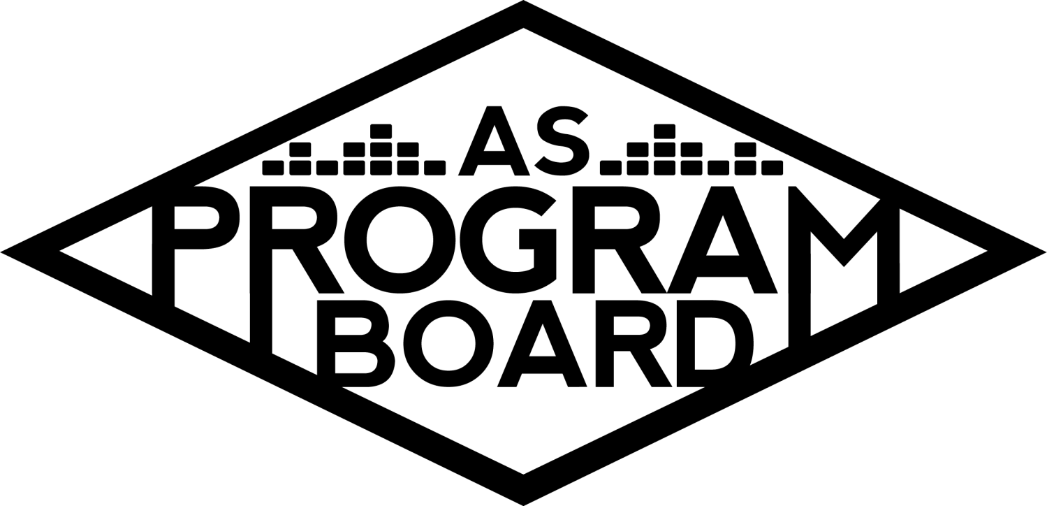

Program Board Agenda

## Associated Students

## October 5th, 2020

Remote

**CALL TO ORDER: 5:09PM by Kathryn Quinones**

**A. MEETING BUSINESS**

1. **Roll Call**

|  |  |  |  |
| --- | --- | --- | --- |
| **Name** | **Note:**  absent (excused/not excused)  arrived late (time)  departed early (time)  proxy (full name) | **Name** | **Note:**  absent (excused/not excused)  arrived late (time)  departed early (time)  proxy (full name) |
| Adam Salton |  |  |  |
| Alexis Xa |  | Kathryn Quinones |  |
| Celine Liu |  | Lucas Jackson |  |
| Emily Duong |  | Sophia Castro |  |
| Emily Kocis |  | Sophie Sharma |  |
| Enaiya Judkins |  | Hayley Slater |  |
| Gabriel Reyes |  | Bee Schaefer | Absent |
| Halle Dawite |  |  |  |
| Jake Einsiedl |  |  |  |
|  |  |  |  |

**Acceptance of excused absences, absences, early departure and proxies**

Motion by Jake, second by Lucas. Consent with 13 present.

**B. PUBLIC FORUM**

**C. ACCEPTANCE of AGENDA/CHANGES to AGENDA**

Motion by Jake, second by Gabe. Consent with 13 present.

**D.ACCEPTANCE of ACTION SUMMARY/MINUTES**

Motion to accept 9/28 minutes. Motion by Gabe, Second by Sophie. Consent with 13 present.

Motion to accept 6/1 minutes: Motion by Gabe second by Alexis. Consent with 13 present.

**E. ANNOUNCEMENTS**

1. Land Acknowledgement
2. Office Hours
   1. Should have started them today or at least get them done this week
   2. Fun to have them with other people for collaboration
3. Olivia has let us know she can no longer be on board

**F. SUMMER IN REVIEW**

1. Session A
   1. Saweetie
      1. Crazy event w/ lots of logistical issues
      2. Switched from live performance to an “in conversation with”
      3. Was only 30 -45 min
   2. Tabitha Brown
      1. Cooking demo
      2. 200 registered 150 max showed up
   3. Monte Booker
      1. Producer collab w/ Smino
      2. 27 attended
2. Session B
   1. Antoni Porowski
      1. 128 attended
      2. Fun event
      3. Should look into more cooking events because they are popular
   2. Storke show w/ Chloe Moriondo
      1. Small indie artist
      2. Instagram live set and q and a
      3. Highest number was 431 people
      4. Had issues with getting her to join the live and inviting her
      5. Really good at engagement with the viewers
      6. Instagram live is difficult because of the two cameras
   3. Bretman Rock
      1. Make up event
      2. Announced day of which is not ideal
      3. 422 people attended
      4. Youtubers do well

**G. WEEK IN REVIEW**

1. Welcome Back 10/03
   1. Shout out to everyone that helped
   2. Show went well even though there was some technical difficulties
   3. Good job Gabe for stepping in for Jake when he was getting dropped from the call
   4. Usually there wouldn't be as long of a time gap between the Q&A and performance
   5. Whethan had really cool visuals
   6. Miscommunication about the production tutorial
   7. Whethan enjoyed it
   8. Highest was 45 people
      1. Maybe because it started later
      2. Maybe people still went out
   9. Should start with the music next time and do Q&A after
   10. Should continue to set a backup moderator for future shows just in case of technical issues
   11. Need to figure out how to reach freshman or students better
       1. Maybe a mass email to all students
       2. Event was sent out on shoreline
       3. Also ambassadors is starting soon
       4. Start sending out newsletters
       5. Join the c/o 2024 Facebook page
       6. reach out to other instagram pages so that our events get out there

**H. PREVIEW OF THE WEEK**

1. Cultural Event 10/06
   1. Not happening tomorrow
   2. Contracting issues- have to push the show back
   3. Makes sense to have an event every week leading up to Delirium
   4. Moving Artist A to next week- thursday or Friday
2. Cautious Clay 10/8
   1. 8pm Acoustic performance followed by a Q&A
   2. Sound check is at 6:30 pm
   3. Zoom link goes to ucsb email
   4. Pub went up the day of welcome back
   5. 45 people going or interested on FB
   6. Make sure to invite your friends on FB

**I. OLD BUSINESS**

1. Delirium 10/30
   1. Reminder Artist B had to reschedule
   2. Thanks for the good conversation on Artist C & D
   3. Would like a contingency. Artist E?
   4. If we confirm Artist C & D soon we can add an opener for 10k
   5. Maybe we should pair someone with Artist E if we have them as contingency?
      1. Might be hard because they are close to the top of the budget
      2. It would increase attendance
2. Delirium 10/31
   1. Artist F passed
   2. Do we want to move forward w/ Artist G or go in a different direction
      1. Artist H asking 55-65k but would have a lot of name pull
         1. Huge pull and people who go out are his fans
         2. 13.9 million spotify listeners
         3. Produces some of the biggest rap songs
         4. Just released an album w/ Artist I
      2. Artist J
         1. 36 million listeners on Spotify
         2. Is a newer artist
         3. On the cheaper side of the budget so that we can get another artist too
         4. Can’t bet on up and coming need to bet on current relevance
         5. 35th in the world
      3. Artist K
         1. Kind of more of a meme
         2. Even if people watch just for the meme they are still watching
         3. 30k might be a little pricey for them
3. Care Packages
   1. Will be reaching out to graphics for designs
   2. Maybe pair mask with giveaway ideas
4. Giveaway
   1. Go over the doc that alexis sent to everyone
   2. Need to figure out how to pick the winners
5. Hub Show 11/12
   1. Still have to vote to pass money for Artist L
   2. Maybe do a guided meditation and performance
6. Cultural Event 11/19
   1. Artist B had a conflicting obligation
   2. Still moving forward with him but on a different date

**J. NEW BUSINESS**

1. Halloween Collaboration
   1. Kat and MD had a meeting with the people from IV services center and Lucidity
   2. There would be live music, giveaways, and costume contests
   3. Want us to help pub their event
   4. Want us to partner to advertise the event
   5. Their event is for everyone in IV but our event is only for UCSB students
2. Ambassadors
   1. This week we are rolling out ASPB virtual ambassadors
   2. Helps us increase our numbers for events
   3. Hoping to get 10 ambassadors
   4. Really want to push ambassadors
3. AS Trans and Queer Commission
   1. Needs help with booking, advertising, and funding the event
   2. We usually do not help groups fund but maybe we can do that for online events
   3. Lucas will send out an email with all of our questions tomorrow

**K. ACTION ITEMS**

1. Cultural Event 10/06 Date Change: Motion to change the Cultural Event from 10/06 to 10/15. Motioned by Jake, Second by Gabe. Consent with 13 present.
2. Delirium 10/31 Headliner: Motion to pass Artist H as Headliner and Artist J as Contingency for Delirium on 10/31.

**L. FINANCIAL ACTION ITEMS**

1. OBSD Until Freedom 10/12: Motion to pass $3500 for OBSD Until Freedom event. Motion by Gabe second by Sophie. Consent with 13 present.
2. Delirium 10/30: Motion to pass Artist C and Artist D for Delirium 10/30/2020 starting at $38k and ending at $40k. Motion by Gabe second by Adam. Consent with 13 present.
3. Hub Show 11/12: Motion to pass Artist L for Hub show starting at $4K and ending at $10K. Motion by Jake second by Sophia. Consent with 13 present.
4. Cultural Event 11/19: Motion to pass $50,200 for Artist B on November 19th starting and ending at $47K. Motion by Gabe second by Sophie. Consent with 13 present.
5. Delirium 10/31: Motion to pass Artist H for Delirium headliner on 10/31 starting at 55k and ending at 65k. Motion by Alexis second by Gabe. Consent with 13 present.
6. Delirium 10/31: Motion to pass Artist J for headliner contingency on 10/31 starting at 25k and ending at 40k. Motion by Alexis second by Halle. Consent with 13 present.

**M. REPORT**

**Facebook Factory / Tuesday Slide / Thursday Ad**

* **Free & For Sale post**

**Kudos**

Alexis for WB

Gabe for brain cell

Halle for being enaiya’s rock

Adam for the music during dead time of show

Everyone that helped for Welcome Back especially Gabe

Gabe for saving Jake

Kudos to Gabe’s wifi

Emily for saving Celine

Kudos to graphics

Sophie and Sophia for the ambassadors doc

**The Marilyn Report**

Talk about stuff on Slack. It's a great resource for making meetings faster!

**The Kris Report**.

Great Job

**Commissioner's Report** .

Go to others office hours to connect and just say hi!! Thanks for being patient with kat’s chaos

**Deputy Commissioner’s Report** .

Shout out to y’all for being cool

**Coordinators’ Reports**

Adam- preshow stuff will continue to be smoothed out and refined

Alexis- Will pop into other office hours to say hi

Celine- will continue to work on graphics and other fun stuff

Enaiya- go to her office hours if you need her. INVITE YOUR FRIENDS ON FB

Gabe- very productive meeting. Meeting with other groups for winter events

Jake- thanks to everyone that has volunteered to help out please keep pubbing it

Sophie- getting newsletters together and send in pics and bios.

**Assistants’ Reports**

Emily D- working on the spotify playlist and brainstorming for the tapestry

Emily K- Excited for the cool events that are coming up and is excited to help

Halle- thanks to graphics and pub and digital and volunteering. SHARE WITH YOUR FRIENDS ON FB

Sophia- Send songs for the spotify playlist it’s back to school themed also pub ambassadors

**Senator’s Reports**

Bee-

Hayley- First senate meeting of the year is Wednesday

**ADJOURNMENT: 7:35 PM by Kathryn Quinones**

**Artists mentioned: Metro Boomin, Pete Davidson, Chloe x Halle, 24kGoldn, 100 Gecs, Jack Harlow, Raveena, 21 Savage, John Mulaney, Ramy Youssef, Alex Moffat, Issa Rae**