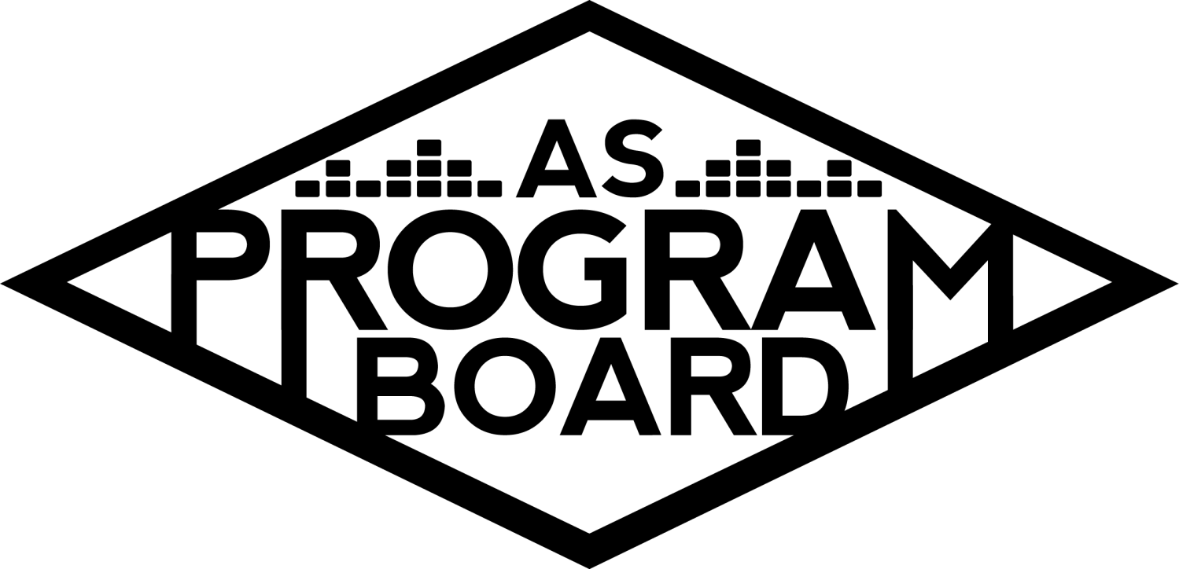
Program Board Agenda

Associated Students

September 28th, 2020
Remote

CALL TO ORDER: 3:07 PM by Kathryn Quinones
A. MEETING BUSINESS
- Roll Call
Name | Note:  absent (excused/not excused)  arrived late (time)  departed early (time)  proxy (full name) | Name | Note:  absent (excused/not excused)  arrived late (time)  departed early (time)  proxy (full name)
Adam Salton
Alexis Xa |  | Kathryn Quinones
Celine Liu |  | Lucas Jackson
Emily Duong |  | Olivia Aboagye | absent
Emily Kocis |  | Sophia Castro
Enaiya Judkins |  | Sophie Sharma
Gabriel Reyes |  | Hayley Slater | absent
Halle Dawite |  | Bee Schaefer | absent
Jake Einsiedl

Acceptance of excused absences, absences, early departure and proxies
Motion by Gabe, second by Alexis. Consent with 12 present.

B. PUBLIC FORUM

C. ACCEPTANCE of AGENDA/CHANGES to AGENDA
Motion by Sophie, second by Adam. Motion to accept the agenda. Consent with 12 present.

D.ACCEPTANCE of ACTION SUMMARY/MINUTES

E. ANNOUNCEMENTS
- Land Acknowledgement
- Check In: If you had to teach a class on one thing, what would you teach?
- Send small bios & pics to Sophie!
- Weekly meetings every Monday at 5 pm

F. WEEK IN REVIEW

G. PREVIEW OF THE WEEK
- Welcome Back 10/03
  - Waiting on graphic to be approved
  - Thanks Pub for bios
  - Q and A is ready to go
  - We all need to register
  - BE THERE ON SATURDAY @ 9PM
  - Post something without the artist graphic to get the word out there
  - We need mods for the chat (Gabe, Halle, Kat) and the conversation (Alexis and Jake)
  - 5000 person cap
  - Announce at 12pm tomorrow with the artist approved photo if not with the graphic
    - Maybe send it out to the Listserve?
    - Also put it on Shoreline
  - Maybe deliver a sweatshirt to Artist K for them to wear on stream?
    - Do it for the bookstore to send out tomorrow
  - First show so be excited but it sets the tone so be on your A+ game!!!!!!!
  - Sending graphic in the Slack

H. OLD BUSINESS
- Cultural Event - Artist A 10/06
  - Second offer is out for 20k but they are asking for more time
  - Hoping for an answer by end of day
  - 7pm 45min moderated conversation and 15 min Q and A from zoom or social media
  - Good event to test out student engagement
    - Maybe 3 pre selected students do the rapid fire questions at the end of the zoom but will look into it
- Hub Show 10/08
  - Waiting on Artist B graphic to be approved
  - Starting pub on 10/2
  - Looking for moderators (Sophie and Gabe) monitoring chat (Enaiya and Sophia)
  - Starts at 8pm with 30 min acoustic set and 20 min Q and A
- Delirium 10/30
  - Booked Artist C on 8/2 but the artist now has a scheduling conflict so now using that artist for a separate event
  - Looking into new artist for this event
  - One big artist or multiple smaller artists?
    - One big artist
  - Always keep controversies in mind for artists we book
  - Budget was 50k total 40k for talent 1 and 10k for talent 2
  - Depending on artist might increase budget
- Delirium 10/31
  - Thanks for the good email correspondence about Artist M
  - Artist D as contingency?
  - Book ends with R&B?
  - Separate budget for giveaway
  - 3 or 2 musical acts?
    - Hitting different genres can bring in different crowds for a longer amount of time
    - Youtuber opener?
    - Laid back artist would be best for the after party artist or an EDM artist
- Care Packages
  - Looking into pint glasses and other goodies

I. NEW BUSINESS
- Spotify Playlists
  - 2 rotations of playlists 1 of solely board suggestions and the next would include other student suggestions
  - They will be themed
  - New theme every week
- Hub Show 11/12
  - Artist E
    - Artist E would cater to the underlying R&B fanbase
    - Could help students destress
    - Could cater to the same crowd that UMI did
    - Could be easier to pair with an activity
    - Has been asked for a lot low key
  - Artist F
    - Groovy enough for a hub show
    - Recently released an album
    - Great rapper and can do a variety of song styles
  - Artist G
    - Highest numbers on spotify
    - Tiktok
    - Could be a better spring show

J. ACTION ITEMS

K. FINANCIAL ACTION ITEMS
- Reaffirming Email Votes
  - Motion to reaffirm 6/25 motion to pass $12,500 for a 5,000 capacity Zoom License for the 2020-2021 school year. Motioned by Gabe Reyes , Seconded By Lucas Jackson .
  - Motion to reaffirm 7/20 motion to pass Artist H for the Hub show on 10/08/2020 starting at $9k and ending at $12k. Motioned by Jake, Seconded By Adam.
  - Motion to reaffirm 7/20 motion to pass Artist B as contingency for the Hub show on 10/08/2020 starting at $9k and ending at $12k. Motioned by Jake, Seconded By Lucas.
  - Motion to reaffirm 7/20 motion to pass Artist C as headliner for Delirium 10/30/2020 starting at $37k and ending at $50k.Motioned by Sophia, Seconded By Gabe .
  - Motion to reaffirm 7/20 motion to pass Artist I as contingency for Delirium 10/30/2020 starting at $30k and ending at $50k. Motioned by Gabe , Seconded By Sophie .
  - Motion to reaffirm 8/9 motion to pass Artist J as headliner for Welcome Back on 10/03/2020 starting at 10k and ending at 15k.Motioned by Alexis, Seconded By Sophie.
  - Motion to reaffirm 9/11 motion to pass Artist K as headliner for Welcome Back on 10/03/2020 starting at 20k and ending at 25k.Motioned by Alexis, Seconded By Lucas.
  - Motion to reaffirm 9/11 motion to pass Artist A for 10/6/2020 starting at $18k and ending at $20k .Motioned by Gabe, Seconded By Alexis.
  - Motion to reaffirm 9/11 motion to pass Artist L as contingency for Welcome Back on 10/03/2020 starting at 25k and ending at 30k. Motioned by Alexis, Seconded By Gabe.
  - Motion to reaffirm 9/23 motion to pass Artist M as headliner for Delirium on 10/31/2020 starting at $25k and ending at $45k. Motioned by Sophia, Seconded By Gabe.

L. REPORT
Facebook Factory / Tuesday Slide / Thursday Ad
- Free & For Sale post

Kudos

The Marilyn Report

The Kris Report. Thanks everyone for the signatures!!

Commissioner's Report .
Thank you for being attentive.
Deputy Commissioner’s Report . Great first meeting everyone!

Coordinators’ Reports
Adam- Sorry for missing retreat but working on cool stuff for zoom
Alexis- thanks everyone for the discussions!!
Celine- Thanks for heads up for graphics stuff
Enaiya- l excited to pub events
Gabe- Thanks for bearing with me for everything that happened during the meeting and working on other great stuff for community
Jake- thanks to everyone for working on his events
Sophie-we’re all champs

Assistants’ Reports
Emily D- excited
Emily K- excited for everything
Halle- take care of yourselves self care
Olivia-
Sophia- shout out to pub and be ready for ambassadors announcements

Senator’s Reports
Bee-
Hayley-

ADJOURNMENT: 5:13 PM by Kathryn Quinones

Artists mentioned: NIKI, Chloe x Halle, IDK, Ramy Youssef, Flo Milli, Raveena, Dayglow, Cautious Clay, beabadoobee, Whethan, John Mulaney, Issa Rae, Jack Harlow

