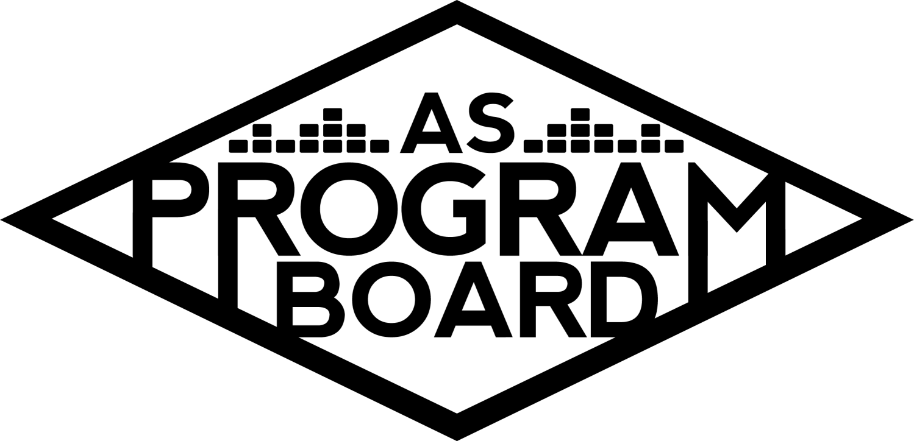
Program Board Agenda

Associated Students
June 1, 2020
Remote

CALL TO ORDER: 5:08 by Kiyomi Morrison

LAND ACKNOWLEDGEMENT

A. MEETING BUSINESS
- Roll Call
Name | Vote:  absent (excused/not excused)  arrived late (time)  departed early (time)  proxy (full name) | Name | Note:  absent (excused/not excused)  arrived late (time)  departed early (time)  proxy (full name)
Adam Salton
Alexis Xa |  | Kathryn Quinones
Bethel Tammerat |  | Kiyomi Morrison
Brenna Collins | Absent | Lucas Jackson
Brett Friedman |  | Mikio Sacramento
Carlos Aviles-Sullivan |  | Mitchell Lewis
Conner Jones |  | Nathaly Pacheco
Enaiya Judkins |  | Sarah Danielzadeh
Erica Ko |  | Benjamin Chocron
Esteban Alvarado
Gabriel Reyes

Acceptance of excused absences, absences, early departure and proxies
Motion by Nathaly, second by Gabe. Consent with 17 present.

B. PUBLIC FORUM

C. ACCEPTANCE of AGENDA/CHANGES to AGENDA
Motion by Mitchell, second by Adam. Consent with 17 present .

D.ACCEPTANCE of ACTION SUMMARY/MINUTES
Motion by Gabe, second by Esteban. Consent with 17 present .

E. ANNOUNCEMENTS
- OUR LAST MEETING!
  - New Board will meet after us at 6PM
- AS Awards Banquet - AFTER MEETING AT 7PM
  - RSVP!
  - Member of the Year will be announced!!
- Transition Dinner - 5/5 @ 6PM
  - 6PM-7PM Old Board
  - 7PM-8PM Old Board AND New Board
- Pick up stuff at the Office this week
- Transitioning information
  - Please meet with the new person in your position and transfer email/slack accounts by this Thursday(5/4)
    - If you have remaining work and need access longer let me know
    - Will be sending out everyone’s contact info soon after
    - May be more helpful to do this over the phone because of verifications
  - Checks
    - Taking more than 2 weeks to get sent out, looks like the process will take a while
- Thank You All

F. WEEK IN REVIEW
- David Dobrik - 5/19
  - One of the largest events in terms of numbers on socials and attendees
  - Confirmed right before, short turnover period
  - Approved ~1300 people with 1000 person capacity
  - Received ~400 questions from students
  - Manager was letting other people use his email to get on so there was an issue with David joining the Zoom right before the event
  - Got an email back from their team that they thought the event went really well
  - Wish we could have had higher capacity and capability to get students more engaged
  - Going forward, we are only able to show ourselves
  - Recording
    - David’s team wanted to record and it’s on the agent to record- they need to be on the call as well
    - Figured out the day of how to record
    - If you need to know more about recording, can talk to Gabe
- SadGirl - 5/20
  - First event with a band/group not just one person
  - They did a live session on Instagram before our event and the sound was great in the practice studio
  - During our event, they went to a different venue and the sound was not great plus the internet was poor
    - Audio went in and out
  - Went from 50 people to about 18
  - Q&A went really well- Esteban moderated and Brett and Kat asked questions. Students seemed to enjoy it
    - Over under questions were a good way to open up fun conversations
  - People were excited that we kept our promise to bring them
- Noon Storke Show: Juniper - 5/21
  - 289 total people and it was a later afternoon show
- Ari Aster - 5/27
  - Confirmed at $15k
  - Kiyomi and Esteban went through student questions- ~50
  - Everything went well with run through before the event
  - Looked like there were about 314 attendees
  - People in the chat were pretty nice compared to other events, but Erica and others moderated and added questions onto the google doc
  - Good to go between live questions and pre-submitted questions
    - Be careful with what live questions you pick from
      - Need room for guest to answer
- Noon Storke Show: Squirrel Flower - 5/28
  - Wifi cut stream halfway through so they have to restart
  - Singing was quiet so it would be good to remind people that they need to have loud locals

G. PREVIEW OF THE WEEK
- Artist A - 6/5
  - Still waiting to hear back
  - Insta will have to be turned private the day of the show
  - 5 posts throughout the day, 30 min performance, 15 min Q&A
  - Industry-wide blackout tomorrow- do we want to change sentiment
    - Could be weird to ask her to turn it into that kind of event in case it isn’t done well
  - Should we still do the event given the current climate?
    - We shouldn’t do anything unless we say something or make a statement first
    - Could be a good moment of levity but need to communicate with her
    - Feels like we can’t focus on anything else right now- maybe inappropriate to host an event right now
    - Offer may have technically expired today so we may be able to use that
    - She graduated college recently so may want to say something to college students?
      - Don’t think we’re prepared to handle this with the care it needs
    - There are ways to do it right- could make it a collaboration with BSU
    - She’s been active on social media about this
    - Would she even agree to do it?
      - Tweeting is different than vocally discussing your thoughts
    - Giving Black students a voice in general could be good but is she the person we want as a spokesperson?

H. OLD BUSINESS

I. NEW BUSINESS
- BLM / George Floyd
  - How do we as an org want to respond to this?
  - Media blackout that a lot of groups are participating in tomorrow
  - Want to avoid performative action but respond the best way that we can
  - If we make a post, it will need to be worded carefully and approved by all
  - Open discussion:
    - Important for us to make a statement because we book artists of color and profit off of these events
    - Crucial to mention and support other resources
    - Could we redirect funds to donate to a group?
      - We aren’t allowed to donate to outside groups- student fees
      - AS fund?
        - COVID-19 task fund?
      - Would be better to put funds to a good use instead of just making an empty statement
    - Candlelight vigil? Could put on an event to commemorate these events and have students voices heard
      - Zoom/In person? Could we hand out masks
        - Live stream might seem impersonal but there are COVID worries
        - Unsure if we can even do anything in person?
          - May not be able to have it
          - Livestream would be the easier way to do it
      - Pardall boards for shooting
      - MCC is putting on an event Thursday evening
        - Could we sponsor other places and support other orgs?
    - Think we should participate in blackout tomorrow and maybe make a post about it?
    - Can compile resources
    - Informal meeting tomorrow?
  - Budget
    - Gabe can make a budget for an event
  - We need to reach out to BSU/center other voices before making any decisions.

J. ACTION ITEMS

K. FINANCIAL ACTION ITEMS
- BLM Event
  - Motion to pass $350 for BLM event (name subject to change) for this week.
    - Motion by Brett, second by Nathaly. Consent with 17 present.

L. REPORT
Facebook Factory / Tuesday Slide / Thursday Ad
- Free & For Sale post

Kudos
Gabe for making others' voices heard. Kiyomi for helping with Esteban’s event. Esteban’s event! Everyone on the hiring committee, it’s awesome to see the new faces. Everyone for doing a fantastic job!! Everyone that showed up to protest.

The Marilyn Report
Will be in the office Friday- if you need your gift card mailed tell her by TONIGHT. Congrats on a great year and for such a quick transition!!

The Kris Report.
Playing around with a new platform- performing platform for artists.

Commissioner's Report .
So proud of all the work!! You are all amazing.

Deputy Commissioner’s Report .
Lovely working with all of you and great to see all the new faces. Willing to help with public statement.

Coordinators’ Reports
Adam- Working on visual stuff. Grateful to have ASPB as another group to be a part of
Brett- We killed it this year!
Carlos- Congrats to new board
Conner- Didn’t expect this experience and wouldn’t change anything about it. Excited to see ambassadors on new board.
Erica- tears
Esteban- Thank you all for becoming such a big part of my life and MD for believing in me 3 years ago. We broke the mold!
Gabriel- It’s been great to make all of these relationships and see people grow.
Mitchell- Learned so much from everyone. Congrats to new board.
Nathaly- So proud of how far board has come and so excited for new board! You have a huge platform.

Assistants’ Reports
Alexis- So grateful to everyone on board especially MD and Kris. Hope everything is taking care of themselves and getting educated.
Brenna-
Enaiya- Had a great year and looking forward to more! Shoutout to Kris for pretending to ignore all the crazy stuff Enaiya says. Check on your Black friends.
Kathryn- So proud of everyone and everything we’ve done. MD and Kris are the best!
Lucas- SPEECH on friday. No other group he’d rather work with.
Mikio- Board is a family. Here for all of it! (well not office hours but)!!

Senator’s Reports
Benjy- Great to be a part of the group and loved learning from everyone. Can’t wait to see where everyone goes and how new board does next year
Sarah- So cool to see how innovative everyone got!

Receptionist’s Report
Kiera- I won’t be able to attend all of transition dinner so I just wanted to say thank you for an incredible year. I’ve been a receptionist for 3 different boards and this year was so special- you all made me feel so included. Thank you to all of you for being so welcoming and kind and for making me SO excited to be in the office every day. I never expected ASPB to become such an amazing part of my experience at UCSB and I’m really going to miss you all! This really is one of my hardest goodbyes in college thanks to you all.
Also if you need me to scan anything lmk I’ll send my personal email xoxo

ADJOURNMENT: by Kiyomi Morrison.

