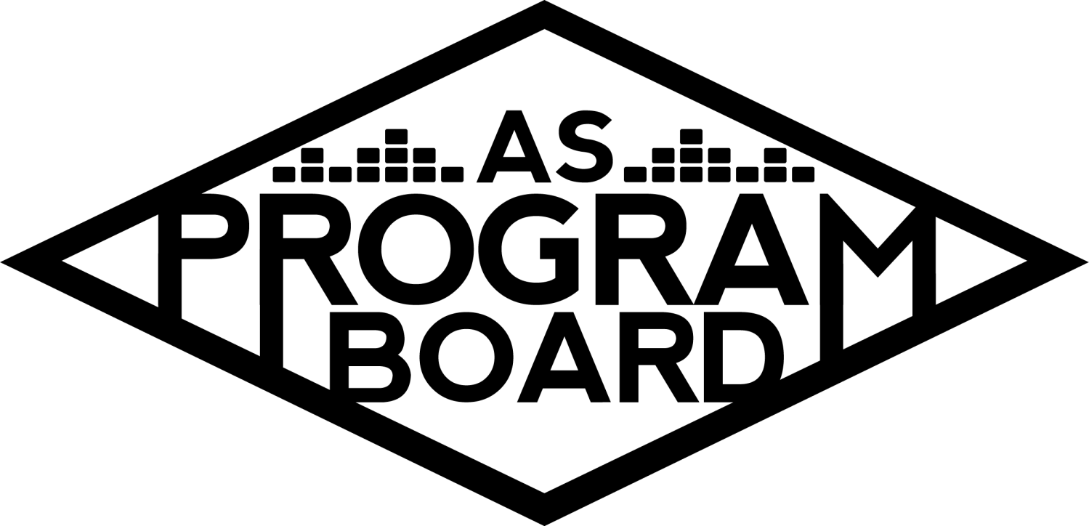
Program Board Agenda

Associated Students
June 1st, 2020
Remote

CALL TO ORDER: 6:33PM by Kathryn Quinones
A. MEETING BUSINESS
- Roll Call
Name | Note:  absent (excused/not excused)  arrived late (time)  departed early (time)  proxy (full name) | Name | Note:  absent (excused/not excused)  arrived late (time)  departed early (time)  proxy (full name)
Adam Salton
Alexis Xa |  | Kathryn Quinones
Celine Liu |  | Lucas Jackson
Danielle Smith |  | Olivia Aboagye
Emily Duong |  | Sophia Castro
Enaiya Judkins |  | Sophie Sharma
Gabriel Reyes |  | Hayley Slater
Halle Dawite |  | Bee Schaefer | Absent
Jake Einsiedl
Kassandra Ni

Acceptance of excused absences, absences, early departure and proxies
Motion by Gabe, second by Lucas. Consent with 15 present.

B. PUBLIC FORUM

C. ACCEPTANCE of AGENDA/CHANGES to AGENDA
Motion by Adam, second by Gabe. Consent with 15 present .

D.ACCEPTANCE of ACTION SUMMARY/MINUTES
No previous minutes

E. ANNOUNCEMENTS
- Land Acknowledgement
- Introductions: Name, Year, Major, Fav Song Right Now
- Robert’s Rules of Order
- Zoom Etiquette
  - Keep your mic off when you aren’t speaking
  - Can use the chat to bring up points
  - Raise hands- use this for votes
    - Go to “participants” and you can press “raise hand” from there
  - No hate speech or discrimination tolerated
- Email Votes
  - Will be doing these until we have full board meetings again in the fall
- Applications for Summer Board!
  - Priority goes to those taking classes, but still apply in case they don’t get filled up
- Groupme, Contacts, & Slack
  - Keep an eye on all these modes of communications
- AS Awards moved to June 22nd time TBA

F. WEEK IN REVIEW

G. PREVIEW OF THE WEEK

H. OLD BUSINESS

I. NEW BUSINESS
- Summer Board 6/22-9/12
  - Put on various events for people that will be at UCSB over the summer
  - Increase budget for programming?
    - Unofficial vote:
      - Y: 0 N: 15 A: 0
  - Need to decide if we want to have fewer more expensive events or more smaller ones
  - Money goes back into overall budget, so if we don’t use it for this we can use it for other things
  - Will adjust amount for posters
- Film Event 9/30
  - Lagoon Lawn film during welcome week- targeted at first years
  - Won’t be having this event in person
  - Instead, can have a virtual event with someone in the film industry
    - “Back to school with ___”
  - Could look into making shirts/materials
    - $200 allotted right now- is that enough?
- Welcome Back 10/03
  - Alternative programming for first weekend back to school
  - More than 3,000 people attended last year
  - Posters: hybrid quarter for fall- expect September
    - We could poster on campus, but unsure how many students could be on campus
  - Planning on everything large being virtual for Fall
  - Online ads- social media/other online sources
- Cultural Event 10/06
  - Week after welcome week
  - Passing blanket budget for a possible speaker
    - Focusing on current political climate
  - Do we need openers?
    - May not be as necessary for online shows
    - Expose students to up and coming artists
- Hub Show 10/08
  - Can provide materials via give-away
  - Can focus on interactive events to increase student participation
  - Pub has an overall budget but can also pass things for individual things
- Delirium 10/30 & 10/31
  - Increase budget?
- Storke Shows
  - Afternoon shows during the week by Storke tower
  - On Instagram live since campus shutdown- will continue them online for fall
  - Could focus on getting some bigger names
    - Clairo last year
  - Give away items?
    - Can’t do yerba and kind bars anymore
  - Could look into getting out own cameras too
  - Could these happen in person??
    - Possibly if campus is open- but assume it's all online
- Summer Merch
  - Lowered amount of stickers and pop sockets because we have a lot left
  - Everyone can send in suggestions/designs for stickers
  - MD has looked into stuffed mapaches, has a quote for the Fall
  - Possibly looking into other colors for the phone wallets? Blue, teal, grey, earth tones?
  - Jake knows a recent grad making masks out of LA
  - Lucas will make a separate budget for items such as masks and hand sanitizer
  - Board leaning towards spending less on the current things we have and spending more on other items (masks, hand sanitizer, mapaches)
  - Adding money for stuffed animals
- Publicity Budget
  - Mojo app- can make fun insta stories that we don't need to go through graphics to get
    - $40/yr
    - Can add videos unlike canva
    - Link is in first email sent
  - Numbers in budget are slightly arbitrary but will be adjusted

J. ACTION ITEMS

K. FINANCIAL ACTION ITEMS
- Summer Board 6/22-9/12
  - Motion to pass $60,000 for the summer 2020 board from 6/22-9/12.
    - Motion by Gabe, second by Alexis. Consent with 15 present.
- Film Event 9/30
  - Motion to pass $25,300 for the Lagoon event for 9/30.
    - Motion by Kassandra, second by Sophie. Consent with 15 present.
- Welcome Back 10/03
  - Motion to pass $30,050 for welcome back on October 3rd.
    - Motion by Alexis, second by Sophia. Consent with 15 present.
- Cultural Event 10/06
  - Motion to pass Cultural Event for 10/6/2020 for $20,200.
    - Motion by Gabe, second by Kassandra. Consent with 15 present.
- Hub Show 10/08
  - Motion to pass $12,400 for the Hub show on 10/8.
    - Motion by Jake, second by Gabe. Consent with 15 present.
- Delirium 10/30 & 10/31
  - Motion to pass $136,050 for Delirium on 10/30 and 10/31.
    - Motion by Alexis, second by Gabe. Consent with 15 present.
- Storke Shows
  - Motion to pass $12,200 for Storke shoes for the 2020-2021 school year.
    - Motion by Alexis, second by Lucas. Consent with 15 present.
- Summer Merch
  - Motion to pass $1,455 for summer merch for 20-21 school year.
    - Motion by Lucas, second by Sophie. Consent with 15 present.
- Publicity Budget
  - Motion to pass $2,355 for the fall 2020 publicity budget.
    - Motion by Enaiya, second by Halle. Consent with 15 present.

L. REPORT
Facebook Factory / Tuesday Slide / Thursday Ad
- Free & For Sale post

Kudos
Kat for running her first meeting well!! All the people that did budgets for the first time. You'll get the hang of it! Halle for listening to Enaiya for 4 hours (poor Halle). Olivia for chatting today when she had a big test! Everyone for creative ideas! Everyone for making it on board!!

The Marilyn Report
Congrats to everyone for your first meeting! (They don't ways go this long). Have a good summer if I don't see you!

The Kris Report.
Welcome to ASPB! Congrats, looking forward to working with everyone.

Commissioner's Report .
Very excited to work with you all! Thank you for offering your opinions.

Deputy Commissioner’s Report .
Excited to work with everybody! Liking the ideas and creativity.

Coordinators’ Reports
Adam- Excited to work with everyone! Production is different now but we're excited. Looking at YouTube private Livestreams.
Alexis- Congrats for making it on board! Let her know if you have artist suggestions!
Celine- Excited to work with everyone and make cool graphics.
Enaiya- Congrats for getting hired! Excited to work with everyone especially graphics and digital media because we work closely together. Will be reaching out soon.
Gabe- Congrats! A lot of ideas and please send him more! Stay educated on what's going on right now.
Jake- Thanks for all the help, excited to work with everyone! Send artists recommendations.
Kassandra- Excited to see how the year unfolds!
Sophie- Happy to be here! Will probably reach out for one on one zooms after finals.

Assistants’ Reports
Danielle- Excited to get to know everyone better! Everyone did a great job with the transition to online!
Emily- Look forward to working with everyone and using zoom!
Halle- Excited to be here! Shout-out to Enaiya our queen. And shout-out to Gabe for the land acknowledgement!
Olivia- Grateful to be here!
Sophia- Excited to get to know everyone. We're in a unique situation with lots of good stuff to come!

Senator’s Reports
Bee-
Hayley- Thanks for letting me join! Honoraria closes tomorrow at noon. Thanks for adding new resolution! Next meeting is Wednesday and I encourage you to join.

ADJOURNMENT: 9:06PM by Kathryn Quinones

Artists mentioned:

