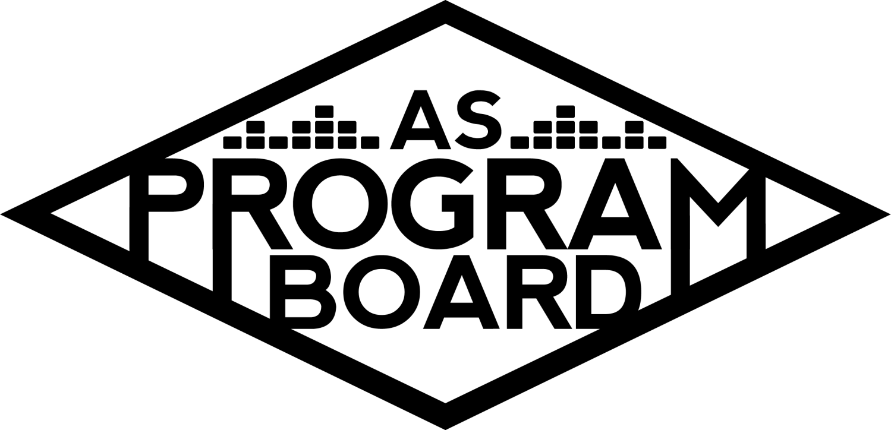

Program Board Agenda

## Associated Students

May 18th, 2020

Remote

**CALL TO ORDER: 5:01PM by Kiyomi Morrison**

**A. MEETING BUSINESS**

1. **Roll Call**

|  |  |  |  |
| --- | --- | --- | --- |
| **Name** | **Vote:**  absent (excused/not excused)  arrived late (time)  departed early (time)  proxy (full name) | **Name** | **Note:**  absent (excused/not excused)  arrived late (time)  departed early (time)  proxy (full name) |
| Adam Salton |  |  |  |
| Alexis Xa |  | Kathryn Quinones |  |
| Bethel Tammerat |  | Kiyomi Morrison |  |
| Brenna Collins |  | Lucas Jackson |  |
| Brett Friedman |  | Mikio Sacramento |  |
| Carlos Aviles-Sullivan |  | Mitchell Lewis |  |
| Conner Jones |  | Nathaly Pacheco |  |
| Enaiya Judkins |  | Sarah Danielzadeh |  |
| Erica Ko |  | Benjamin Chocron | Absent |
| Esteban Alvarado |  |  |  |
| Gabriel Reyes |  |  |  |
|  |  |  |  |

**Acceptance of excused absences, absences, early departure and proxies**

Motion by Bethel, second by Carlos. Consent with 17 present.

**B. PUBLIC FORUM**

**C. ACCEPTANCE of AGENDA/CHANGES to AGENDA**

Motion by Gabe, second by Bethel. Consent with 17 present .

**D.ACCEPTANCE of ACTION SUMMARY/MINUTES**

Motion by Brett, second by Gabe. Consent with 17 present .

**E. ANNOUNCEMENTS**

1. No meeting next week! (Memorial Day)
2. Transition Meeting on 6/1 at 5PM
3. As Awards Virtual Ceremony 6/1 @ 7PM
   1. RSVP HERE: <https://forms.gle/Qp6fhMuyqpRNBJTX7>
   2. Send photos if you have them!

**F. WEEK IN REVIEW**

1. Channel Tres - 5/13
   1. Channel’s team joined a Zoom call about 1.5 hours before to check audio and visuals
      1. Think audio will be a challenge going forward and the hour helped
   2. Agent came in with camera and mic on when students were joining in the beginning
   3. Had issues with camera until Kiyomi joined and fixed it
   4. MD was having wifi issues- may need to make more people co-hosts
   5. Pub- maybe we could post daily about the events that we have and then we delete them after so more people see our events and attend them
      1. Could consider doing ads
2. Storke show: Art Official - 5/14
   1. Biggest turnout so far- 215 total viewers
   2. Had some issues with sound quality on Insta- better during practices than live show
      1. Did a test run on their instagram
      2. Quality could be different after posting
3. Steve Aoki - 5/17
   1. We expected it to do better than it did- FB page had similar numbers as Lil Yachty but the ratio of interested:going was different
   2. Steve Aoki numbers—Registered 694. unique viewers-410. Max Concurrent views-260.
   3. Could be cool to have openers for music livestreams
   4. Also, timing with classes may not have been great
   5. Can choose to send a notification an hour before the event, but so many people register at the last minute so it may not be helpful
   6. Can be more clear about where comments go- panelists/general chat
   7. In the future, want to figure out a way to set up a waiting screen while people filter in at the beginning

**G. PREVIEW OF THE WEEK**

1. David Dobrik - 5/19
   1. Everything is set, we’re just waiting for the registration link to be posted- probably want to post tonight
   2. Nat and Gabe will be asking questions- need one more moderator if possible
   3. Test run at 1PM tomorrow
   4. Received a lot of questions- going through and picking out which to ask
   5. Combining live questions with prerecorded questions
   6. Can use Cal Poly questions as an example and see what didn’t work
   7. Made comments about the value of schools paying him to do livestream- should talk to agents about this beforehand- he has a huge reach with students
   8. Rating events- how do we know how successful our events really were?
      1. Post-event poll?
         1. A lot of people leave events quickly
         2. Can add these to webinars
         3. Could send emails after the event- would need to figure out what to say in email
      2. Include in newsletter?
   9. Registration- says advertised to UCSB only, not necessarily requires registration
      1. Impacts attendance- if we can avoid it for some shows it may be good but moderators will need to be more careful
      2. If you think it'll be more than 1000 people, may be helpful to have registration
         1. Registration would be delayed if we try for the 3000 person room
      3. Will help us get a better idea of what shows require larger rooms
2. SadGirl - 5/20
   1. First virtual show with more than 1 member
   2. Think sound will be the trickiest aspect
   3. 40 min set and 20 min Q&A- probably don’t have enough time to do a student Q&A and won’t have much time in general
   4. Graphic- change date on approved graphic?
   5. No registration for this event
   6. Insurance is the most difficult part of the virtual booking process so far
3. Noon Storke Show: Juniper - 5/21
   1. Second to last stroke show

**H. OLD BUSINESS**

1. Youtube Channel
   1. Posted video this morning on insta and snapchat
   2. Video is long- people aren’t watching the entire time, but we’re doing it!!
   3. Next video ready but no one ever wants to go first and that's ok
2. Artist A - 5/26
   1. Passed on the offer :(
3. Noon Storke Show: Squirrel Flower - 5/28
   1. Waiting on contract and graphic
4. Artist B - 5/29
   1. Team was interested but remix came out and prices went up
   2. We can have another event but we don’t need to
   3. Contingencies
      1. Artist C
         1. High asking price but is she super popular?
      2. Artist D
         1. Little hesitant- just did a live show and Q&A and didn’t seem like he was happy to be there and he was awkward
         2. Has a large following and price is better but video^ is concerning
         3. Could propose an activity instead of a livestream
         4. Could get bigger name for same price
      3. Artist E
         1. May be too expensive
   4. Could also look into escape room MD brought up
   5. Interest in doing the event?
      1. Majority want to do it
      2. Make sure to share events!!
         1. Same people are sharing events every time

**I. NEW BUSINESS**

1. Film event - 5/27
   1. Artist F
      1. He is available and the agent wants us to send best offer- starting at $8k
      2. Could show film- may be issue with good faith on showing movies
      3. Let Esteban know if you have any good name ideas
2. Transition- Virtual
   1. Gift Cards in lieu of banquet
      1. Comes out of office budget
      2. Could get all food from the same place but people will probably get food based on needs and preferences
      3. Purchase then get reimbursed- so people could go anywhere that has gift cards/emails
      4. People need to send where they want it from in advance
   2. Zoom Dinner on Friday 6/5?
      1. Time: ~6-7PM- whenever people can make it
3. Pub Giveaway
   1. Senate needs to approve any prizes we give away
   2. Amazon gift cards
   3. To boost engagement
   4. 1 $50 gift cards and 2 $25 gift cards

**J. ACTION ITEMS**

1. Arist B contingency
   1. Artist C vs. Artist D
      1. Artist C: 2 Artist D: 11 Abstain: 2

**K. FINANCIAL ACTION ITEMS**

1. Reaffirm email votes
   1. David Dobrik offer increase
      1. Motion to change the ending price from $15k to $20k.
         1. Motion by Gabe, second by Alexis. Consent with 17 present.
   2. Artist F
      1. Motion to pass Artist F as the talent for the film event on May 27th starting at $8k and ending at $20k.
         1. Motion by Esteban, second by Erica. Consent with 17 present.
2. Artist B contingency
   1. Motion to pass Artist C as contingency for the date of 5/29 starting at $15k and ending at $25k.
      1. Motion by Nathaly, second by Esteban.
         1. Yes: 11 No:0 Abstain: 4
3. Transition Dinner
   1. Motion to pass $525 for transition dinner on June 5th.
      1. Motion by Gabe, second by Alexis. Consent with 16 present.
4. Publicity Giveaway
   1. Motion to pass $100 for 1 $50 gift card and 2 $25 gift cards for instagram giveaway gift cards.
      1. Motion by Erica, second by Brett. Consent with 17 present.

**L. REPORT**

**Facebook Factory / Tuesday Slide / Thursday Ad**

* **Free & For Sale post**

**Kudos**

Erica for Nat for helping with David Dobrik questions. Gabe for doing DD contract. Enaiya and Brenna for staying in touch with Kat! Kiyomi for checking in with everyone. Conner for ASPB emails. Nathaly for being Gabe’s sensai. Kiyomi and bookers for helping Esteban with his first offer. Kiyomi and her BF for her hair! Nathaly for her hard work and for X. No kudos for plywood. Nathaly for being the person to go to for anything throughout the year. Hiring committee for 8am interviews. MD for doing it every week- she has to be at every show!!

**The Marilyn Report**

Don’t forget AS banquet after last meeting. Had a meeting where people were asked to share events and sent some of them care packages! Beginning of the year we talked about getting some custom mapache stuffed animals- could be good if we still virtual. Save one for MD. Maybe we could propose some budgets for giveaways at next meeting.

**The Kris Report**.

Baby is good :’)

**Commissioner's Report** .

Interviews are fun and going well!

**Deputy Commissioner’s Report** .

Last full old board meeting :( Missing class for returner interviews. Tell her where you’re ordering dinner from!!

**Coordinators’ Reports**

Adam- Doing visual work for livestreams. Willing to help with livestream production.

Brett- Excited for show this week. Has been doing a lot of interviews.

Carlos- Interviews are going well and looking forward to the rest of our events.

Conner- Will have the newsletter out tomorrow. If you pass any events late and they don’t make it on the newsletter, let him know so he can make a graphic and help pub.

Erica- Excited for pub gift cards. Please share and mark that you’re going for events.

Esteban- Working on film event, hoping to hear back soon. Interviews are tiring but cool. Interviewers are forming a CLIQUE. Don’t be scared if you’re interviewing as a returner!! Sad this is our last meeting

Gabriel- Working on DD. Erica is posting the registration link soon. Think we made the best of the current circumstances!! People are saying we are top notch (obviously).

Mitchell- If anyone needs graphics let him know. He has free time???

Nathaly- Will work on the last show. Been a great year!

**Assistants’ Reports**

Alexis- Very proud of everything that we’ve done.

Brenna- Storke shows have been fun to put on so far!

Enaiya- Making infographic of all past X’s

Kathryn- Very proud.

Lucas-Nervous for interviews. Let him know if you need help with anything

Mikio- Saving emotional speech for next meeting

**Senator’s Reports**

Benjy-

Sarah- Had a lot of fun working with you all this year. Let her know if there are any questions you want to ask senate liaison.

**ADJOURNMENT: 7:06 by Kiyomi Morrison.**

**Artists mentioned:**  Billy Porter, Megan Thee Stallion, Omar Apollo, Kehlani, Leon Bridges, Ari Aster