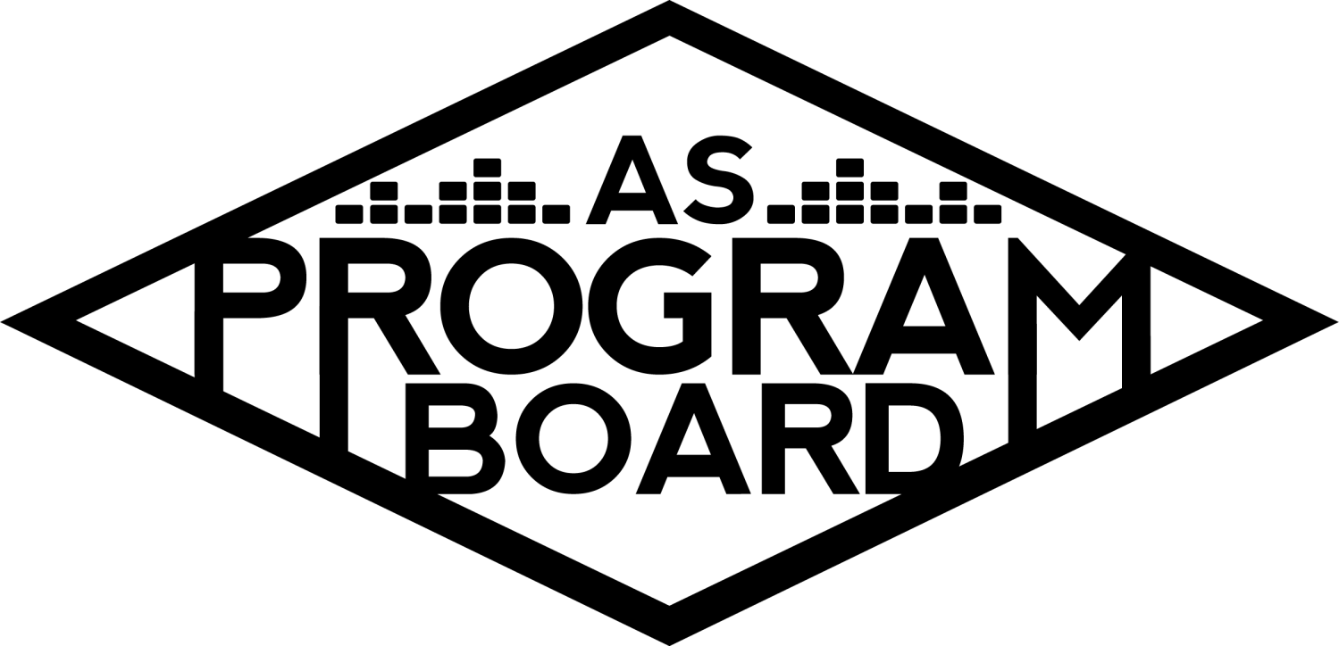
Program Board Agenda

Associated Students
May 11th, 2020
Remote

CALL TO ORDER: 5:04PM by Kiyomi Morrison
A. MEETING BUSINESS
- Roll Call
Name | Vote:  absent (excused/not excused)  arrived late (time)  departed early (time)  proxy (full name) | Name | Note:  absent (excused/not excused)  arrived late (time)  departed early (time)  proxy (full name)
Adam Salton
Alexis Xa |  | Kathryn Quinones
Bethel Tammerat |  | Kiyomi Morrison
Brenna Collins |  | Lucas Jackson
Brett Friedman |  | Mikio Sacramento
Carlos Aviles-Sullivan |  | Mitchell Lewis
Conner Jones |  | Nathaly Pacheco
Enaiya Judkins |  | Sarah Danielzadeh
Erica Ko |  | Benjamin Chocron | Absent
Esteban Alvarado
Gabriel Reyes

Acceptance of excused absences, absences, early departure and proxies
Motion by Adam, second by Carlos. Consent with 17 present.

B. PUBLIC FORUM

C. ACCEPTANCE of AGENDA/CHANGES to AGENDA
Motion by Carlos, second by Esteban. Consent with 17 present .

D.ACCEPTANCE of ACTION SUMMARY/MINUTES
Motion by Gabe, second by Bethel. Consent with 17 present .

E. ANNOUNCEMENTS
- CONGRATS TO KRIS FOR THE BABY!!!!
  - YAY BABY HARLOW IS HERE!!!!
    - YAY!!!!!
- Holy Interviews
  - People on the hiring committee will be busy (especially MD!)
  - Kiera will be emailing returners soon!!
- Position Guides
  - Turned out good! Erica did it up
  - Notes for some people to add things throughout the year
- Remote Summer Session
  - Campus announced that all of summer session will be remote- will work with new board on this
- Req Forms - Event numbers available on the drive
  - Will put in Slack
  - Need to download form, fill it out, then send it to different authorized signers
    - Make sure to read the instructions carefully

F. WEEK IN REVIEW
- 3NGHTMRE - 5/5
  - Show went well, visuals and sound turned out better than expected and better than trials
  - Students that attended seemed to have a good time- talked a lot in the chat
  - Could have pubbed it more
  - 176 registered, 234 total users
    - Agreed not to do registrations but it ended up asking for registrations
- Noon Storke Show: Grant Chesin - 5/7
  - 180 total viewers!
  - Easy to set up and went as well as others
  - Audio cut out at end- think it was a connection issue on his end- made ending a little awkward but was a really fun show
  - Did a short intro
    - Could add a closing next time as well
- Lil Yachty - 5/8
  - Overall, show was a success
  - Seemed to answer multiple questions in one story- moderators were good at finding new questions from the chat
  - Some questions were awkward but the list of questions was sent before and no one said anything about them
  - A lot of students tagged us in painting photos
  - Stressful because contract was finished 20 minutes before we went live
  - He was late to call time but went the entire 60 minutes
  - Students were complaining about questions, but most of the questions were sent in by students
    - Some people asked the same questions
  - Registration issue- released link morning of and announced that people could only register until 6PM because MD had to register them individually. Originally ~10% were not using correct emails
    - Could we post a screen recording of how to register the email?
  - Couldn’t get link out in advance because the contract was late- issues on both ends with agreeing on contract
  - And had issues on agreeing on recording the event
  - A lot of positive comments!!
  - Moderators didn’t know they weren’t on the screen too- in the future it might be better to do gridview
    - Can change how many panelists are on the screen by having some mute and turn off their cameras then using spotlight view
  - 1137 registered, 872 unique names, 1027 logins
    - Reflected FB numbers well too
  - Can say student names before questions to lessen criticism from students
  - Ran out of questions?- we didn’t run out but a comment about student questions made it seem like we hadn’t been asking student questions
    - Had 25-30 questions
    - In the future, should probably prepare more questions

G. PREVIEW OF THE WEEK
- Live & On the Rise: Channel Tres - 5/13 8PM
  - Finishing up contract now
  - Will be announced at 6PM today- make sure to share
  - One hour long unregistered event
  - Confirmed name: Live & On the Rise
  - Could structure like NGHTMRE and have a set with a few questions at the end
  - Got emails from those who are not UCSB affiliated and sent them to MD- can add them as panelists
  - Brett will be introducing and moderating chat
    - Moderating the chat?
      - This is a good time to write a guide on moderating the chats
      - You get made a co-host and can access tools to kick people out
      - Could be good to post rules beforehand- conditions on which you will get kicked out of the event
      - Can change whether participants can see the Q&A questions or not
  - Should try to announce sooner if possible
- Noon Storke Show:Artificial - 5/14
  - Still waiting on W9 and graphic
- Artist A - 5/15
  - Offer was sent out on Friday with likely confirmation but she has been getting offers for higher amounts of money
  - Want to give everyone a break this week- can look at other options next week
  - Planned on posting 5 posts, then doing 30 minute performance and 15 minute Q&A but wanted $50k
    - Have confirmed other artists for a lot less
    - Want agents to think we are sticking to our range of $10-30k

H. OLD BUSINESS
- Youtube Channel
  - Coffee video and cooking video have been uploaded but not posted on socials yet
  - Have 4 videos ready and can post 2 per week
- Artist B - 5/17
  - Confirmed an hour ago!
  - Show will be at 6 or 7PM
  - 3000 capacity zoom with 50 minute live dj set and 25 minute moderated Q&A
    - Set first then Q&A
  - Want to announce Wednesday but we do need a graphic
    - Could use X graphics as base for graphics for this event
  - Name of event?
    - Virtual X?
      - We had a lot of talent planned and people may be disappointed
        - Could make a comment about nothing being able to replace X but that were offering a different event in its place
    - Calling it something separate may be better
      - Names?
        - Could use a play on X- Xtraordinary
- Artist C - 5/19
  - Sent offer on Friday and they responded that they wanted more $
  - Sending out second offer
  - Erica had some ideas for pub- using feature on zoom that we can preselect students to join the zoom call and ask him questions
    - Could have them sign an informal agreement with the rules of what they can and cannot say/do on the call
      - Tell them if they deviate from their question they get kicked out
      - And banned from future ASPB events
- Noon Storke Show: Juniper - 5/21
  - Cute band based in Boston
- Live & On The Rise
  - Sad Girl - 5/21
    - In contact with new agent- still performing for original price but want to move it to 5/20, 8PM
      - Too early to book with IT? Think we already have a 1k room booked
      - If we change the date, do we have to make a new offer?
        - You could just put it in writing separately
    - Asking to do 40 minute set and Q&A
    - Getting info to pub to announce early would be good
- Artist D - 5/26
  - Sent out offer and still waiting to hear back
  - Brought up the issue of insurance
- Noon Storke Show: Squirrel Flower - 5/28
  - Has a pretty decent following
- Artist E - 5/29
  - Sent first offer on Friday and agent is pushing to make it happen
  - Don’t think they’ll take the first offer, but waiting to hear back

I. NEW BUSINESS
- Film event - 5/27
  - Trying to find someone in film industry to do a Q&A
  - Looking at Artist F or Artist G
  - Budget starting at $15k and ending at $20k
  - Need to start wrapping up offers- end of the week
- Remote in Fall? - not filling all positions
  - Thinking UCSB may be online for Fall
  - Board for next year will need to think about this
  - Need to think about positions we need to fill if we are going remote
  - Live events probably won’t resume until 2021 year- should we leave some positions unfilled that we don’t have jobs for?
  - Hiring committee can see if there is someone really good who can be slotted in somewhere
  - Could have someone help pub instead of have an in-person position because only having 2 people right now is hard
  - Has to go through AS Legal Code as well
  - Need to focus on skill sets too- can’t hire someone who’s good at graphics for production
  - It wouldn’t be easy to add a new position- takes a few weeks
  - Production, event safety, volunteers, and tickets- jobs that will be difficult to find work for
    - Production can help out with livestream logistics and help out with podcast and videos
  - Will make it harder to select people during hiring too
  - Can consider what positions applicants prefer but can also put them in different slots
- Transition
  - Happening later
    - Hiring during the next 2 weeks
    - Want to have everyone hired by the 23rd
  - Transition dinner :(
    - Should we do something instead?
      - Zoom party?
        - Could be weird/sad?
      - Once everything lightens up, we can host something
      - Could have a transition/wrap-up thing and do speeches and awards ceremony
  - Last/First meeting
    - No meeting 5/25 (memorial day)
    - Will be having a meeting June 1
    - Old board has a quick meeting then it transfers over to new board
  - Training your new positions
    - Want to have everyone “meet” with their successors

J. ACTION ITEMS
- Sad Girl date change
  - Motion to change the date for Sad Girl to perform on 5/20.
    - Motion by Brett, second by Conner. Consent with 17 present.

K. FINANCIAL ACTION ITEMS
- Film guest event - 5/27
- Motion to pass $20k on 5/27/2020 for Film Guest Event with artist TBD starting at $15k and ending at $20k.
  - Motion by Esteban, second by Brett. Consent with 17 present.

L. REPORT
Facebook Factory / Tuesday Slide / Thursday Ad
- Free & For Sale post
- Share and pub events!!
Kudos
Nat for having 2 shows last week! Hiring committee for sticking through it. MD for handling EVERYTHING right now. Mitchell for turning 21!! Brenna for the Storke shows. Everyone who sent Mitchell for the birthday wishes and Nat for the video. Youtube team for working on the videos. Kris for baby!!! Kiyomi’s leadership during this time! Kris and MD for doing other work outside of this. Thank you for everything you do! Kiyomi and Gabe for helping Esteban with his event. Kiyomi for keeping her cam and mic on for every meeting.

Should start voting on who did the theme the best each meeting? We need prizes as incentive

The Marilyn Report
Apologize for how long it’s taking to get stuff done. Working out a lot of the online kinks for this summer and next year. On a zoom call tomorrow with other programming advisors for Fall plans. Got an email from an advisor at Cornell and they were asking about Binging- they did a virtual escape room that got 800 people to attend.

The Kris Report.
Great to be back and see everyone! Good job everyone and thanks for the card!

Commissioner's Report .
Want to reiterate how proud she is of everyone. We’re doing that. Take a moment to reflect on the good job we’re doing. Did an interview with the Nexus and they were super nice!

Deputy Commissioner’s Report .
A lot of people are reaching out saying they are so impressed! Excited for Wed event. Might make a skincare routine video this week.

Coordinators’ Reports
Adam- Got rehired! Doing live event training and can give good input. DJ Salt set??
Brett- Excited for upcoming events. Great to see where we are now vs the start of the quarter.
Carlos- Enjoying hiring and hope next year can have same # of people on board.
Conner- Proud of everyone for awesome events.
Erica- Excited for upcoming events. Keep sharing.
Esteban- Excited for upcoming events. Proud of everyone! Working on new event.
Gabriel- Working with agents and sending offers
Mitchell- Excited for upcoming events. If you need graphics, keep reminding him.
Nathaly- Could do IV graphic for Artist B

Assistants’ Reports
Alexis- Excited for upcoming events. Proud of everyone! Want to send a thank you card to Rick.
Brenna- Planning Storke shows has been fun. Excited for upcoming events.
Enaiya- Excited for upcoming events. Looking forward to Artist B. Her brother kinda graduated!
Kathryn- Gotta give ourselves more credit! Shoutout Conner for newsletters.
Lucas- Everyone is doing amazing! Do school.
Mikio- Zoom backgrounds! Excited for upcoming events.

Senator’s Reports
Benjy-
Sarah- Added songs to study playlist. New senators get sworn in next week. Will be hiring new senate liaisons.

ADJOURNMENT: 6:56by Kiyomi Morrison.

Artists mentioned: Billy Porter, David Dobrik, Logan Lerman, Doja Cat, Megan Thee Stallion, Steve Aoki, Taika Waititi

