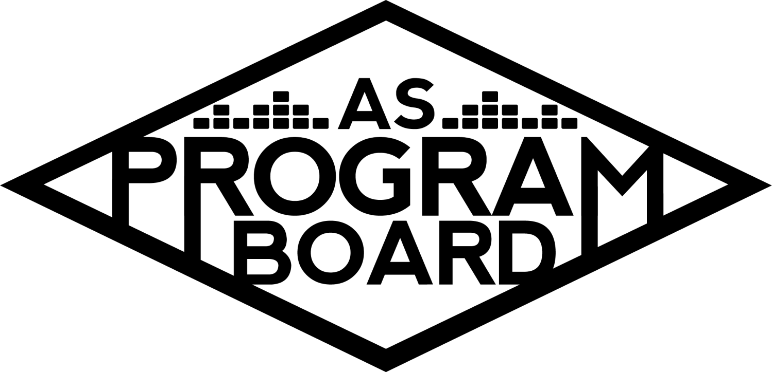
Program Board Agenda

Associated Students
May 4th, 2020
Remote

CALL TO ORDER: 5:04PM by Kiyomi Morrison
A. MEETING BUSINESS
- Roll Call
Name | Vote:  absent (excused/not excused)  arrived late (time)  departed early (time)  proxy (full name) | Name | Note:  absent (excused/not excused)  arrived late (time)  departed early (time)  proxy (full name)
Adam Salton
Alexis Xa |  | Kathryn Quinones
Bethel Tammerat | Late Arrival 7PM | Kiyomi Morrison
Brenna Collins |  | Lucas Jackson
Brett Friedman |  | Mikio Sacramento
Carlos Aviles-Sullivan |  | Mitchell Lewis
Conner Jones | Absent | Nathaly Pacheco
Enaiya Judkins |  | Sarah Danielzadeh
Erica Ko |  | Benjamin Chocron | Absent
Esteban Alvarado
Gabriel Reyes

Acceptance of excused absences, absences, early departure and proxies
Motion by Kat, second by Nathaly. Consent with 14 present.

B. PUBLIC FORUM

C. ACCEPTANCE of AGENDA/CHANGES to AGENDA
Motion by Gabe, second by Nathaly. Consent with 14 present .

D.ACCEPTANCE of ACTION SUMMARY/MINUTES
Motion by Brett, second by Lucas. Consent with 14 present.

E. ANNOUNCEMENTS
- Applications are in!
  - First interviews last week! People on hiring committee will be busy
  - 64 applications received
- Position Guides - DUE WED MAY 6 @5PM
  - Info sent out in email last week
  - Please put some time into it and make sure it’s a good guide for whoever is next
  - Put it in the drive folder attached to the email

F. WEEK IN REVIEW
- Binging with Babish LIVE - 4/28
  - First bigger livestream event
  - Went smoothly, having questions in advance was good and helped us get through it
    - Wished we had more questions on hand
  - 30 minutes longer would have been good
  - One person in the comments was saying profanities- MD has to report when this happens
    - Comment stays in the chat even after person is removed
      - Could copy large text of spaces so it moves the comment up, but they can’t be deleted
  - People from other schools were able to login
    - Allowing only UCSB students caused problems with classes here, so UCSB disabled the login for students only
    - Only way to ensure it’s only UCSB students is have registration
    - Can also tag people as guests if they don’t login through UCSB
      - Can also try using Shoreline
  - Max # of guests: 330, stayed around 200 the whole time
  - He was a great host and did a great job
  - People wanted to see the finished product- make sure the event is long enough
  - If artist wants to go over time limit, what do we do?
    - Close contact with agent and MD- text MD
    - Probably wouldn’t go over 30 extra min
  - Agent may want to be in the Zoom call during the event
- Storke Show: Delta Dagger - 4/30
  - Was similar to previous week except was full band
  - Hard to hear singer but rest of the ban sounded good
  - ~150 people attended
  - Used Storke tower image as part of background
  - In the future, can say announcements/pub during show
  - In the beginning, could go on and introduce them and APSB and make some announcements
    - Good way to stall if band is a few minutes late
  - Should start pubbing them earlier
  - Standard graphic is already made- can put different names and photos in it
    - Working on creating a lineup for future artists as well
- Eric Andre Live Stream - 4/30
  - Total: 843 people, max at one time: over 750
  - Bethel and Lucas moderated but Lucas’s computer started crashing with the high chat volume, so Gabe hopped in at the end
  - Issues with team- confirmed everything the day before the show
  - Many members of agency wanted to be on call- need to prioritize
    - Added them and changed them to guests
  - Ran out of questions pretty early- may have been helpful to have someone just looking for questions and feeding them to moderators
  - Some people asked the same question over and over or asked dumb questions
  - Questions in the beginning were compiled list of ones agent sent and ones we added
  - People seemed very excited!
  - A little awkward at points- didn’t always flow great especially after Lucas’s computer gave out
  - May be good to find some deeper questions
  - Also depends on guest to help things go smooth- some are more talkative and personable than others
  - Moderators need to be able to have conversation and flow with the guest
  - If something happens with connection, should turn off video as well to limit confusion

G. PREVIEW OF THE WEEK
- NGHTMRE - 5/5
  - Were on a call testing video and sound- had some issues with sound but was getting better towards the end- will hop on before show to make sure it’s good
  - Link is available now, but need to figure out how to let people in
    - Registration would be used to make sure it’s only UCSB students- how much time should we give to register?
    - Registration is over Zoom
    - Registration may affect attendance
    - Should try registration for next show
    - But should maybe avoid the word “register”, could say “login”
  - Shoreline
    - How many people actively use it?
  - Post registration and it could let you in right there- post registration link instead of zoom link- lets you login and see stream with that link
  - Will need to do something like this for larger artists
- Live & On the Rise - 5/6
  - Supposed to be Wed, but was given list of a lot of bigger artists with low asking prices then when offers were sent they were declined quickly- they wanted a lot more money
  - Skipping this week
  - Will send list of artists whose asking prices are more accurate
- Noon Storke Show: Grant Chesin - 5/7
  - Next two shows planned, and hoping on confirming last two shows today
  - Will be same as others except with announcements first
  - Waiting on contract
- Lil Yachty - 5/8
  - Just confirmed 20 minutes ago!!
  - Time: 7:00PM
  - Will try to register people for this event
  - Announcing tomorrow at 12, hopefully with graphic
  - Current capacity: 1000 people, may look into larger capacity options
  - From agent: “This one is going to be legendary. It’s my favorite offer ever.”
  - Brenna has been helping find info and links so pub doesn’t have to
  - Will post question box on Insta story
  - May need more help finding questions to ask during interview
  - Planned on giving artist questions beforehand so they can talk naturally and tell stories
  - People want grid view
  - Could try to have some students on the call
    - there’s a feature where you can chose someone to show their face
  - Could be good to have someone following along- may be better to have someone from board do it than random student
    - Bigger risk inviting random students on call
    - Contest to pick who can join or show final product
    - Could submit pictures live and show some on the screen

H. OLD BUSINESS
- Youtube Channel
  - Working on making channel more finished
  - Sent links to videos in chats today- will be posted this week
    - 3 videos are done, 2 are ready to post
  - Schedule: posting coffee vid W then keep up with MW, but depends on what other events we have going on that week
- Playlists
  - Enaiya wants to make a Bedroom Pop playlist
  - Might be cool to have some new playlists- can make own graphics on canva
- Extravaganza
  - Drafted announcement and will try to post this week!
- Live & On The Rise
  - Artist A - 5/13
    - Want to increase offer to start at $4k because want to confirm ASAP
    - They may ask for more anyway
    - Don’t want agents to think we will always send the amount they request from the start and want to limit use of student fees
    - $1k can make a difference
  - Artist B 5/21
    - Making sure they can still do the show and do this date
    - Been confirmed for months
    - Agent may want to reschedule
  - Thinking about adding another show-
    - (Discussion with list of artists)
    - Artist C- if we want to spend more he could be a good choice
      - Will probably only have one slot for a show- 5/27
        - Logistics for registration- will probably need to register people for this show
        - Can consider doing multi-lineup if virtual programming goes on longer
  - Smaller artists (less money) or do people want to consider a bigger artist?
    - Artist C will probably just get bigger and a lot of students want him
      - Different genre than what we have been looking at
  - Sticking with Artist A- agent thinks number is within what we already voted on
- Artist D - 5/15
  - Working on offer tonight and schedule will be sent tomorrow morning- working on Artist D, Artist E, and Artist G all now
  - Hoping to confirm by Thursday
- Artist E - 5/17
- Artist F - 5/26
  - Waiting on offer
- Artist G - 5/29
  - Would be great to culminate the year with her

I. NEW BUSINESS
- Artist H - 5/19
  - Is available and actively looking to do college shows
  - Very popular and may be bigger event than Eric Andre
  - Could do Q&A or plan an activity like other shows
    - GIANT baking?
- AS Award Nominations
  - Yearly awards- they extended the deadline
  - Link is in meeting email
  - Different awards for staff, students, board members
  - Each AS entity gets to select a member of the year
    - How should we select our member of the year?
      - Kiera will take submissions anonymously- form will be done by tomorrow
        - Will list everyone and see who gets the most votes
        - Will make sure it’s a surprise
      - Seniors who aren’t returning to board

J. ACTION ITEMS

K. FINANCIAL ACTION ITEMS
- Artist H - 5/19
  - Motion to pass Artist H for $15k for May 19th 2020 starting at $10k and ending at $15k.
    - Motion by Gabe, second by Erica. Consent with 17 present.

L. REPORT
Facebook Factory / Tuesday Slide / Thursday Ad
- Free & For Sale post
Kudos
Gabe for first virtual event. MD for putting in the work every week! Kiyomi for her event this week. Nat and Brenna for upcoming events. Brett’s goin! Lucas and Bethel for moderating. Everyone who sent Nat’s birthday videos.

The Marilyn Report
Requisition forms are online now- instructions are online. Need to schedule practice session times for virtual events.

The Kris Report.
BABY IS COMING!!!!!!!!!! YAY BABY!!!!!!!

Commissioner's Report .
Excited for upcoming events and for hiring. Dying.

Deputy Commissioner’s Report .
First round of interviews done!

Coordinators’ Reports
Adam- Updating playlist, can help moderate other events.
Brett- Excited for upcoming events and hiring committee. Chicano Batman released an album.
Carlos- Excited to be on hiring committee and looking forward to events.
Conner-
Erica- Excited for hiring, working on announcements.
Esteban- Excited for events, fun and weird to be on hiring. School sucks!
Gabriel- Excited for more events, started UCLA law program. Is now friends with Eric Andre. Got mad on Twitter. Um.
Mitchell- Working on Lil Yachty graphic. Excited for upcoming events.
Nathaly- Excited for upcoming events. Really proud of us!! Keeping us distracted. Only 3 more meetings!

Assistants’ Reports
Alexis- It’s getting real!
Brenna- People are commenting on our events!
Enaiya- Excited for upcoming events. She likes my EDM playlist :,)
Kathryn- Hoping to put on a big show at the end of the quarter.
Lucas- Highlight was Eric Andre!
Mikio- Excited for upcoming events.

Senator’s Reports
Benjy-
Sarah- People are raving about our events! Looks forwards to meetings. Excited for upcoming events.

ADJOURNMENT: 7:28 by Kiyomi Morrison.

Artists mentioned: Billy Porter, Channel Tres, Megan Thee Stallion, David Dobrik, Doja Cat, Omar Apollo, Steve Aoki, Sadgirl

