AS Food Bank Committee Agenda

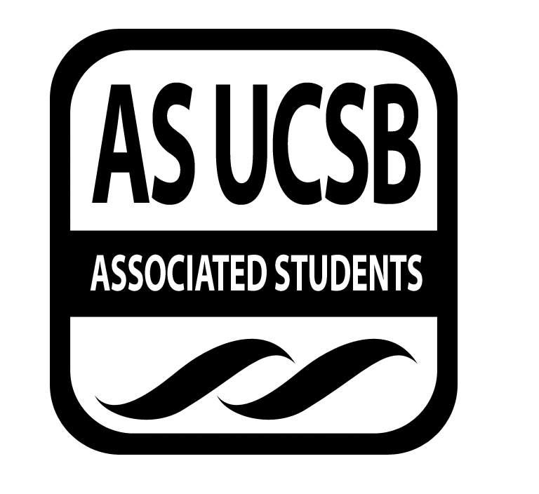
Associated Students
5/5, 6:00 PM
Food Bank Lounge

CALL TO ORDER

A. MEETING BUSINESS
- Roll Call (Pre-entered Names)

Name | Note:  absent (excused/not excused)  arrived late (time)  departed early (time)  proxy (full name) | Name | Note:  absent (excused/not excused)  arrived late (time)  departed early (time)  proxy (full name)
Yanira Flores |  | Honglei Liu | absent
Katie Freeze | Arrived late (6:12) | Zoe Monty-Montalvo
Olga Gomez |  | Tuyen Nguyen
Erick Lankey |  | Andre Taylor | absent

B. PUBLIC FORUM
  - Announcements/Information/Introductions
    - May 12th-San Nic Food Demo Event
        - Date change to the 15th (8-9pm)
        - Add-ons to food: eggs, tortillas, lettuce, vermicelli
        - Create your own/experimental style
    - May 16th-Freshman Transition into IV Event at Santa Rosa Lawn (12-2pm)
    - May 19th-May 23rd-Possible Food Demo Event in Manzanita
    - Late May-ELF Gardening at Arroyo Gardens Housing Authority-Food Demo
    - Spice guides/ suggestions at food demos?
  - Appreciations/Concerns
  - Request to have item added to today’s agenda

- REPORTS
- Advisor’s Report
  - Discussion of surveys and how to advertise- flyers?
- Executive Officer’s Report(s)
  - Zoe Monty-Montalvo-External Affairs Coordinator
    - Chilla Vista-Boards
- Group Project/Member Report(s)

- ACCEPTANCE of AGENDA/CHANGES to AGENDA

- ACTION ITEMS

E-1. Old Business: None

E-2. New Business: Motion to pass $75 for San Nic food demo
Erick motions, Katie seconds, Yanira calls to question, Zoe calls consent

- DISCUSSION ITEMS

F-1 Discussion of Ecoaliton Discussion Items
  - GE-sale of carbon credits
    - Will be retired and reduce carbon dioxide allowable levels
    - What to do with $700,000?
    - Yes or No?
      - Yes
  - AS Fracking Resolution
    - Would suggest ban on fracking in Santa Barbara County
    - What is fracking? –extracting natural gas from rocks deep below sea level
    - Yes or No?
      - Postpone for next meeting
  - Sustainable Living Research Ordinance
    - Wants an endorsement
    - Monitors ongoing projects in the county and make sure code requirements allow these projects to keep moving forward
    - Yes or No?
      - Yes

F-2 Discussion of Freshman Eating Events in IV
- May 12th-RA wanted to move the event up to a Monday night (now May 15th)
  - Event will be in San Nic
  - Recipes that you can make without a stove
    - Ex. Salad-what greens, other veggies, protein
- Larger Brainstorm Working Group on Developing programs to how to collaborate with RA’s for next year

F-3 Discussion of Recruitment
- Do we want to table at all this week?
  - Yes, Thursday at the UCen during Swipes giveaways (tentatively 10-12)

- REMARKS

ADJOURNMENT

