AS Food Bank Agenda

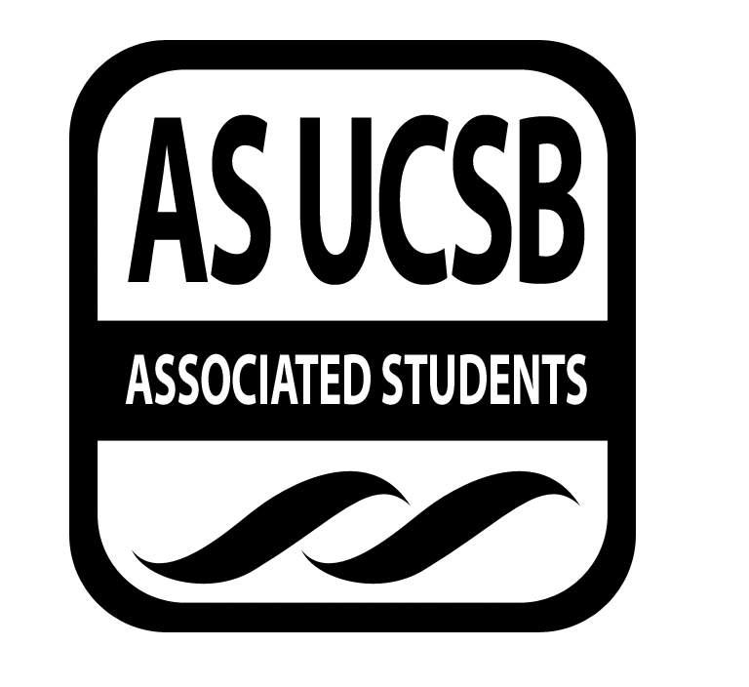
Associated Students
1/14/15
3rd Floor UCEN

CALL TO ORDER by Katie Freeze at 5pm

A. MEETING BUSINESS
- Roll Call (Pre-entered Names)

Name | Note:  absent (excused/not excused)  arrived late (time)  departed early (time)  proxy (full name) | Name | Note:  absent (excused/not excused)  arrived late (time)  departed early (time)  proxy (full name)
Katie Freeze | Present | Tuyen Nguyen | Present
Erick Lankey | Present | Brendan Byrne | Absent
Vi Truong | Present | Zoe Monty-Montalvo | Absent
Rachel England | Absent (not excused)
Kevin Mailangkay | Present

- Acceptance of Excused Absences
- Acceptance of Proxies

B. PUBLIC FORUM

- REPORTS
Brief reports on matters relevant to the AS Food Bank and matters of general interest to the public in attendance.
- Advisor’s Report-Tuyen Nguyen-N/A
- Executive Officer’s Report(s)-N/A
- Group Project/Member Report(s)-N/A

- ACCEPTANCE of AGENDA/CHANGES to AGENDA

- ACCEPTANCE of ACTION SUMMARY/MINUTES

- ACTION ITEMS

F-1. Old Business: N/A

F-2 New Business: N/A

- DISCUSSION ITEMS

Associated Students Staff would like us to approve all of the planning team minutes for the Food Summit in order to have more documentation and transparency when it comes to showing all the decision making our team has made and to help with processing funding.

Lankey makes a motion to approve the CA Higher Education Food Summit (CAHEFS) minutes for the planning team, content team, speakers and entertainment, outreach, promotion, and registration, and UCSB logistics.

Motion/seconded/called the question/call consent: Lankey/Mailangkay/Freeze/Truong
Vote: 4-0 to APPROVE

- REMARKS
Working meeting for the remainder of the meeting

ADJOURNMENT 7:00 PM

