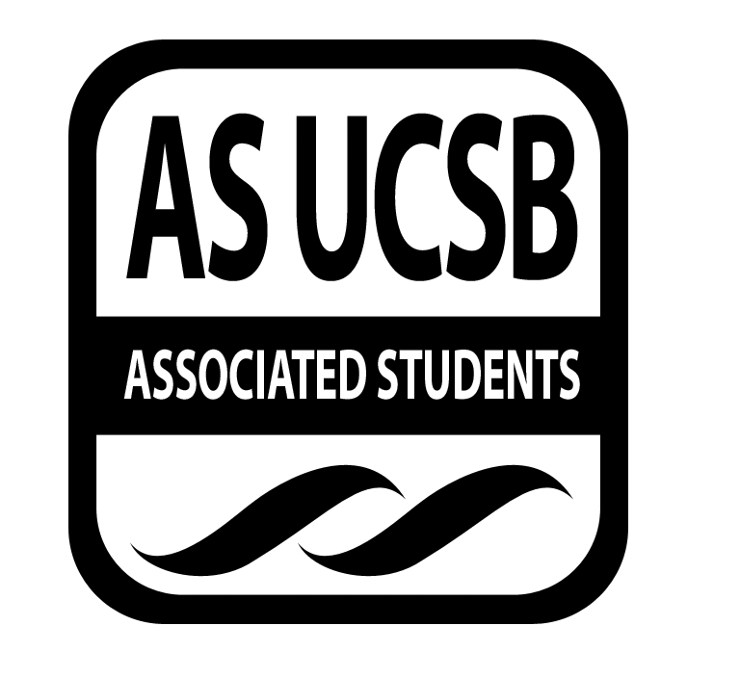
AS Food Bank Committee

Associated Students

November 4, 2016;

Food Bank Lounge Minutes taken by: Gary Van Huynh

CALL TO ORDER by Bre Jones, Chair at 2:10pm

A. MEETING BUSINESS
- Roll Call (Pre-entered Names)

Name | Note:  absent (excused/not excused)  arrived late (time)  departed early (time)  proxy (full name) | Name | Note:  absent (excused/not excused)  arrived late (time)  departed early (time)  proxy (full name)
Breanna Jones | Present | Liyan Wang | Absent
Gary Van Huynh | Present | Refina Chan | Absent
Yanira (Jenny) Flores | Present | Patsy Solana | Absent
Steven Marquardt | Excused | Bianca Fernandez | Excused
Wen Ying Liu | Present | Patrick Dohoney | Present
Nathalie Recendez | Present | Priyanka Bist | Excused
Kathy Lee | Present | Camden Palm | Absent
Eileen Lui | Present | Khalil Kochiyama | Absent
Doriana Abeyta | Absent | Teniola Adedji | Absent
Juli Nguyen | Absent | Tuyen Nguyen | Present

- Acceptance of Excused Absences
MOTION/SECOND: Jones/Flores
ACTION: Passed by Consent
B. PUBLIC FORUM
a. Check ins:
1. Ice breaker.
2. Agenda summary / anything to add.

- REPORTS
  - Chair (Bre Jones):
    - TINY screening update.
      - Reach out to different on campus organizations for possible collaboration
      - Possible collaboration with Human Rights Board
        - Meeting with Hubert Zhang (Chair) on Monday, November 7th at 1pm
      - Nikki from Swipe out Hunger
      - E-mailed Niki from Swipe out Hunger for collaboration
        - Has not responded to the email yet
    - Advocacy meeting (November 2nd) debrief.
      - Beginning the Associated Student Food Bank Campaign for a bigger space allocation
        - Next meeting on Monday (November 7th) at 2pm
  - Vice Chair (Gary Van Huynh)
    - Honoraria information
      - Application are due November 11th
      - Bre Jones (Chair) will send out emails of the link to the ASFB committee.
      - Please submit the honoraria application before the due date
        - Any application submitted after the due date may not get accepted
  - Internal Affairs Coordinator:
    - Wen Ying Liu:
      - Had a meeting with Eileen last week to talk/discuss future plans and events for the winter quarter
    - Eileen Lui:
      - Discussed and started to plan Ideas for the next produce first event (Winter Quarter)
      - Community Housing Office (CHO) has approached for a possible future collaboration
        - CHO has quarterly neighborhood party/concerts.
        - ASFB committee will discuss about how we can contribute to the event
          - Talk to Jen (friendly neighbor representative)
      - Debrief about first produce event at Sierra Madre
        - Successful
      - Katie Maynard (UCSB Sustainability department)
        - Had a meeting on Tuesday (November 1st) with Katie M for requesting grants
          - What are the purpose of the vertical garden project
            - How to use the garden
            - Field trips to the garden for education purposes
  - External Affairs Coordinator: None
  - Publicity Coordinator:
    - NewsLetter update/debrief
      - Nathalie will send out on Monday (November 7th) ASFB newsletter
      - Nathalie will send out emails to the ASFB committee asking about any upcoming/future events
        - Guidelines for what / when to send
        - Needs to establish guidelines for what to send
          - Needs to establish how in advance the ASFB needs to send event notice to Nathalie
            - When will be the cut-off/due dates for event submission to be put on the ASFB newsletter
  - Treasurer:
    - Sent email funding request for the ASB Thanksgiving luncheon
      - Community Affairs Board (CAB) funding request
        - Eileen Lui will present on Monday, November 7th @ 7pm
      - Residential Housing Association (RHA)
        - Will present on Monday, November 7th @7pm
          - Billy will present for Kathy
      - Associated Student Finance and Business committee
        - Kathy will present
      - Coastal fund grant application
        - Applications are due Friday, November 11th
        - Request funding for potential swag items
  - Others/Voting Members:
    - Patrick (Senator):
      - Talked to Global Food Initiative (GFI) intern
        - February Food Rally event
          - To bring awareness to the campus
          - Main objective: will discussed next meeting
          - Meeting again next week: have not scheduled yet
        - Will answer questions regarding past senate meeting (11/2) at the next ASFB committee meeting
  - Advisor (Tuyen Nguyen):
    - Monday, November November 7th from 11-12pm
      - Monthly Food Security Meeting
        - Location: Ucen Mission Room
        - Talk/debrief more in depth about the Food insecurity data
          - Operation update
        - ASFB Mobile Food Distribution Update
          - Good/positive number
            - About 100 people attended the event at Sierra Madre
            - About 60 people attended the event at Family Student housing
          - Worth continuing
      - ASFB operation team hiring process
        - One (1) new staff member started last week
        - In the process of hiring three (3) more staff
        - Internal hire for one (1) ASFB Student Coordinator

- ACCEPTANCE of AGENDA/CHANGES to AGENDA
MOTION/SECOND: Jones/Flores
ACTION: Passed by Consent

- ACCEPTANCE of ACTION SUMMARY/MINUTES
- Approval of our Action Summary/Minutes from 10/28/2016
MOTION/SECOND: Jones/Flores
ACTION: Passed by Consent

- ACTION ITEMS
F-2 New Business

- NONE

- DISCUSSION ITEMS
a. Big Ideas (Joanne) representative
- Blum Center
- First Started at UC berkeley
  - http://blumcenter.berkeley.edu
- Three (3) page proposal due November 16th
- Can book advisor appointment with folks at Berkeley
- Guidelines online as well (resources tab)

b. Hunger Banquet:
- Tuesday, November 15 @ 6:30 - 8:00pm (MCC lounge).
- Interactive event to highlight issue of hunger throughout the world.
- Oxfam America club interested in a collaboration.
- Need someone to present / participate in the event:
  - Nico, Patrick, and Teni are interested
-
c. Food recovery: Discussion tabled for next meeting
- Thomas Wang & Brianna Duplessis working on food recovery program.
- Still in early development
  - currently working through logistics.
- Hope to work with AS Food Bank
  - Use of ASFB space as a hub.
- What would our role be in future? What is our capacity to help?
  - Should a new position be implemented in future?

d. Coastal Fund grant proposal:
- Kathy Lee:
  - Application deadline is November 11th
  - Exploring Potential ASFB swag items
- Gary Van Huynh
  - Needs to meet the requirement of the Coastal fund mission statement and Associated students Green bill.
  - Double check the company’s website regarding where the items are made and what materials are used

ADJOURNMENT
MOTION/SECOND: Jones/Recendez
Motion to adjourn at 3:02pm
ACTION: Passed by Consent

