AS Food Bank Minutes

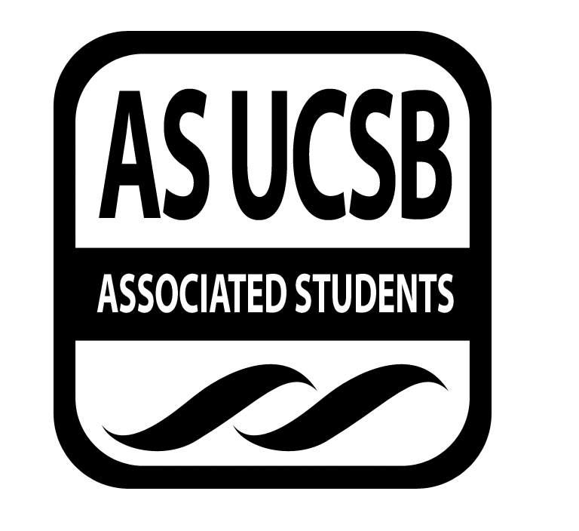
Associated Students
10/22, 6:00 PM
Food Bank Lounge

CALL TO ORDER 6:05pm

A. MEETING BUSINESS
- Roll Call (Pre-entered Names)

Name | Note:  absent (excused/not excused)  arrived late (time)  departed early (time)  proxy (full name) | Name | Note:  absent (excused/not excused)  arrived late (time)  departed early (time)  proxy (full name)
Brendan Byrne | Present | Honglei Liu | Present
Katie Freeze | Present | Zoe Monty Montalvo | Present
Erick Lankey | Present | Tuyen Nguyen | Present
Tina Lee | Absent | Andre Taylor | Present

B. PUBLIC FORUM
  - Announcements/Information/Introductions
  - Appreciations/Concerns
  - Request to have item added to today’s agenda

- REPORTS
- Advisor’s Report
  - Tuyen-Advisory Board
    - Donation Drive Calendar
      - Newsletter for the 4th to kickoff drive
    - Constitutional Convention-4-6pm GSA Lounge
      - Will go over grouping that we are in-Business Services
    - Houseless Students Conversation Next Meeting
      - Monday 10/28 2-3pm Non-Traditional Resource Center
- Executive Officer’s Report(s)
  - Erick Lankey & Katie Freeze-CAB Meeting Announcement
    - When: Wednesday 6pm
  - Erick Lankey-Gaucho Certified Farmer’s Market
    - When: Wed 10/23 11am-3pm
    - Where: Lot 23 Faculty Club (near SRB)
    - Tabling?-Not this week
    - Extra food from farmers? Look into purchasing at lower price in a matter of time?

  - Honglei Liu-Conference-San Francisco
    - Will not be able to attend meeting next week

- Group Project/Member Report(s)

- ACCEPTANCE of AGENDA/CHANGES to AGENDA

- ACTION ITEMS

E-1. Old Business: None

E-2. New Business: None

- DISCUSSION ITEMS

F-1 Discussion of AS Recruitment Fair
- When: Thursday October 24th 11am-2pm
- Where: Arbor
- Work out tabling schedule?
  - 1230-2pm
  - Katie and Erick Will attend

F-2 Discussion of Human Rights Week
- Week 7 of Fall Quarter
- Do we want to create an event for this?
  - Tuesday 5pm-7pm
  - Andre-Program Board + Katie leading this event
  - Work up a future budget for the event

F-3 Discussion of Parents Night In
- Week 7 of Fall Quarter-November 21st 6pm-9pm
- West Campus Community Center-Marta
  - IV Food Co-op

F-4 Discussion of AS Food Bank Advisory Board
- Presentation of what our PowerPoint will look like

- REMARKS

- Think about incorporating Youtube videos into advertising for the future (media center equipment)

ADJOURNMENT 6:55 PM

