AS Food Bank Agenda

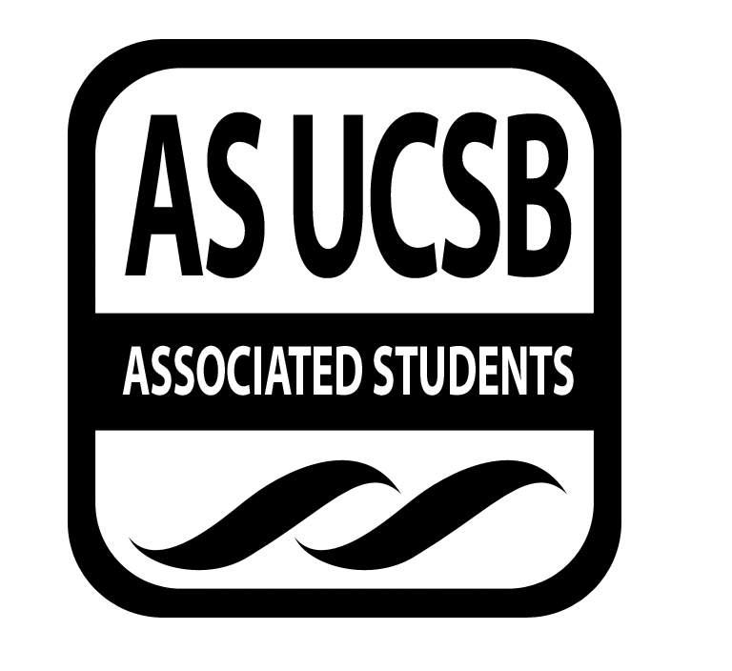
Associated Students
12/9/14, 6:30 PM
Email Vote

CALL TO ORDER

A. MEETING BUSINESS
- Roll Call (Pre-entered Names)

Name | Note:  absent (excused/not excused)  arrived late (time)  departed early (time)  proxy (full name) | Name | Note:  absent (excused/not excused)  arrived late (time)  departed early (time)  proxy (full name)
Katie Freeze | Present | Tuyen Nguyen | Present
Erick Lankey | Present | Brendan Byrne | Present
Vi Truong | Present | Zoe Monty-Montalvo | Present
Rachel England | Present | Pre-entered Name
Kevin Mailangkay | Present | Pre-entered Name

- Acceptance of Excused Absences
- Acceptance of Proxies

B. PUBLIC FORUM
  - Announcements/Information/Introductions
  - Testimony for items on today’s agenda (out of order)
  - Appreciations/Concerns
  - Request to have item added to today’s agenda

- REPORTS

- ACCEPTANCE of AGENDA/CHANGES to AGENDA

- ACCEPTANCE of ACTION SUMMARY/MINUTES

- ACTION ITEMS

F-1. Old Business: N/A

F-2 New Business

- Approval/Consideration of Burrito Bar funding
Advisor/Staff recommendation/instruction/request: Nguyen/ingredients for Finals Burrito Bar Dinner Tuesday December 16th 6pm in the SRB MPR
Responsible for Follow-through: Nguyen/will complete order
Additional approval required? YES Senate

Motion: I motion to allocate $200 for the funding of AS Food Bank Burrito Bar Event.
Motion/second/question/consent: Lankey, Freeze, Monty-Montalvo, Mailangkay
Vote: 7-0 to APPROVE

- DISCUSSION ITEMS

- REMARKS

ADJOURNMENT

