## Elections Board Agenda

## ASsquare_logo.tifAssociated Students

3/27/20, 11:00 AM

Virtual Meeting - Zoom

**CALL TO ORDER by Davis Quan at 10:58 AM**

**A. ATTENDANCE**

|  |  |  |  |
| --- | --- | --- | --- |
| **Name** | **Note:** | **Name** | **Note:** |
| Davis Quan  (Chair) | **Present** | Ruth Garcia Guevara  (Advisor) | **Present** |
| Andrew Yan | **Present** |  |  |
| Emma Xing | **Present** |  |  |
| Wessal Esber | **Present** |  |  |
| Shannon Hollingsworth | **Present** |  |  |

**B. DISCUSSION ITEMS**

**B.1. Intro & Voter Threshold**

Davis: Thanks everyone for coming during spring break. We do have a new member this quarter, Shannon. Let’s have everyone introduce themselves.

Shannon: Hey everyone, I’m a second year.

Davis: I don’t know if you’ve been seeing these emails yet but we’ve been getting emails from two parties regarding what’s going on. Today we should come out of these meeting with regard of what our plan is. Additionally, I think we want to talk about any rule changes we would want to make besides social media. There were questions about changing the threshold.

Davis: I want to get Shannon up to date on how we want to proceed with next quarter. Before the quarter ended, we decided to go with the totally online campaign for everyone. Were you able to read over the elections code I sent you, just a glance over it?

Davis: First, how do we manage the voter threshold for candidates, fees, and reaffirmations?

Ruth: The 20% threshold for fees and reaffirmations is in the by-laws.

Davis: So that can’t be changed.

Emma: I agree with lowering the 20% for candidates.

Wessal: What does everyone think about 15%?

Shannon: I feel like students will be able to check their emails a lot more.

Andrew: Yes, I agree with Shannon. I still think that we’ll be able to get students to vote. Still, I do also agree with lowering the threshold to account for the worst-case scenario.

Emma: 12-13%?

Andrew: I wouldn’t want to take it too low.

Ruth: We have to remember that we still need 20 for the reaffirmations and other things. So if it’s 15% we would probably have a better chance to reach that second threshold at 20%.

**Motion to change the threshold for all candidates from 20% to 15% due to virtual campaigning and school closure because of COVID-19**

*First/Second: Esber/Xing*

*Vote: 4-0 to APPROVE, no abstentions*

Davis: Everything else is still 20%, like fees and affirmations?

Ruth: If we changed that it would have to go to UCOP and I don’t think we will be able to.

**B.2. Campaigning**

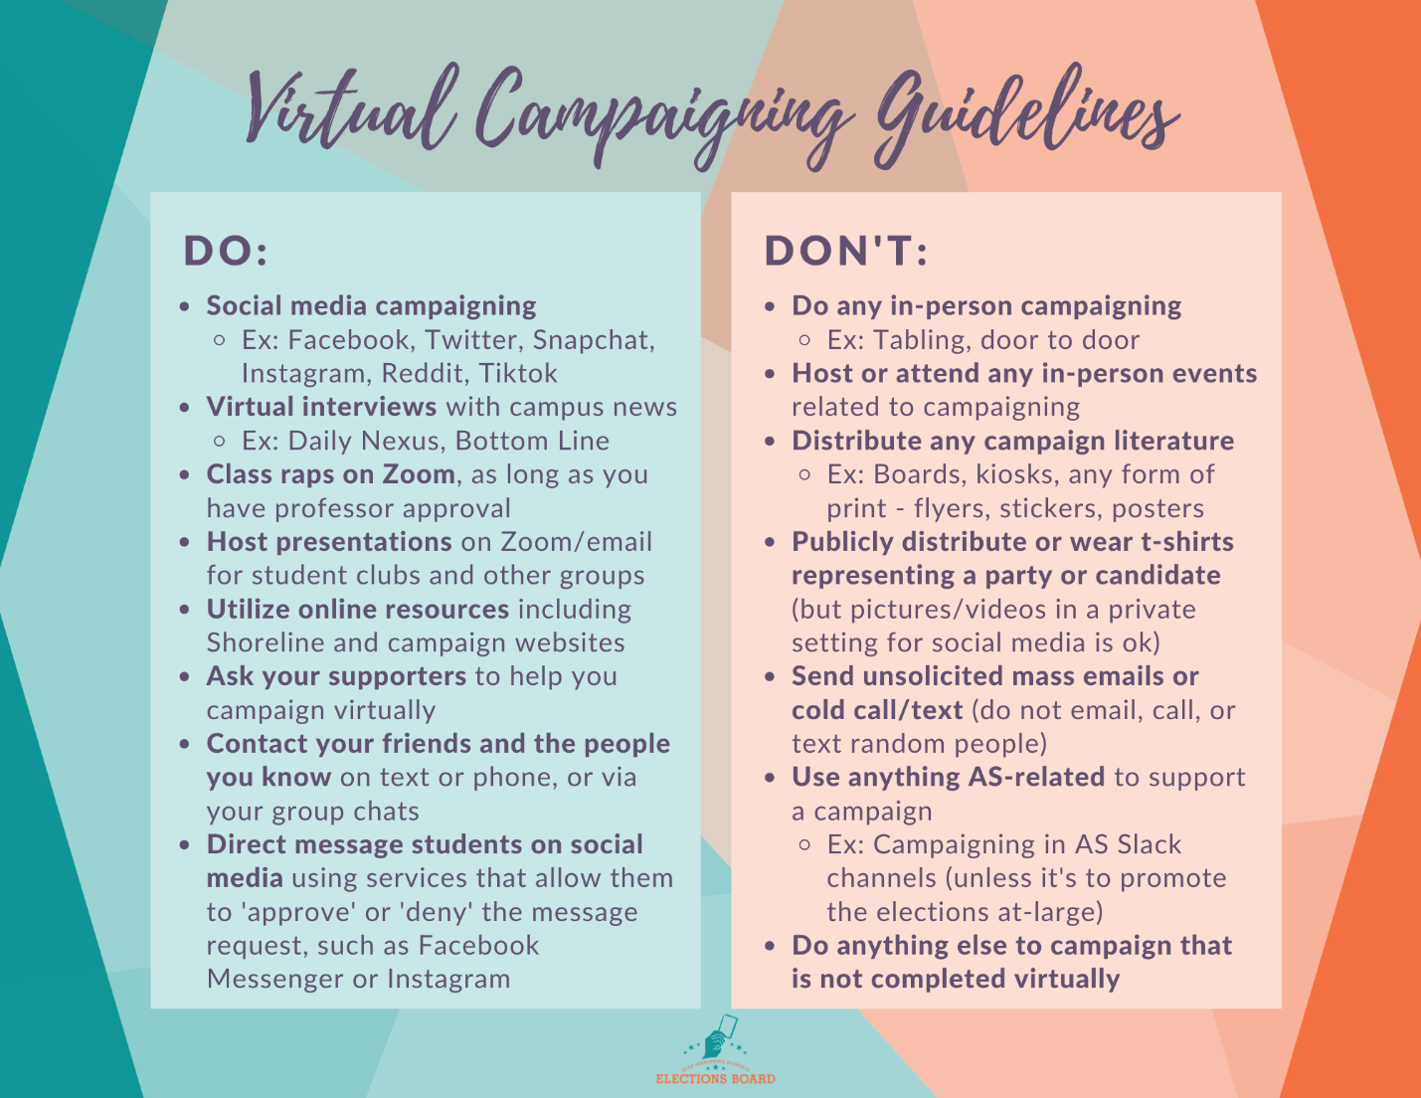

Andrew: So we have a draft list already. But there are a few things I wasn’t sure about so we should discuss those.

Andrew: What do we think about class raps?

Davis: Yes if it’s on Zoom and the professor agrees.

Andrew: Ok, and then what if someone sends mass emails?

Davis: No, there’s a line for that in Elections Code. “Unsolicited usage of an electronic medium” is not allowed.

Wessal: But it would be ok if they messaged students on Facebook or Instagram. That has message requests. If someone doesn’t want the message they can deny the request.

Andrew: Alright, I’ll make a graphic and release it today.

Wessal: Also, we should send an email to the student body to tell people that the elections are still happening.

**B.3. Procedural**

Ruth: One more thing, can we push the pro/con statement deadlines to later?

**Motion to change the pro/con deadline to Friday, April 17 at 8pm**

*First/Second: Esber/Xing*

*Vote: 4-0 to APPROVE, no abstentions*

Davis: And how much money do we have for advertising?

Andrew: Technically zero because the money we allocated last quarter said winter quarter advertising.

**Motion to allocate $3,000 for Elections advertising**

*First/Second: Hollingsworth/Xing*

*Vote: 4-0 to APPROVE, no abstentions*

**Motion to allocate $400 for food on Elections Results Night**

*First/Second: Hollingsworth/Xing*

*Vote: 4-0 to APPROVE, no abstentions*

**MEETING ADJOURNED by Davis Quan at 12:46 PM**