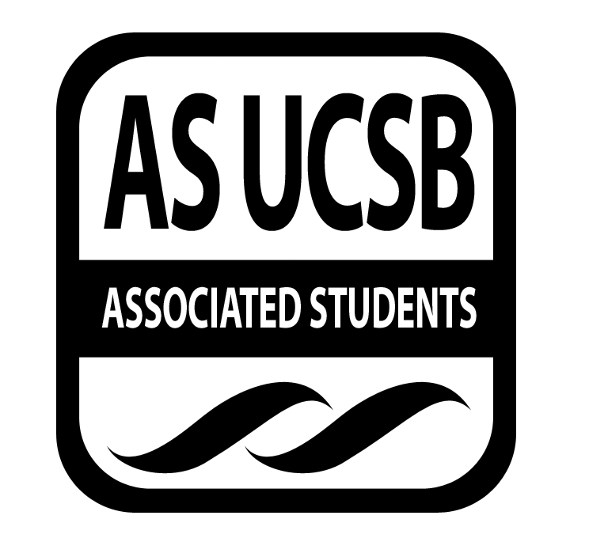
Environmental Affairs Board Minutes

Associated Students
05/16/2022 Zoom:
CALL TO ORDER 7:02pm called by Kat Lane by minutes recorded by Emily Cohen

- ATTENDANCE

Name | Note: | Name | Note:
Lily Ortiz  Co-Chair | Present | Varun Iyer  Sustainable Foods | Present
Kat Lane  Co-Chair | Present | Vacant  Sustainable Foods | N/A
Jen Stein  Sustainable Lifestyle Chair | Present | Maritza Vasquez  Student Affairs | absent
Katherine Jiang Li  Sustainable Lifestyle Chair | Present | Soham Ray  Student Affairs | Present
Vacant  Policy Campaign Chair | N/A | Alicia Yu  Publicity Chair | Present
Jesse Casey  Policy Campaign Chair | tardy | Diane Nguyen  Publicity Chair | Present
Saul Ventura  Environmental Justice | Present | Paige Lund  Earth Day Chair | Present
Naomi Charlet  Environmental Justice | absent | Tara Robinson  Earth Day Chair | Present
Jesus Gomez Garcia  Social Chair | Present | Coltin Sanders  Senate Liaison | Present
Carissa Garcia  Social Chair | Present | Sarah Siedschlag  Advisor | Present
Landry Guillen  Volunteer Chair | Present | Emily Cohen  Admin Assistant | Present
Hadley Mahoney  Historian | Present | Grant  Special Coordinator | Present

MOTION/SECOND: Kat/Lily
Motion language: motion to approve Martiza and Naomi as absent and Jesse as late
ACTION: Consent
Additional approval required: YES (Senate)

- PUBLIC FORUM
- Amruta, case worker at office of attorney general (amrutabaradwaj@ucsb.edu)
  - Tyler - MW 11AM-12:30 PM attorneygeneral@as.ucsb.eduJuan - T 9:30-11:30 AM as-solicitorgeneral@ucsb.edu

- COMMITTEE BUSINESS

- Approval of Minutes
MOTION/SECOND: Lily/Soham
Motion language: motion to approve last weeks minutes
ACTION: Consent
Additional approval required: YES (Senate)

- INDIVIDUAL REPORTS

  - Co-Chairs
    - interviews ended yesterday, will be reviewing core applications for the next week or two
    - winter honoraria checks available at AS ticketing office; spring honoraria due wed at 8pm https://www.as.ucsb.edu/senate/honoraria/bcc-appointed-position/
    - last core meeting of the year is next monday!
    - EAB Superlatives to be completed before next monday: https://forms.gle/tvwc8CdrpC2R4FjU8
    - res hall competition event with raffle prizes had good turnout and was a success
    - this week: social chairs san marcos working group and hike, eco tourism working group from student affairs
    - tabling at stigma free went well
    - eab legal codes updated at senate
    - remember to continue updating your journals for new core
  - Student Affairs Chairs
    - working group on wednesday
    - Munger Hall student response panel June 1st from 6:30 to 9:30pm in Campbell Hall
      - CHAMP had a meeting on Sat talked about how the event would go / assigned responsibilities
      - asked if EAB wants to be an official co-sponsor of the event
      - asked if EAB would like to volunteer at the event as well
  - Historian
    - bird of the week: Hairy Woodpecker
    - check groupme for weekly recap photo reminder
    - been planning the bird of the year
  - Publicity Chairs
    - please send in your descriptions for this weeks events and working groups
    - botanical gardens tour saturday may 28th around 11am - let us know if you can drive
  - Earth Day Chairs
    - just working on the journal
    - working group last week went pretty well
  - Social Chairs
    - San Marcos Foothills Preserve working group this wednesday
      - includes a land acknowledgement and chumash history
    - sunset painting was really fun and had a decent turnout
    - Kat, Lily, Tara, Carissa driving at 11am this Sunday for San Marcos hiking ~ 15mins away for a 35-40min long hike
  - Volunteer Chair
    - photos this wed starting at 6pm (come as soon as possible)
      - wear your nice clothes for headshots and bring your EAB shirt for the group photo
    - Dr. Carlisle book event this week - check slack
  - Sustainable Foods Chairs
    - Green Chef on Sunday - thank you everyone who came and brought food
      - turnout a bit low probably due to late advertising but there were some new faces
      - event ran smoothly despite forgetting lighter fluid
    - Varun will be traveling this week and may not be here this wednesday or next monday
  - Environmental Justice Chairs
    - healing grounds event may 19th at 3pm ucsb marine science building 1302
    - thursday and friday zoom EJ symposium - see slack for details
  - Policy Campaign Chairs
    - had good working group last week
  - Sustainable Lifestyle Charis
    - had working group last week that was successful, people seemed to enjoy
  - Administrative Assistant
    - remember to bring your receipts this wednesday
  - Community Affairs
    - was at Stanford this weekend to expand cool campus challenge
      - scale of success 6/10 ; made a lot of connections but overall not quite as effective as would have hoped
  - Senate Liaison
    - senate meeting last week was very long
    - core positions will pass on wednesday and be officially changed
    - last week as a senate liaison, there will be a new one next year

- DISCUSSION

- NEW BUSINESS

1.

MOTION/SECOND: Kat/Tara
Motion language: motion to table the discussion of co-sponsoring the CHAMP Munger Hall event until next week
ACTION: Consent
Additional approval required: YES (Senate)

ADJOURNMENT AT 8:30pm

MOTION/SECOND: Lily/Kat
Motion language: motion to adjourn meeting at 7:42pm
ACTION: Consent
Additional approval required: NO

