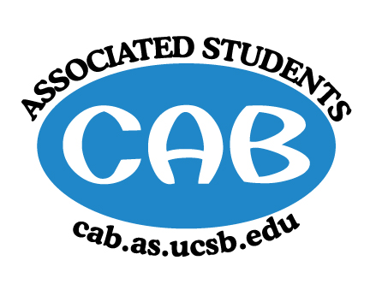
AS Community Affairs Board Minutes
Monday, May 20, 2019, 7:30PM
University of California, Santa Barbara
AS Community Affairs Board Office, University Center 2523

Roll Call and Attendees:
Name | Status | Name | Status
Christian Larson (Co-Chair) | present | John Balbuena | excused
Steven King (Co-Chair) | present | Katie Lydon | present
Ambar Gonzalez | excused | Kellie McManamon | present
Andrea Nonato | excused | Siena Matsumoto | present
Claire Bolton | present | Megan Lee | present
Claudia Okuniewski | present | Oscar Ramos | present
Colin Wu | present | Raphael King | present
Ricky Nguyen | present | Shivani Shah | present
Katarina Petritsch | present | Kyla Gelev | present
Edwin Ballesteros | present | Allina Mojarro  (Advisor) | excused
Joanna Kim | present | Lea Toubian  (Senate Liaison) | present

Ruth Guevarra-Garcia (advisor) | present | Yara Khamis (Senate Liaison) | present

- Acceptance of Agenda
  - Acceptance of Excused Absences
  - MOTION/SECOND: King/Kim
  - ACTION: Passed by Consent

- Public Forum/ Announcements

- Funding Requests
a . Playsia
Funding Request
      - Budget
      - Requesting: $850 for stickers, programs, and flyers
        - Motion to fully fund $850
        - Motion/Second: Kim/King
        - Action: motion passes by consent

- Action Items (Internal Funding)
  - Ruth- $15,000 admin budget
    - Motion to fully fund $15,000 for admin budget
  - Motion/second: Lee/Kim
  - Action: motion passes by consent
B. Special Projects- $300 for You Matter stickers
Motion to fully fund $300 for You Matter stickers
- Motion/Second: Bolton/Lee
- Action: motion passes by consent
C. Cab Cochairs- $4000 for cab banquet
- Motion to fully fund $4000 for CAB Banquet
  - Motion/Second: Bolton/King
  - Action: motion passes by consent
D. Alt Breaks - $200 for Banquet
- Motion to fully fund $200 for Banquet
  - Motion/Second: Bolton/King
  - Action: motion passes by consent
2. Advisor Updates
  - Allina M.: Was out sick but would like to help new leaderboard with their events.
  - Ruth G.:

1. Co-Chair Updates (Steven King & Christian Larson)
- Going to move to new room
- Work on the transition document together if you haven’t already done so.
- Talk about challenges/successes/tricks and what not.

2. Board Updates
  - Secretary/Webmaster: John Balbuena

  - FLP Co-Coordinator: Johanna Najera/Colin Wu

  - Alternative Breaks Co-Coordinator: Ambar Gonzalez/Shivani Shah

  - Animal Coordinator: Katarina Petrisch

  - Childcare Director: Claudia Okuniewski

  - Community Outreach Coordinator: Kellie Mcmanamon

  - Environmental coordinator: Oscar Ramos

  - Historian: Siena Matsumoto

  - Hunger/Houseless Co-Coordinator: Katie Lydon/Andrea Nonato

  - Public Relations Co-Coordinator: Ricky Nguyen/Claire Bolton

  - Senior Citizen Coordinator: Raphael King

  - Social Chair: Kyla Gelev

  - Special Projects Coordinator: Joanna Kim

  - Treasurer: Edwin Ballesteros
    - deadline to turn in requisitions is 5/31
  - Youth Outreach: Megan Lee

  - CAB Student Staff

- Motion to Adjourn the Meeting at 8:15PM
  - MOTION/SECOND: King/Kim
  - ACTION: motion passes by consent

