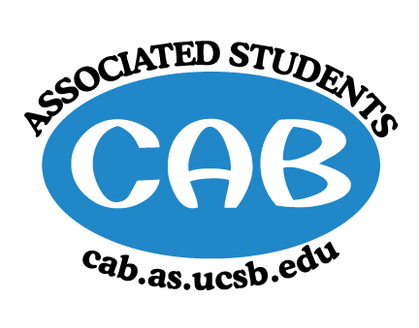
AS Community Affairs Board Minutes
Monday, March 16, 2019, 7:XXPM
University of California, Santa Barbara
AS Community Affairs Board Office, University Center 2523

Roll Call and Attendees:
Name | Status | Name | Status
Christian Larson (Co-Chair) | Present | John Balbuena | present
Stephen King (Co-Chair) | Present | Katie Lydon | Absent
Ambar Gonzalez | Present | Kellie McManamon | Absent
Andrea Nonato | Absent | Siena Matsumoto | Absent
Claire Bolton | Present | Megan Lee | Present
Claudia Okuniewski | Present | Oscar Ramos | Absent
Colin Wu | Present | Raphael King | Present
Ricky Nguyen | present | Shivani Shah | Present
Katarina Petritsch | present | Kyla Gelev | present
Edwin Ballesteros | Present | Allina Mojarro  (Advisor) | Absent
Joanna Kim | Present | Lea Toubian  (Senate Liaison) | Absent

Ruth Guevarra-Garcia (advisor) | Absent | Yara Khamis (Senate Liaison) | Absent

- Acceptance of Agenda
  - Acceptance of Excused Absences
  - MOTION/SECOND: Kim/Ballesteros
  - ACTION: Passed by Consent
- Public Forum/ Announcements

- Funding Requests
Sensible Student Drug Policy
  - Funding Request
      - Budget
- Motion to fully fund SSDP $1480 for the conference tickets
  - First- Gonzalez, Second- Wu
  - Passed by consent

- Action Items (Internal Funding)
  - FLP - $15,000 for Book Fair
    - Motion to fully fund $15,000 for book fair
      - First- Kim, Second- Gonzalez
      - Passed by Consent
  - H/H-$650 for snacks, food and uber/lyft rides to PATH
    - Motion to fully fund $650 for snacks, Uber rides to PATH
      - First- King, Second- Gonzalez
      - Passed by Consent
  - CoChairs 10500 for volunteer festival
    - 8000 for entertainment
    - 2000 for food
    - 500 for succulent event
      - Motion to fully fund $10,500 for volunteer festival
        - First- Nguyen, Second- Kim
        - Passed by Consent
  - Senior Citizen - 400 for plants.and gardening supplies
    - Motion to fully fund $10,500 for volunteer festival
      - First-Bolton, Second- Kim
      - Passed by Consent
  - Alternative Breaks
    - Motion to fully fund $5,000 flights, car rental, lodging, food, gas
    - Motion to fully fund Alt Breaks $5,000 for flights, car rental, lodging, food, gas
  - MOTION/SECOND: Balbuena/ King
  - ACTION: Passed by consent

2. Advisor Updates
  - Allina M.:
  - Ruth G.:

1. Co-Chair Updates (Steven King & Christian Larson)

2. Board Updates
  - Secretary/Webmaster: John Balbuena

  - FLP Co-Coordinator: Johanna Najera/Colin Wu

  - Alternative Breaks Co-Coordinator: Ambar Gonzalez/Shivani Shah

  - Animal Coordinator: Katarina Petrisch

  - Childcare Director: Claudia Okuniewski

  - Community Outreach Coordinator: Kellie Mcmanamon

  - Environmental coordinator: Oscar Ramos

  - Historian: Siena Matsumoto

  - Hunger/Houseless Co-Coordinator: Katie Lydon/Andrea Nonato

  - Public Relations Co-Coordinator: Ricky Nguyen/Claire Bolton

  - Senior Citizen Coordinator: Raphael King

  - Social Chair: Kyla Gelev

  - Special Projects Coordinator: Joanna Kim

  - Treasurer: Edwin Ballesteros

  - Youth Outreach: Megan Lee

  - CAB Student Staff

- Motion to Adjourn the Meeting
  - MOTION/SECOND: King/Balbuena
  - ACTION: Passed by consent

