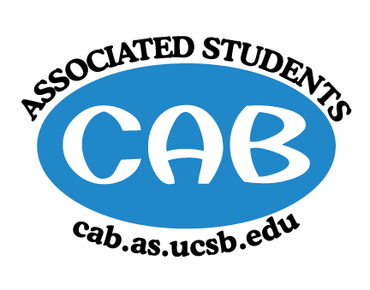
AS Community Affairs Board Minutes
Monday, Feb. 5 2018, 7:41PM
University of California, Santa Barbara
AS Community Affairs Board Office, University Center 2523

Roll Call and Attendees:
Name | Status | Name | Status
Stephanie Nguyen (Co-Chair) | Excused | James Ferraro | Present
Morgan Lee (Co-Chair) | Present | Ileana Navarro | Present
Nancy Huang | Present | Siena Matsumoto | Late
Steven King | Present | Emma Wiley | Present
Shivani Shah | Excused | Daniel Flores | Present
Tejna Patel | Present | Miranda Spring | Excused
Matt Garnica | Present | Olivia Hornstein | Excused
Tessa Fieri | Present | Allina Mojarro (Advisor) | Absent
Glynnis Foley | Present | Ruth  Garcia-Guevara (Advisor) | Present
Ambar Gonzalez | Present
Ricky Nguyen | Present
Gabe Tienda | Absent
Brandon Mora  (Senate-Liaison) | Excused | Anthony  Pimentel  (Senate-Liaison) | Excused

- Acceptance of Agenda
  - Acceptance of Excused Absences
  - MOTION/SECOND: Garnica/Foley
  - ACTION: Passed by consent

- Public Forum/ Announcements
Tejna: fellow RA event- “Learning how to be a humanitarian” event : Feb 15th at Santa Ynez 7pm, suggest CAB can represent

- Funding Requests
  - Alpha Kappa Psi- 5K for Suicide Prevention ($595)
    - Funding Request
    - Budget
    - Motion to fully fund $595
      - Motion/Second: Flores/Foley
      - Vote: 14-0-0
      - Action: Passed

- Action Items (Internal Funding)
  - Ricky Nguyen (Childcare Director) - $3900 for MOXI Museum Passes.
    - Motion to fully fund $3900
      - Motion/Second: Flores/Foley
      - Action: Passed by consent
  - Ricky Nguyen (Childcare Director) - $75 for Kid’s Movie Night food and arts and crafts supplies. (This fri.)
    - Motion to fully fund $75
      - Motion/Second: Garnica/Foley
      - Action: Passed by consent
  - Ambar Gonzalez- $100 entertainment (band) + $100 (food) for Friendship Manor’s Valentine’s Dance
    - Motion to fully fund $200
      - Motion/Second: Flores/Foley
      - Action: Passed by consent
  - Ambar Gonzalez- $75 for baked goods + decorative baking supplies for event
    - Motion to fully fund $75
      - Motion/Second: Foley/Flores
      - Action: Passed by consent

- Advisor Updates
  - Ruth Garcia-advisor Chelsea will come next week
  - Allina Mojarro

- Co-Chair Updates (Morgan Lee & Stephanie Nguyen)
- Volunteer Week Updates: Email/FB Morgan → Date/Time/Name of event by this Thursday.
- General Meeting: Slides/Speaker/Setup/Cleanup (Morgan/Steven/Ambar--Danny/Tessa/Nancy)
i. Volunteer activity - Olivia (to prep for Youmatter event)

- Board Updates
  - Nancy - Secretary/Webeditor
    - Pass
  - Siena & Emma -FLP Co-Coordinator
    - Pass
  - Tejna & Tessa - Alternative Breaks --Co-Coordinator
    - Released spring break application and will get on University Announcement soon
  - Glynnis - Animal Coordinator
    - Pass
  - Ricky - Childcare Director
    - Kid’s movie night this Friday
    - Had a meeting with NTSRC every monday
  - James - Community Outreach Coordinator
    - In process of CARE-EXPO, reaching out to non-profits
  - Ileana - Environmental Coordinator
    - Restoration event this Friday and Saturday (7 spots left in total for both days)
  - Matt - Historian
    - Pass
  - Daniel & Gabe- Hunger/Houseless Co-Coordinator
    - Pass
  - Shivani & Olivia - Public Relations Co-Coordinator

  - Ambar - Senior Citizen Coordinator
    - Valentine’s dance at friendship manor and TBA for decoration event
  - Miranda - Social Chair
    - Don’t forget ice cream social at this week’s general meeting 6:30-7pm
  - - Special Projects Coordinator

  - - Youth Outreach Coordinator

  - Michael - CAB Student Staff

  - Steven - Treasurer
    - Pass
- Motion to Adjourn Meeting at 8:09pm
  - MOTION/SECOND: Wiley/Foley
  - ACTION: Passed by consent

