

**AS Community Affairs Board Minutes**

**Monday, November 14th, 2016, 7:31PM**

**University of California, Santa Barbara**

**AS Community Affairs Board Office, University Center 2523**

**Roll Call and Attendees:**

|  |  |  |  |
| --- | --- | --- | --- |
| **Name** | **Status** | **Name** | **Status** |
| **Michelle Leonard (Co-Chair)** | **Absent (excused)** | **Gary Van Huynh** | **Present** |
| **Jacqueline Vierra (Co-Chair)** | **Present** | **Renee O’Donnell** | **Present** |
| **Jacob Morales** | **Present** | **Jordan Freedlander** | **Present** |
| **Michelle Vu** | **Present** | **Monica Luna** | **Present** |
| **Elizabeth Mendez** | **Present** | **Tanios Boudames** | **Present** |
| **Joi Duncan** | **Present** | **Eric Wang** | **Present** |
| **Connie Lin** | **Absent** | **Mauricio Baltrons** | **Late** |
| **Jasmin Gutierrez** | **Present** | **Allina Mojarro (Advisor)** | **Absent** |
| **Morgan Lee** | **Present** | **Ruth**  **Garcia-Guevara (Advisor)** | **Absent** |
| **Stephanie Nguyen** | **Present** | **Aaron Jones (Advisor)** | **Absent** |
| **Nancy Huang** | **Present** | **Ileana Navarro Hernandez** | **Present** |
| **Tiffany Vuong** | **Absent (unexcused)** | **Bianca Fernandez**  **(Senate Liaison)** | **Absent** |
| **Gabe Tienda** | **Present** | **Felipe Recinos Quant (Senate Liaison)** | **Absent** |

1. **Acceptance of Agenda**
   1. **Acceptance of Excused Absences**
   2. *MOTION/SECOND: Wang/Luna*
   3. *ACTION:* Passed by Consent
2. **Public Forum/ Announcements**
3. **Funding Requests**
   1. none
4. **Action Items**
   1. Michelle and Jac - Requesting $1230.00 for Thanksgiving Bundles to give away to families in need in IV. This will include canned foods as well as money for the families to buy a turkey.

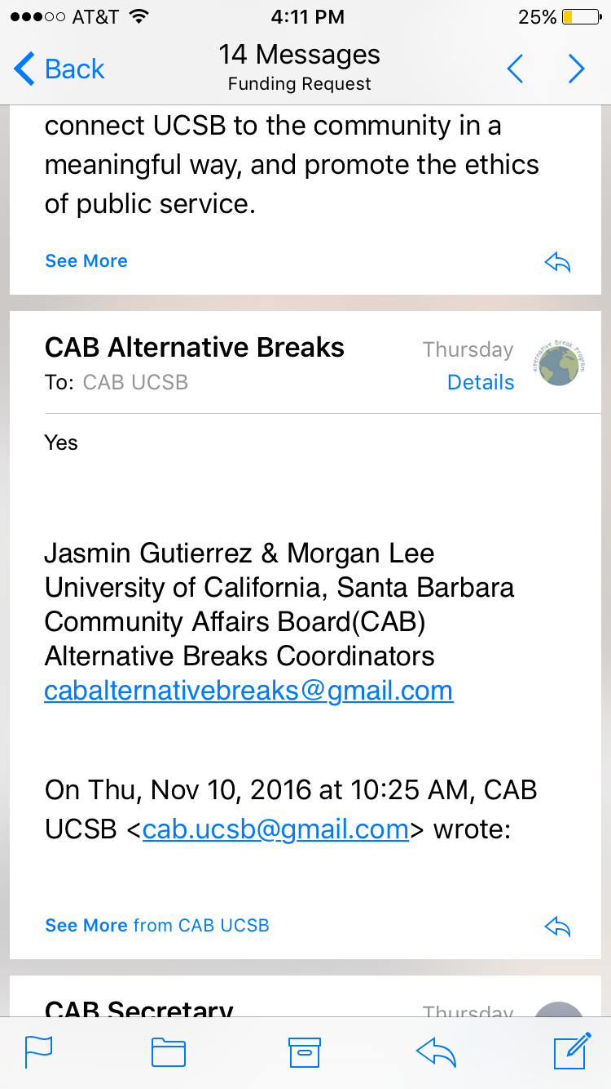

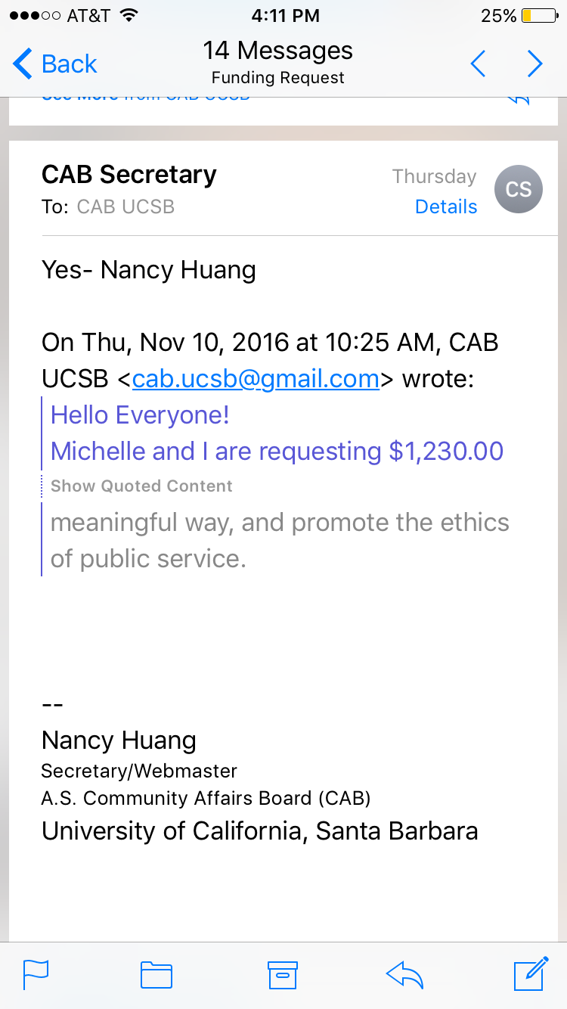

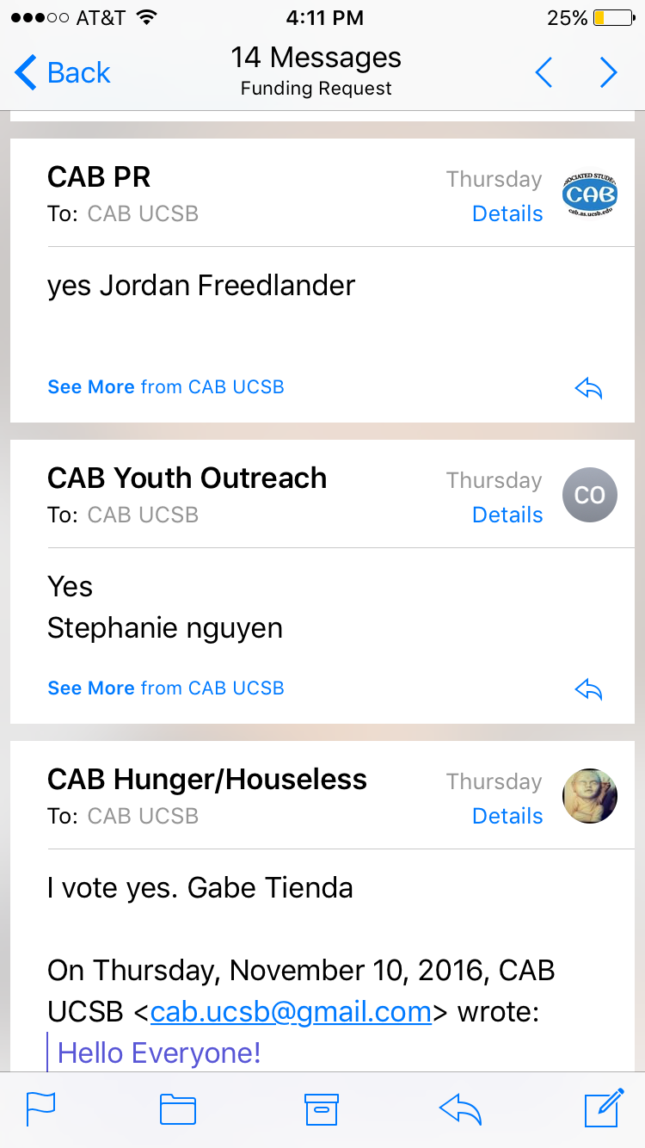

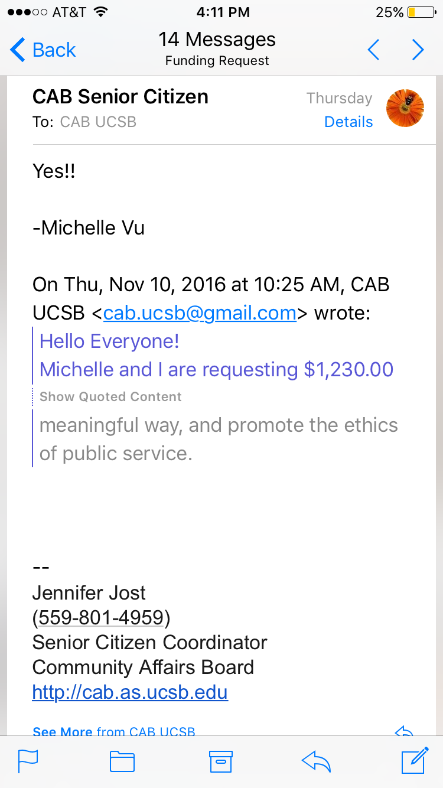

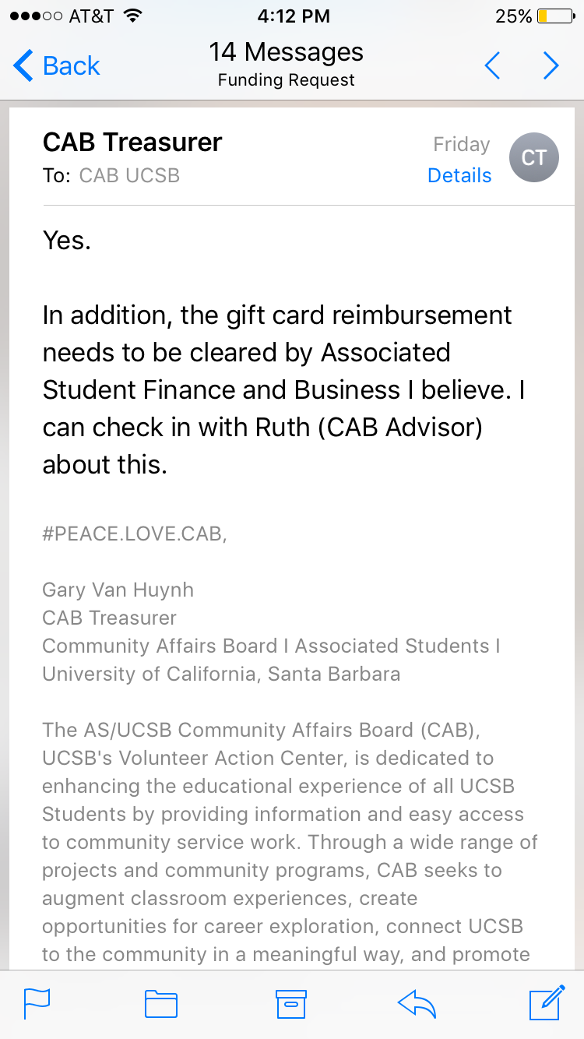

* + 1. *Motion:* 13-0-0

Action: PASSED

* 1. Stephanie- Funding Request
     1. Juguemos- $10 Clothespins for Thanksgiving craft
     2. Motion to fully fund $10 to Stephanie
        1. *MOTION/SECOND: Morales/Huynh*
        2. *ACTION:* Passed by Consent
  2. Jordan-funding request
     1. 60$ for cat toy supplies . volunteer activity at 11/16 meeting
     2. Motion to fully fund $60 to Jordan
        1. *MOTION/SECOND: Mendez/Luna*
        2. *ACTION:* Passed by Consent

d. Joi - Funding Request

1. $130 for Holiday Wishlist party : art supplies and soccer ball (on dec. 3rd)
2. Money for Photo frames/stickers/soccerball/other toys
3. Motion to fully fund $130 to Joi
   1. *MOTION/SECOND: Morales/Luna*
   2. *ACTION:* Passed by Consent

e. Tanios & Gabe-Funding Request

1. $100 for Transition Housing Thanksgiving Dinner: dinner rolls, drinks, and stuffing.
2. Motion to fully fund $100 to Tanios and Gabe
   1. *MOTION/SECOND: ODonnell/Gutierrez*
   2. *ACTION:* Passed by Consent
3. **Advisor Updates**
   1. Ruth Garcia
   2. Allina Mojarro - The Creative Media Unit and the Advisors team have organized important materials essential to Associated Student’s yearlong marketing campaign.

Pertinent to send a CAB rep to one of the two dates, specifically targeting PR coordinators, but everyone is welcome. RSVP here for one of the dates or let us know if you cannot make it. <https://goo.gl/forms/lJrLEyNttd9byYTd2>

* 1. Aaron Jones

1. **Co-Chair Updates (Michelle Leonard & Jac Vierra)**

* One on ones this week

<https://docs.google.com/spreadsheets/d/1OAXZ6qLVxIM-JMWSW7cVfmbQ-FZJhHLDhqthohhVw3A/edit?usp=sharing>

* Honoraria review <https://docs.google.com/document/d/1t0dl4JSMVTJ0eD1F2qGgChJqUoZncbtV1kEeLPq_iuE/edit>
* No meeting the Wednesday before thanksgiving
* Will be giving out an hour of community service for this week’s meeting
* Pumpkins in the closet need to be distributed
* Set up/ clean up (TANIOS/GARY/JOI--JASMIN/GABE/RENEE)

1. **Board Updates**
   1. Nancy - Secretary/Webmaster
      1. Anncemt: Please send post-pic of gm volunteer activity to me via email to feature on care-mail
   2. Ileana & Tiffany-FLP Co-Coordinator
      1. Met with YMCA coordinator to perhaps use that space/room
      2. Established tuesdays and thursdays (time to be decided)
   3. Jasmin & Morgan - Alternative Breaks Co-Coordinator
      1. Got a van (15 person)
      2. Going to Louisiana, having a social on fri., reorganized budget (same but re-allocated)
   4. Eric - Animal Coordinator
      1. BUNS tues, fri, sat -- have snacks for buns
      2. Announcement: on thurs. COC/Dante 3-4pm AS main
   5. Joi - Childcare Director
      1. Working on holiday wishlists, next quarter bi-monthly events , edit childcare bi-laws in future
   6. Renee - Community Outreach Coordinator
      1. Still working with same two orgs. and getting ready for care-expo
   7. Jacob - Environmental coordinator
      1. Planning out compost project, still contacting the people
   8. Elizabeth - Historian
      1. Put up silly CAB polaroid pics/leaves for decoration in office
   9. Tanios & Gabe - Hunger/Houseless Co-Coordinator
      1. Have been having dinner clubs, have another one @SB rescue mission tomorrow
      2. Contacted Swipe out hunger, transition housing
   10. Monica & Jordan - Public Relations Co-Coordinator
       1. Jordan is going to the Annex event on Thursday
       2. Monica may table Wed. and other CAB leaders will help at SRB org mixer
   11. Michelle - Senior Citizen Coordinator
       1. Thanksgiving event is moved from Wed. to Saturday 1pm
   12. Connie - Social Chair
       1. Pass
   13. Mauricio - Special Projects Coordinator
       1. Need someone to table for You Matter Nov. 23rd
   14. Stephanie - Youth Outreach Coordinator
       1. Juguemos and Dental buddies-thanksgiving and fall activities this week
       2. Still trying to contact people to see if can give thanksgiving/christmas goodies
   15. Michael - CAB Student Staff
       1. Pass
   16. Gary - Treasurer
       1. Information about cash advances
          1. Michelle’s Cash Advance for 11/16
2. **Motion to Adjourned Meeting at 7:57pm**
   1. *MOTION/SECOND: Huynh/Boudames*
   2. *ACTION: Passed by Consent*