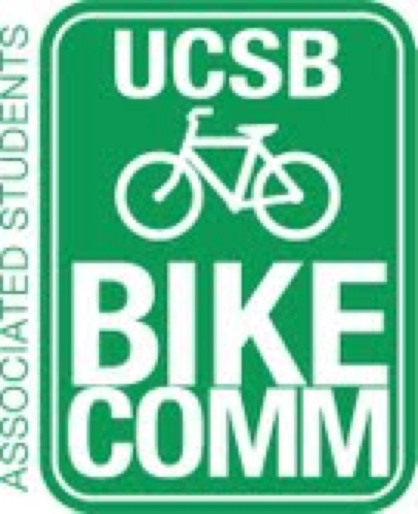

Bike Committee Minutes
Associated Students
01/27/14@ 3:30 PM
A.S. Conference Room

CALL TO ORDER

- Meeting Business
  - Attendance

Name | Present/Absent | Name | Present/Absent
Emily Littleworth | Present | Mac Kennedy | Present
Richard Lo | Absent | Reida Khan | Present
Chris Bustos | Present | Alex Kim | Absent
Zac Armour | Present | Aaron Jones | Absent
Dennis Whelan | Present | Frank Castanha | Absent
Jamey Wagner | Absent | Ralph Fertig | Present
Thomas Bell | Present | Mike Rogers | Absent

- Public Forum
  - General Announcements
    - 3100 Signatures are due February 28 at 4 pm for the SAASB Spring Ballot Initiative
    - Ralph-2 bike shops opening up in SB
    - SB is 8th largest bike commuting city (tied with Davis)
    - Emily-Jamey and Steve from TAP say have extra bike racks to implement in needed areas (low racks though)
    - Nikki Cooper- more bike racks through center? No
  - Appreciations/Concerns
  - Requests to have items added to the agenda
- Committee Member Reports
  - Treasurer Report
  - Bike System Analyst Report
  - Social Media Report
    - FB growth
    - to improve website in the upcoming weeks
- Action Items
  - Approval of Funds
    - Waiting for budget reorganization for promotional items
    - Mac motions to approve $8680 for the consultation fees of the SAASB roundabout ($5930 for RRM Revisions and $2750 for D&CS PM Time)/Chris seconds/Emily calls to question
- Campus Improvement
  - Projects Completed
    - Pardall yield in south completed
    - No North side markings or Campbell numbering
  - Projects Underway
    - SAASB Intersection
      - Physical Planning
        - Need $8680 to finish consultation
      - Ballot Initiative
        - Need 3100 signatures (to ask campus organizations and classes)
      - University Loan
  - Primary Prospective Projects
    - Path South of Girvetz
      - Number one problem is the drainage
      - More costly than it appears to be
      - Should also improve the entry and exit of the music lot
      - Crude estimate of around $100,000
    - Broida Parking
      - Possibly second in project priority
      - Be careful due to campus expansion in that area erasing our projects
    - Parking at HFH
      - Already a big lot
      - Possibility of adding lot south of Kohn Hall
    - Other high priority projects?
      - HSSB North side lots
        - Moving racks south possibly
        - North racks are impacted also
      - Bike parking to be added by lot 7 to help Psych
      - *Sidenote: 18645 spaces on campus
        - more information on the campus Geography interactive map
  - Maintenance
    - Underway
      - Dero Airkits
        - Mike still in the process of upgrading these
          - (planning something for Mike’s retirement?)
        - Alex still in charge of checking on the Airkits
      - Housing
        - Santa Catalina Path
          - Meeting with Willie Brown Wednesday
        - Fix it stations
          - Richard in charge of checking up on these
        - Freshmen Bike Education
          - Meeting with Willie Brown Wednesday
      - Yield at Pardall
      - Campbell Numbering
    - Prospective
      - Ocean Road Path
      - El Greco IV entrance
        - Dennis will check on this to evaluate if within our jurisdiction
      - Kerr Hall Rope Fence
        - John Cook to fix
- Outreach, Business, and Events
  - Budget Reorganization
    - To craft new bylaws and get this down
  - Bike Auction
    - January 29 from 1:30 to 3:30
  - Bike Safety Week
    - $2961 left in promotional budget
  - Shirts
- Closing Remarks
  - Bike path south of FT needs renovation still
  - Off campus housing plans of expansion

ADJOURNMENT

