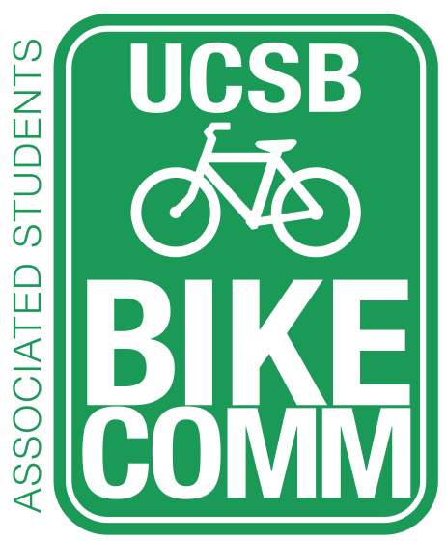
Associated Students Bike Committee
General Meeting Agenda

1/23/15 @ 11:00am- Nati Conference Room

CALL TO ORDER: 11:05AM by Emily Littleworth

- Meeting Business
  - Attendance
Name | Present? | Name | Present? | Name | Present?
Emily Littleworth | Present | Sarah Siedschlag | Present | Joey Lee | Absent
Mac Kennedy | Present | Aaron Jones | Absent | Fabi Perez-Lua | Present
Richard Lo | Present | Dennis Whelan | Absent | Kevin Jin | Present
Chris Bustos | Present | Jamey Wagner | Present | Jennifer Liem | Present
Nicole Ng | Present | Matt Stern | Absent | Jimm Villareal | Absent
Ava Cheng | Absent | Steve Conner | Present | Tiffany Wu | Present

- Public Forum
  - General Announcements
  - Appreciations/Concerns
  - Requests to have items added to the agenda
- Committee Member Reports
  - Associate Officer(s) Report
    - Person interested in being an officer
  - Administrative Officer Report
    - Emails on the way
    - Start logging office hours
  - Treasurer Report
  - Project Manager Report
    - Getting wooden stakes after meeting
    - Took inventory of bike lights (224)
  - Social Media Report
    - Taking pictures after meeting/schedule a photo for website
    - Update the theme
  - Vice Chair Report
  - Chair Report
    - Met Richard and Sarah for budget of 2015-2016. Budget changed to $2,850. $3,600 for staff. Total honoraria = $6,900. Finance board needs to approve change. Meeting Monday at 4PM. Asking for retroactive funds to fund honoraria for last quarter. Need to sign up for session to speak (Friday 6th) Sarah not available 9th-13th).
    - By Law changes sent to Jennifer/Jimmy.
    - Officer manual for next quarter.
- Action Items
  - Approve up to $70 to Jamey for pump head rubber seal.
    - Motion: Emily/Second: Chris/Calls to question: Mac.
    - Motion passes.
  - Approve up to $700 for Pardall Center Dero Air Kit (shipping and tax included) on the condition that the landlord approves installation.
    - Motion: Richard/Second: Chris/Calls to question: Emily.
    - Motion passes, with consent.
    - Mac will be contact.
- Bike Safety Week
  - Shirts
    - IV Screen Printing – 100 White, 100 Green, $1,738 in total. $8.20/Green tanks, $7.20/White tanks.
    - Adding shirts.
    - Quotes in Dropbox .
    - Shirts $2-3 more than tanks. Getting quotes for shirts.
  - Other Ideas
    - Bike Auction coinciding with Bike Auction on Week 3.
    - Advertising.
    - Tabling.
    - Surveys
      - Ask students about going to soccer games. Gather data to support why Harder Stadium should update racks.
- Progress on Bike Auction
  - Fabi, Kevin, Han, Chris, and Karen (CSO). Best time for the quarter is Week 3 to ensure all CSOs ready.
  - How to ensure quarterly bike auction? Two hands from Bike Committee to help transfer title ownership at the end of bike auction.
  - Around 200 bikes. All are auctionable/fixable. Officers should help fix.
  - Kevin: 25 bikes to fix.
  - No bike auction this quarter.
- Campus Improvement Updates
  - Projects Completed
  - Projects Underway
    - HSSB Parking
      - Funded.
      - Time estimate needed. Check with Olga.
      - Contact Chris from Peak Racks for time frame.
      - CC Richard so they can install Fix It Station at Pardall Center.
    - Psychology
      - Should be done by end of January.
      - Check with John.
  - Priority Project List Voting
    - SAASB Parking Revamp
      - Need sketch and estimate.
    - MCC
      - Need sketch and estimate.
    - UCen
      - Look for old sketch and estimate.
      - Put boneyard racks between trees by Girvetz.
      - Need Marc’s approval and Chris (Peak Racks) to move HSSB old racks to UCen.
    - Library
      - Need sketch and estimate
    - HFH
      - Need sketch and estimate
    - Additional Projects
      - Physical Science Parking – by Phelps, behind Chemistry building. Construction/fence making parking worse. Broida lot empty now.
      - Harder Stadium - Harder Racks need to be revamped. Have Athletics paying (Director). Contact Hazel.
  - Maintenance
    - Update on El Collegio Signage in front of Health Center
      - Matt Stern (police) could fund new signage.
    - Trim Leaves Storke Roundabout
      - Sarah: Facilities needs to get in touch with Indian Student association to cut the branches.
    - Bike Path by Grad Housing
      - Need to fix path through Lacrosse field.
    - Fading Roundabout Striping
      - Needed warranty.
      - Glow in the dark.
      - Possibility of doing this every fall quarter.
  - Naming Bike Paths
  - Pardall Dero Air Kit Update
    - $400 from COSWB
    - $700 from IVTU
    - Left over 471.95. + installation ($200).
    - Who to contact for installation? Peak Racks. But UCSB does not own the property. Need permission. Figure out where to install, color…
- Committee Business
  - Follow Up on Raising Fee Initiative
    - Marc Fisher still not responding. No response for Diane.
    - Proactive meeting? Lisa Tucker deals with Marc Fisher’s schedule for meetings.
  - Han Bike Repairs
    - Han and Kevin meeting with Karen (CSO) to check out more bikes. Finding location to keep new bikes. Adam wouldn’t work to keep bikes. CSO/Devereux has storage space.

ADJOURNMENT: by Emily Littleworth at 12:31PM

