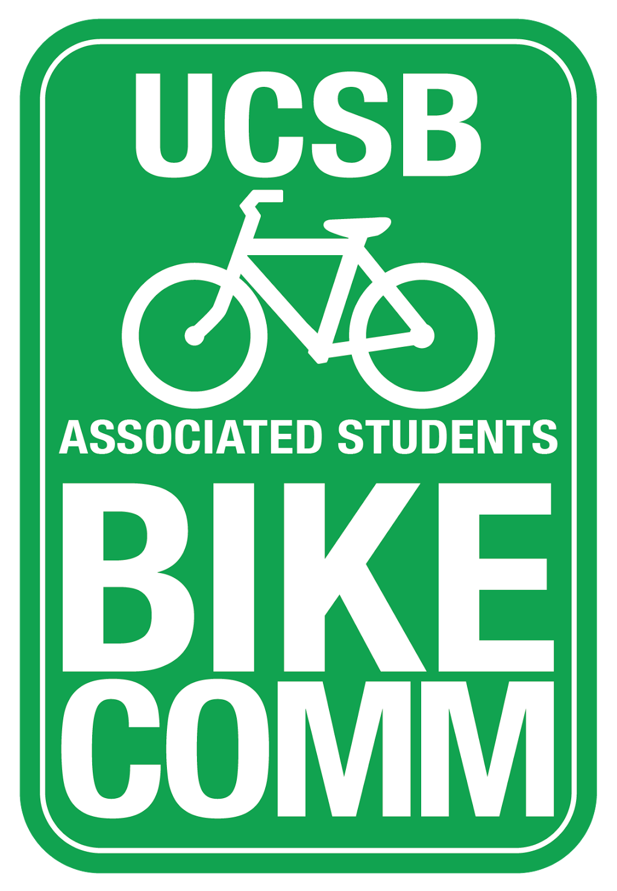
BIKE COMMITTEE WEEKLY MEETING AGENDA
Associated Students
February 1, 2018 5PM
Location: Bike committee office MCC 2521

CALL TO ORDER 5:02 PM

- MEETING BUSINESS
A-1. Roll Call

Name | Note:  absent (excused/not excused)  arrived late (time) departed early (time)  proxy (full name) | Name | Note:  absent (excused/not excused) arrived late (time)  departed early (time) proxy (full name)
Kevin Jin  Chair | Present | Adriana Ocasio  Associated Officer | Absent (unexcused)
Annie Golay  Vice Chair | Present | Sara Lafia  Graduate | Present
Lianna Nakashima  Media Coordinator | Absent (excused) | Sarah Siedschlag  Advisor | Present
Danny Kolosta  Project Manager | Present

A-1. Acceptance of Excused Absences and Proxies MOTION/SECOND: Jin/Golay Motion to acceptance of excused absences and proxies ACTION: Vote: Consent

A-2. Acceptance Previous Minutes MOTION/SECOND: Jin/Golay Motion to accept the minutes ACTION: Vote: Consent

PUBLIC FORUM
  - General Announcements
    - UCSB Reads offering free books from the Library Reference Desk
  - Appreciations/Concerns
    - Sarah appreciates Annie’s efforts in planning Gaucho Bike Fair ii.Danny appreciates Committee’s efforts in his absence Fall quarter
  - Request to have item added to today’s agenda
    - Dennis requested to move racks from Life Science Building

COMMITTEE BUSINESS
- Meeting Times for Quarter
  - Officer Meetings
    - Thursdays at 5pm every other week
  - General Meetings
    - Tuesdays at 4 pm every other week

REPORTS
C-1.Advisor Report
  - SRB meeting is on agenda, AS assembly meeting this Sunday – Kevin has RSVP’d

C-2.Associate Officer(s) Report
C-3.Administrative Officer Report
C-4.Project Manager Report
C-5.Media Coordinator Report
C-6.Vice-Chair Report
- PACES certification program through sustainability
- Katie Maynard wanted us to get involved through Cyclemania
- Sara – would be cool to do larger taco bike ride for Cyclemania
- Sarah – Bike rides outside Isla Vista are helpful for students
C-7.Chair Report

Old Business

- New Business
- Gaucho Bike Fair Recap & Discussion
  - Annie – Gave away most of prizes, went pretty well considering constraints
  - CHP pulled out last minute due to disasters
  - Passports should have been printed sooner and flyers should have been posted earlier
  - Order prizes sooner and attract more people
  - Kevin – Confusion between Bike Fair and CSO Bike Sale
  - Sarah – move in week event potentially and opportunities for education
  - Kevin – decision to separate from CSO to distance from the chaos of the Bike Sale
- Winter Projects Recap
  - Relocating of Life Science racks to Bioengineering
    - Path on west side of Life Science will be repaved in near future
    - Racks will be relocated somewhere along new bike path MOTION/SECOND: Jin/Golay Motion to table the funding of relocation of peak racks from Life Science building to somewhere along new bike path
ACTION: Vote: Consent
  - Psych Circle Improvements

    - $20,000 was passed in November to move light fixture and restripe circle near Psych building
    - Waiting for construction
  - Bren Lot Proposal (Sarah)
    - Last February we approved $12,000 for design work for a Bren lot
    - Beginning to gain traction with design and work orders based off our allocation
    - Once proposal is official they will come back to Committee for more money (Teli)
  - SRB discussions
    - SRB Governance Board will have charrette with Kim True on potential SRB Bike Lot
    - Our position is that aesthetics should not compromise number of spaces
    - SRB 2154 at 12 pm
    - While we approved $12,000 that money was never spent due to SRB’s surplus budget
- Budget
  - Sarah will go to Facilities and inquire about budget to get on the same page
- Potential Ride-Around
  - Plan ride around sometime this quarter or next quarter with Dennis
    - Rec-cen roundabout
    - Potholes
    - Student Health striping
    - Bike path going east from SAASB
- New Project Ideas
  - We have good amount of money to allocate since fee increase
  - Allocate funds towards CSO’s for tagging of abandoned bikes
  - Annie – donate your bike talk to Mo Lovegreen
  - Sara – similar to cash for clunkers and offer small stipend
- Tabling and Education Ideas
  - Go digital with feedback
  - Sara – some sort of pin dropping service for bike survey
  - Summer orientation education
  - Better campus mapping services

DISCUSSION ITEMS

ADJOURNMENT

MOTION/SECOND: Kolosta/Golay Motion to adjourn the meeting at 5:56 ACTION: Vote: Consent

