Senate Minutes

Associated Students
05-22-13, 6:30pm
Flying A Room in the UCen Minutes recorded by: Alexa Stephenson

CALL TO ORDER 6:42pm by Mayra Segovia, INTERNAL VICE PRESIDENT

A. MEETING BUSINESS
- Roll Call

Name | Note:  absent (excused/not excused)  arrived late (time)  departed early (time)  proxy (full name) | Name | Note:  absent (excused/not excused)  arrived late (time)  departed early (time)  proxy (full name)
Nicole “Nikki” Calderon | Present | Angela Lau | Present
Alex Choate | Excused/Present | Lauren Moissiy | Present
Kaitlyn Christianson | Tardy | Kevin Rudolph | Present
Alessandra Cianni | Present | Taryn Sanders | Arrived Late (8pm)
Kayla Donley | Proxy/Present | Karen Sarmiento | Present
Gerardo Gonzalez | Present | Kyley Scarlet | Present
Ben Green |  | Benjamin Shin | Present
Tuquan Harrison | Present | Miya Sommers | Tardy
Genesis Herrera | Arrived Late (7:35pm) | Andrew Soriano | Present
Brandon In | Present | Sam Swift | Present
Navkiran “Navi” Kaur | Present | Tyler Washington
Amir Khazaieli | Present | Michael Zhang
Ashley Koide | Excused/Proxy


- Acceptance of Excused Absences

*Kayla Donley (6:30-9pm) class
*Alexandria Choate (6:30pm-7pm) class
*Ashley Koide (7-8pm) meeting
*Michael Zhang (6:30-9:30pm) class
*Alessandra Cianni (after 12am)

Karen Sarmiento (after 9:45pm) Work
Sam Swift (after 9:45pm) Play Rehearsal

MOTION/SECOND: Cianni/Calderon

Motion language: Motion to excuse Karen and Sam

ACTION: Vote: CONSENT to APPROVE
Vote Taken: 6:45pm

A-3. Acceptance of Proxies
Amanda Manalo For Kayla Donley
Andre Theus for Ashley Koide

MOTION/SECOND: Lau/Scarlet

Motion language: Motion to accept the following proxies [listed above]

ACTION: Vote: CONSENT to APPROVE/DENY
Vote Taken: 6:46pm

B. PUBLIC FORUM
Jordan LuMorde, Elections
- Elections Committee had a talk and they realized that Elections is very limited by the size and by what they can do
- They wrote a bill to revise the code for every Spring, making everyone in AS involved during the Winter, people identifying with a party earlier on also, and also changing around the weeks when candidacy for the parties occurs…etc
- For BCC endorsements, it is the same process but they are adding a form as well
- Can’t declare parties until week 2 of Winter, can’t actively recruit candidates for a week

Sean Swale, Commission on Public Safety
- Recently endorsed by Comm on Comm to be chair of COPS
- Knows CPR and works with EMTs on campus, among other qualifications
- Looking to increase public safety on campus, more signage, improving safety on bike paths so there are less collisions on the bike paths & in IV, working with CSOs, increase the public views of the CSO YouTube videos
- Should include more behavioral activity like physical activity, weekend activity, in order to stay safe
- Really try to get involved with the freshman and CERT (Community Emergency Response Team)
- Get involved with the Womyns Center and make packets for rape prevention/crisis aftermath to give to police in IV
- Came out prepared and gave out business cards

Andrew Soriano, New RHA President
- Newly elected 2013-2014 RHA President
- Completing the bet of dancing at a Senate meeting & showed off his dancing skills

Tiana Miller-Leonard, Student
- Student who has been writing for the Nexus since October
- Her first impression of the Senate was she was really impressed by their work with Hurricane Sandy and the lighting work
- This quarter she thinks it has been really easy to become disillusioned with the Senate with either the parties, or the contentious issues, or people losing elections
- If Senators approach each other not as rivals and collaborate then good things can happen
- She is really glad she had this experience and she could be involved in some way

Alessandra Cianni, Senator
- Did not have a speech prepared because she did not plan on being attacked at her last Senate meeting
- She has never seen people be so mean in last 8 weeks, on campus, in meetings, on Facebook…etc
- You don’t have to like her opinions, she is here to be a voice for students, & she has been very available to students for extra office hours in IV and no one has come to talk to her
- Even though no one has come to talk to her, and she has gone out of her way to hear where people are coming from, people are continually attacking her
- No one knows what she has been through in the past 24 hours and no one has tried to
- If there was a problem with her or anything she might have said, they should have come to her personally & had a discussion versus making a public proclamation or putting it on Facebook

Sally Oh
- She thinks there is an ignorance of sides attacking each other & who is attacking who
- She thinks that if there is a question of attacking, she encourages the attacker to reach out to the attacked to open up a dialogue
- She thinks the dynamic will be interesting for next year’s Senate & she encourages the Senate to not fall into a hierarchy & to dissect everything that comes before them & think for themselves

Anisha Ahuja
- She has been to many Senate meetings in the last two quarters & “yelled at the Senate” many a time
- Brought up the divestment issue again
- She says she does not come to the Senate for certain issues because of racism & the Senate has preconceived notions of her based on the color of her skin & gender
- She says she is allowed to call people out because she is a woman of color

Andre Theus, Student
- He has always been a person who has questioned people, especially when he got to this campus. Questioning his friends, execs, …etc
- He thinks he has grown a lot since freshman year in the way he conducts himself & no one should worry about him next year in Senate
- He has been very disgusted with the behavior of Senators this year since he has been to a great number of Senate meetings
- For next year Senate, he recommends that everyone listens to one another so they don’t have so much disrespect

Hani Tajsar, Undergrad
- He is branching off the privilege discussion & white privilege
- He was excited when the Palestine divestment issue came up during spring quarter & he thinks it passed
- He thinks everyone did a great job about respecting the chair’s decision

Ben Shin, Senator
- Speaking to say he is grateful to serve as a freshman senator and he learned a lot about parli pro
- There were times where it was impossible to reach a compromise but he respects each and everyone of the senators, proxies, & everyone who taught him how to hold himself as a freshman
- He wishes everyone the best for next year

- EXTERNAL REPORTS

C-1. A.S. Committee & Ex-Officio Reports
TBTN Co-Chairs, Danielle Bermudez
  - They appointed new members and they are very excited about that
  - They encourage new Senators to reach out to TBTN next year

AS Student Lobby, America Munez
- Pushing for legislators to get here next Fall because they couldn’t get here
- They went up to Sacramento and lobbied last week and it was a good experience. They talked with some Regents & UCSB Alumni. They were interested in talking to students
- They are trying to make the transition to next year’s officers as smooth as possible with information and ideas

C-2. Executive Director’s Report
Dr. Marisela Marquez
- Starting off with the tradition of distributing legos for the “legislators” & asking them to think about what kind of leaders they want to be in life
- She doesn’t get involved in the Senate because it is not her time, and Senators need to learn what kind of leaders they are so it will serve them in different venues in life
- Personnel Matters: started a search committee for the KCSB appointment and starting one for the Cashier’s Office Coordinator
- Going to make a search committee for Food Bank, Living History, Financial Enterprises Analyst (likely),
- Associated Students Staff Pay Scale Criteria: policy to be instituted that describes why students are hired at a certain level and how they can increase their pay and job level over a certain time. They created their own criteria because A.S. is different in hiring students than any other department on campus. They hire a plethora of job descriptions (bike mechanics to minute takers) but no criteria evaluation should be higher than another.
- 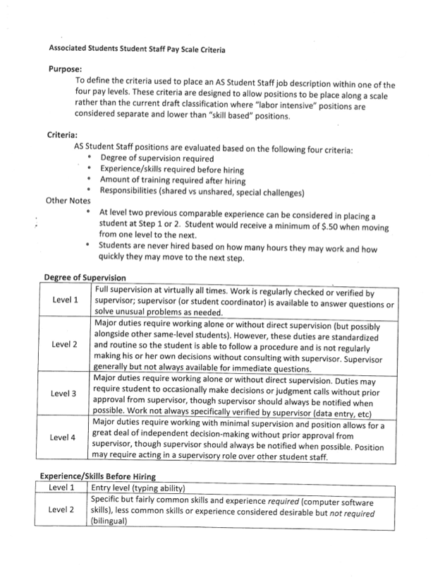
- 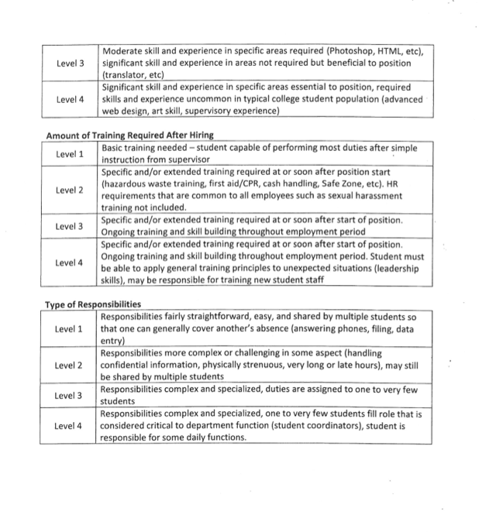

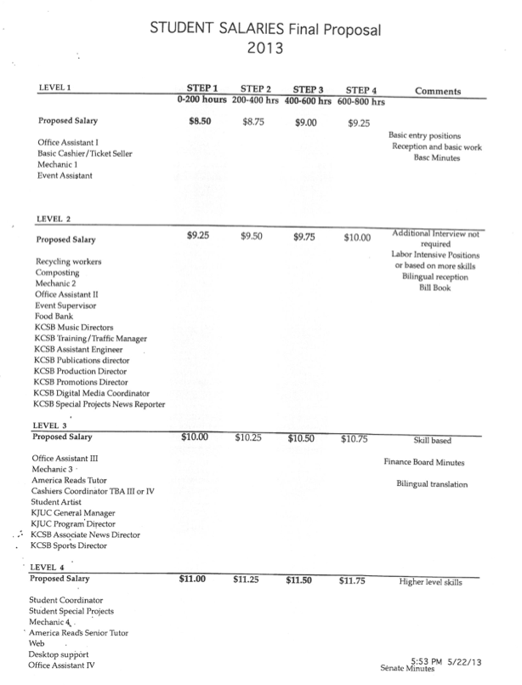

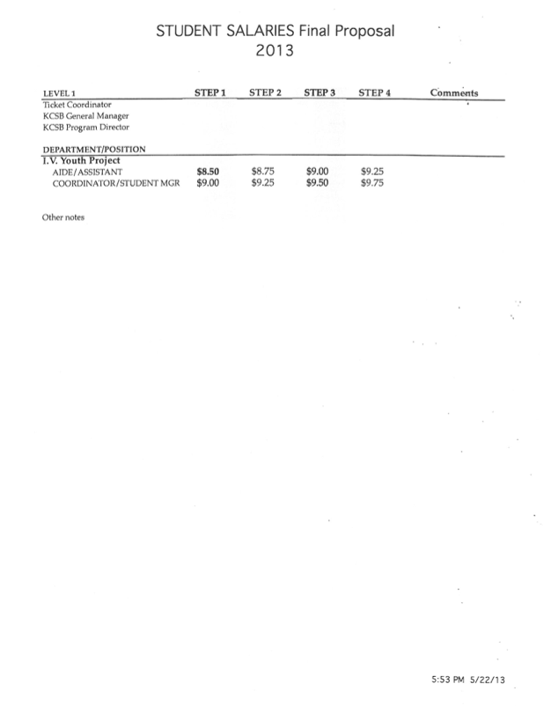

C-3. Executive Officer Reports
President Sophia Armen
  - Thanks everyone for the opportunity to serve and she says this speech comes from the heart (i.e. it’s not written down)
  - She has been in this association for 4 years which has caused breaking up of relationships, friendships but she has always kept her humanity & dignity in all things
  - She has repressed the negative things and events from the past 4 years in Associated Students because it has taken a large toll on her being
  - Everything she has done in the association is about what is best for “us” the students and used love, respect & dignity for everyone she meets
  - She gives major props to her staff because she works them to the bone
  - She also praises the A.S. staff for all the work they do and they are amazing
  - She feels there are party politics in A.S. that need to be addressed since one party has had a majority in the Senate for the last 6 years
  - She is the President but she has never felt that she is better than anyone ever
  - *She performs a piece of spoken word* & talks about occupy movement, diversity, divestment, womyn/men of color, rallies, liberation, UCSB built on Chumash territory, justice, anger stereotypes, questioning why we are here, how we sometimes mass produce/market things, value of success measured in seats filled, anger is a rational reaction to injustice, UC system has nuclear weapons systems facilities, we are a culture of fear & we can’t talk about what things should look like, some students are just trying to survive, work & meanwhile the Regents are rich & dismantling our education system, I don’t want no movement/association if it ain’t about us
  - “I don’t want no movement if it ain’t got no humanity”
  - Favorite part about being President was all the people in her office and the people working for justice on this campus at all times & worst part was finding out that she needed such a thick skin. She wants to tell everyone that they need self love & that women especially
  - She thinks there has not been an adequate response from UCSB Administration about the diversity town hall

Internal Vice President Mayra Segovia
  - Reading Tyler Washington’s letter for why he is absent & reflections on the past Senate year. It’s because he is at his sister’s graduation
  - She stepped away from her sister’s shadow & became her own person
  - She became a Senator & was inspired by her Internal Vice President to run for IVP the next year
  - Switching parties from Senator to IVP didn’t matter because she was doing her job well and staying true to herself & who she is as a person
  - Some people this year think she has not done a great job this year but she knows that she has stayed true to herself and that is all that matters
  - Her speech is followed by a standing ovation
  - Honoraria is always an issue & last year she wrote a bill to cut it. Some BCCs had an issue with it, so she suggests the next IVP creates a form so it can be evaluated
  - She would do this experience all over again because you learn a lot on the job, which she will carry on to future jobs
  - She learned that managing people is really difficult, chairing meetings is hard & she sometimes comes across as very intense
  - She has also witnessed a lot of disrespect this year, not only towards her but towards one another
  - She advocates learning to listen, & being respectful because you never know when you could be in that position

External Vice President of Local Affairs Rhandy Siordia
  - It’s been a great year with 30 different initiatives, planning events, initiating projects…etc
  - Still working on projects: Park podiums in IV that show maps of where you are, the IV Co-op Contract, the Taxi Contract, renting space in IV/negotiating with BCCs. He will continue to work on these even after his term is done because he likes to finish what he starts
  - “How can he leave the one thing he loves most in this world?-Local Affairs”
  - He will still carry the incredible lessons and memories he has learned, keep going if you lose an election, don’t judge a book by its cover or big hair, take the opportunity to do something new or different, or colossal
  - He thanks the current Senate for listening to his long and extensive Exec. Reports
  - He encourages the new Senate to have a good year and that it’s okay to disagree
  - He thanks the AS advisors and adults for all the help they do
  - He thanks his fellow Executive officers for the shared memories of the year and not the long exec. meetings
  - He thanks Kaitlyn for everything and being with him since IVCRC since sophomore year
  - Keep the magic of Isla Vista close to your own heart

External Vice President of Statewide Affairs Nadim Houssain
  - His year has gone by so quickly since getting sworn in
  - He encourages everyone to do everything in their power for the student body & to not leave anyone out
  - Over summer they went to United States Students Association (USSA) in Wisconsin in which they voted on the Dream Act, student loan debt & they went to UCSA Congress in San Diego along with 500 students. Voter registration registered 11,000+ students to vote, so UCSB was #1 in the nation
  - Since we were #1 in Voter registration, we get a free event “Rock the Vote”, which will most likely be a large scale movie screening since a concert is too expensive, so he is trying to organize that before the end of the year
  - Grant for $25000 to address the corruption within the prison system & that restructuring the funds that could better benefit the education system. Prison reform is through UCSA Congress & there is still some work to be done
  - UCSA will be in Irvine this year but UCSB will still maintain leadership in themes and workshops...etc. But in such short notice UCSB could not find an adequate amount of housing to still host
  - He thinks it was unfortunate how Yoel was targeted throughout the year and it could be due to a series of factors. He hopes no student should ever have to go through such targeting
  - He is very glad of what his office was able to accomplish and he looks forward to the future officers carrying on the legacy

Student Advocate General Yoel Haile

MOTION/SECOND: Kaur/Swift

Motion language: Motion to give Yoel 15 more minutes

ACTION: Vote: 18-1-2 to APPROVE
Vote Taken: 7:35pm

MOTION/SECOND: Kaur/Sommers

Motion language: Motion for a Roll Call vote

Name | Note:  absent (excused/not excused)  arrived late (time)  departed early (time)  proxy (full name) | Name | Note:  absent (excused/not excused)  arrived late (time)  departed early (time)  proxy (full name)
Nicole “Nikki” Calderon | Yes | Angela Lau | Yes
Alex Choate | Yes | Lauren Moissiy | Yes
Kaitlyn Christianson | Yes | Kevin Rudolph | Abstain
Alessandra Cianni | No | Taryn Sanders
Kayla Donley | Yes | Karen Sarmiento | Yes
Gerardo Gonzalez | Yes | Kyley Scarlet | Yes
Ben Green |  | Benjamin Shin | Yes
Tuquan Harrison | Yes | Miya Sommers | Yes
Genesis Herrera | Yes | Andrew Soriano | Yes
Brandon In | Yes | Sam Swift | Yes
Navkiran “Navi” Kaur | Yes | Tyler Washington
Amir Khazaieli | Abstain | Michael Zhang
Ashley Koide | Yes
  - *A copy of the speech is on file with certain staff & student personnel*
  - Giving a full report of his year as the Student Advocate General starting since before he was elected to the office
  - Making specific accusations against specific named students & OPP about allegations during/after Elections
  - Says he has the best staff in the Association and that’s why he thrived
  - Winter Quarter: carrying out true mission of office and helping out students...etc
  - Spring quarter: divestment & speaking during public forum & during his executive officer report and the inappropriate questioning or allegations
  - Calling out specific Senators, students and parties repeatedly
  - Says whiteness is a pervasive illness in society
  - Lists specific license plate numbers in his speech of people
  - Cases include helping students being kicked out of school, parental problems, organized walk out in Fall, & averaged 3 cases each week
  - He thanks Marisela, Aaron Jones & Flo Nocar for all the help

- ACCEPTANCE of AGENDA/CHANGES to AGENDA

MOTION/SECOND: Choate/Swift

Motion language: Motion to accept the agenda with the added changes

ACTION: Vote: CONSENT to APPROVE
Vote Taken: 9:29pm

- Minutes and Allocations

- Approval of Senate Marked Agenda/Minutes from Senate 05/15/13:

MOTION/SECOND: Lau/Khazaieli

Motion language: Motion to approve minutes of the previous meeting

ACTION: Vote: CONSENT to APPROVE
Vote Taken: 10pm

- Approve Finance Board allocation of funding action(s) from 05/20/13:

MOTION/SECOND: Kaur/Theus

Motion language: Motion to approve funding

ACTION: Vote: CONSENT to APPROVE
Vote Taken: 10:01pm

- Approve BCC allocation of funding action(s) from the following meeting:

HRB 5/07, 5/14, 5/21
IVTU 5/14 and 5/21,
CoC 514,
ASPB 5/14 and 5/20,
CODE 5/20,
COSWB 5/20,
AS Food Bank 5/14 & 5/21, CAB 5/20, Queer Comm 5/15 & 5/20, Coastal Fund 5/13, Student Lobby 5/13, IVTU 5/21, SCORE 5/21, Womyns Comm 5/21, EAB 5/15, IVCRC 5/21, CBL 5/21

MOTION/SECOND: Khazaieli/Swift

Motion language: Motion to approve funding

ACTION: Vote: CONSENT to APPROVE
Vote Taken: 10:01pm

- ACTION ITEMS

F-1. Stolls for Previous Legislative Council and Current Senate Graduates

Staff/Advisor Instruction/Request: Unless the bcc is going to buy cords/stolls annually for every member, it is not going to be taken as a gift
Discussion began: 10:02pm; Vote Taken: None

G. BILLS and RESOLUTIONS

G-1. Old Business
- A Bill to Update A.S. Food Bank Legal Code (051513: 107)

MOTION/SECOND: Donley/Theus (Koide)

Motion language: Motion to pass bill with CBL recommendations

ACTION: Vote: CONSENT to APPROVE
Discussion began: 10:04pm; Vote Taken: 10:04pm

- A Bill to Update ASIAC by-laws (051513:108)

MOTION/SECOND: Rudolph/Cianni

Motion language: Motion to pass bill with CBL* amendments

ACTION: Vote: CONSENT to APPROVE
Discussion began: 10:22pm; Vote Taken: 10:27pm

- A Bill to Update the EVPLA Legal Code (051513:109)

MOTION/SECOND: Khazaieli/Sanders

Motion language: Motion to pass bill without CBL recommendations of striking the Taxi Cab project & Suicide Prevention Walk, & striking of “2018”

ACTION: Vote: 17-1-3 to APPROVE
Discussion began: 10:44pm; Vote Taken: 10:55pm

- A Bill to Update IVP Legal Code (051513:110)

MOTION/SECOND: Scarlet/Calderon

Motion language: Motion to pass bill

ACTION: Vote: CONSENT to APPROVE
Discussion began: 10:05pm; Vote Taken: 10:06pm

- A Bill to Restructure the Office of the Student Advocate General (051513:111)

MOTION/SECOND: Scarlet/Choate

Motion language: Motion to pass bill

ACTION: Vote: CONSENT to APPROVE
Discussion began: 10:07pm; Vote Taken: 10:07pm

- A Bill to Change EVPSA Legal Code (051513:112)

MOTION/SECOND: Choate/Scarlet

Motion language: Motion to pass bill with CBL recommendations

ACTION: Vote: CONSENT to APPROVE
Discussion began: 10:08pm; Vote Taken: 10:09pm

- A Bill to Update Committee on Committees Legal Code (051513:113)

MOTION/SECOND: Scarlet/Calderon

Motion language: Motion to pass bill

ACTION: Vote: CONSENT to APPROVE
Discussion began: 10:09pm; Vote Taken: 10:16pm

- A Bill to Update ASOP Legal Code (051513:114)

MOTION/SECOND: Scarlet/Choate

Motion language: Motion to pass bill

ACTION: Vote: 11-6-4 to APPROVE
Discussion began: 10:17pm; Vote Taken: 10:18pm

- A Bill to Restructure the Commission on Student Well-Being (051513:115)

MOTION/SECOND: Calderon/Rudolph

Motion language: Motion to pass bill

ACTION: Vote: CONSENT to APPROVE
Discussion began: 10:28pm; Vote Taken: 10:29pm

- A Bill to Restructure the Election Code (051513:116)

MOTION/SECOND: Harrison/Kaur

Motion language: Motion to pass with CBL recommendations as amendments and the amendments of striking out “instead of throughout the entire academic year” to replace with “after week two of Winter Quarter”, “vote of the Senate no later than the 7th week of Spring quarter.” “Advertisement for recruitment events may begin week 6 of winter quarter”

ACTION: Vote: 17-2-2 to APPROVE
Discussion began: 10:29pm; Vote Taken: 10:41pm

G-2 New Business
None

H. DISCUSSION ITEMS
None

I. Internal Reports

J.1. Group Projects:
Andrew Soriano, Wifi Project
- Info got sent to right people & universal wifi is on the brink of Fall 2013
- UCSB secure is live so once you long on, you only have to login once a quarter
- Wifi in Embarcadero & other places

J.2 Senators’ Reports:
Andrew Soriano
- RHA had all town hall & he will taking office soon

Gerry Gonzalez
- Finance Board is out of money & he is the Finance Board chair for next year so he looks forward to working with everyone next year

Genesis Herrera
- Coastal Fund news, & COPS is very important and needs to get going next year

Miya Sommers
- University owned apartments are having elections and they need to vote because they don’t have a committee

Kayla Donley
- Food Bank & HRB are winding down for the school year

Navi Kaur
- Score has new officers and is excited for next year

Sam Swift
- Student Lobby has SLC money for next year & he hopes it goes strong next year

Kyley Scarlet
- Rally Comm had their appointments and picked their people & the Sobering Center needs people for next year

Angela Lau
- Comm on Comm banquet tomorrow, Be there!
- Finance Board banquet was yesterday at El Torito
- ASIA and doing stuff for senate fellows, should be good
- Honoraria on Friday and CBL on Friday

Lauren Moissiy
- AAB put on an event for networking writing after college which collaborated with College of Creative Studies and Writing major

Taryn Sanders
- CAB has been awesome and Kaitlyn is co-chair, they’re still doing some projects too with money they have left
- Honoraria is on Friday

Nikki Calderon
- TBTN got new co-chairs and she is excited to work with them
- COSWB had a great de-stress fest with snow cones…they have a whole new board and are taking advantage of lock in
Amir Khazaieli
- Both his BCCs stopped meeting this year so he thinks that’s unfortunate

Alessandra Cianni
- Finance Board had banquet last night
- She encourages new Senate to be enthusiastic

Kevin Rudolph
- IAC is doing well and has a new board & got a rollover to use over summer
- RHA is doing well

Alex Choate
- SIRRC had banquet last Friday and revealed winners of internal elections, & has one more meeting next week

Kaitlyn Christianson
- Womyns Comm. meets Tuesdays at 7pm
- Working on “I am beautiful runway show” & just had their banquet
- IVCRC just finished Chilla Vista

Tuquan Harrison
- Q comm. appointed new officers for next year
- Elections code got passed for next year so he’s excited

Brandon In
- Doesn’t have any BCCs to report on

J. REMARKS
Ben Shin
- For those who don’t know parli-pro, don’t worry

Tuquan Harrison
- Black & queer reps: your community needs you to continue the work

Kaitlyn Christianson
- Sorry it’s so late, but it’s important to be here and pay attention to the speakers at the podium (i.e. not do homework or anything else)
- Go to your BCCs, or at least email them because many don’t know what is going on in the BCCs or the BCCs don’t know who their Senate rep. is
- Don’t let yourself be passive in Senate & don’t let yourself realize it in Spring

Alex Choate
- Student representation needs to be continued all year round, especially for administration committees because they are the only student voice on those committees
Kevin Rudolph
- Proud of everyone now, but he wants to see everyone at the end of the year also
- He wants everyone to stay true to their political & ideological beliefs and make it known at the very beginning but to stay respectful and to not get intimidated
- But remember that you are a student first, and have families & other obligations

Alessandra Cianni
- Come to every senate meeting and be as excited as you are now

Amir Khazaieli
- Reach out to him as a resource

Nikki Calderon
- Ask her questions because she’ll be around all year

Taryn Sanders
- Come to the meetings, don’t drop, do your responsibilities; don’t neglect yourself even though it’s easy to get wrapped up in the craziness. Keep a balance
- She has full faith & we’ll all be here all year
- She recommends having parties and making personal connections outside of Senate

Lauren Moissiy
- If you get easily frustrated, then you need to learn to stay calm in this space
- If you are confused if what you are voting on, get clarification

Angela Lau
- Public forum isn’t a place to attack anyone’s beliefs or ideas or convince them to a certain viewpoint. It’s a space to listen to the public
- Don’t take anything personally
- Reads a resolution/bill to end the last Senate meeting early & congrats to graduating Seniors

Kyley Scarlet
- She is excited to swear everyone in

Mayra Segovia
- She has been a Senator and now the IVP
- Her advice is to know the Legal Code & know Parli-pro because people voted for you to be here & you are held accountable
- Be in your office hours, inform people about your office hours, know about issues, so you can walk away knowing you did something for this campus

Sam Swift
- With great power comes with great responsibility
- Challenge each other, and make each other be good people

Navi Kaur
- New diversity educator for SCORE & thinks it is important to recognize that everyone on Senate has a lot of privilege
- Everyone on Senate needs to go to one BCC meeting that they do not identify with & it’s important to reach out to new communities
- A.S. Staff have very important advice and are good resources for you
- Read the agenda the day before to make the meeting go smoother

Kayla Donley
- Take your position seriously and you can do a lot with it
- Go to your BCC meetings and be vocal

Ashley Koide
- Get to know legal code, parli-pro, don’t be afraid to ask questions, go to BCC meetings,
- Think about what projects you want to do over the summer

Miya Sommers
- Changes should be done more than just changes to the legal code
- She recommends the new Senate passes a resolution

Genesis Herrera
- It’s her last night involved in Associated Students for a long time
- A.S. a huge network of resources and you should use them
- Don’t let the meetings consume you or be long, so your mental and physical health

Gerry Gonzalez
- Think before speaking and he better see the Finance Board representative at every meeting

Andrew Soriano
- Current Senate gets props for withstanding such long meetings
- Tyler Washington “the Senate feels like you’re running a marathon sitting down sometimes”

ADJOURNMENT

MOTION/SECOND to ADJOURN: Cianni/Kaur
ACTION: Vote: CONSENT to APPROVE.
Vote Taken: 11:43pm

